Mini Project 2 Report
Oscar Sierra:
Joseph Companion, Matthew Rigg,
Le Vi Pham, John Cogburn

- Team Roles Table

Participants’ names | Code Section | Report Section | Documentation Section
Matthew Rigg | Matthew Rigg,  Le Vi Pham | Joseph Companion | Joseph Companion, Matthew Rigg

- Files & Descriptions

Part A – Basic Infrastructure
Implementation of ps and getpinfo system calls
A1. Ps sycall
File | Description
include/pstat.h | Create a new header file, pstat.h, that defines pstate structure so that both kernel and user code can include. This structure holds the statistics of each process (pid, cpu ticks, wait time, start/end times, etc…)
kernel/proc.c | Add the function ps() to print the process information (pid, state, name, etc…) of any process whose state is different of unsused. Place this below ptable struct.  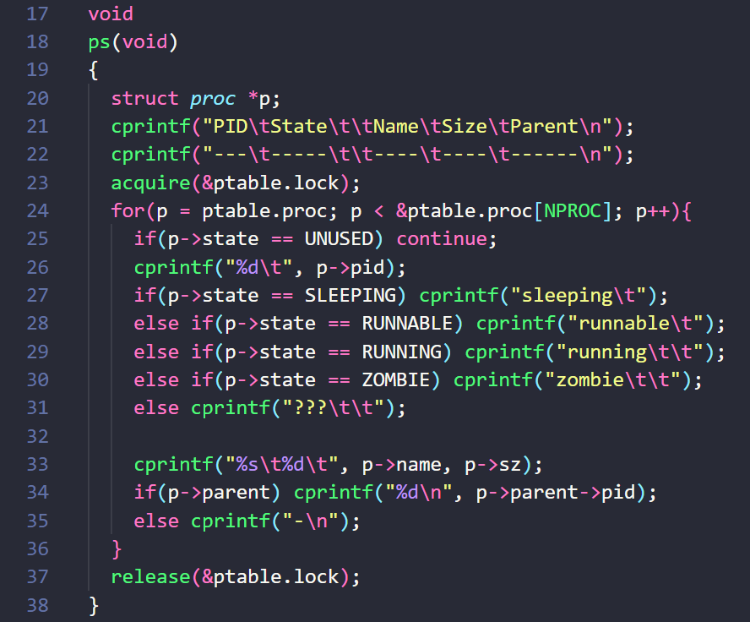
kernel/defs.h | Add definition ps(void) to let sysproc.c access ps() from proc.c
kernel/sysproc.c | Implement ps prototype  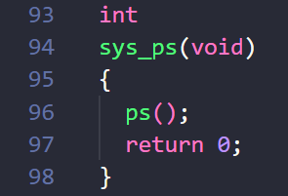
include/syscall.h | Create a new system call number
kernel/syscall.c | Declare ps as a global variable  Add a pointer to the new system call
user/user.h | Define interfaces for the system call in C
user/usys.S | Define interfaces for the system call in Assembly
user/pstest.c | A test program to call ps() system call  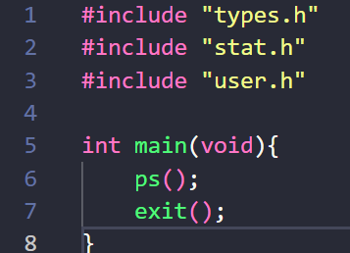
user/makefile.mk | Register pstest to the list of programs so we can run the test  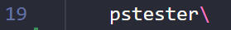

A2. getpinfo syscall + extend struct proc
File | Description
kernel/proc.h | Extend struct proc  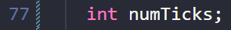
kernel/proc.c | Initialize p variables in allocproc()  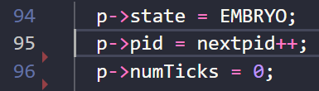  Update scheduler()  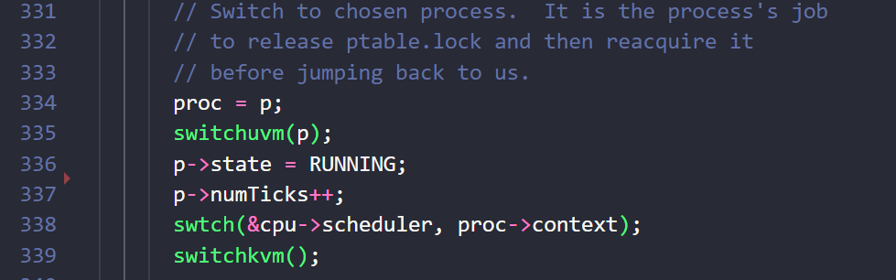  Add #include “pstat.h”  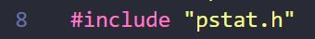  Add the function getpinfo() to get info of the process when called. Place this below ptable struct.  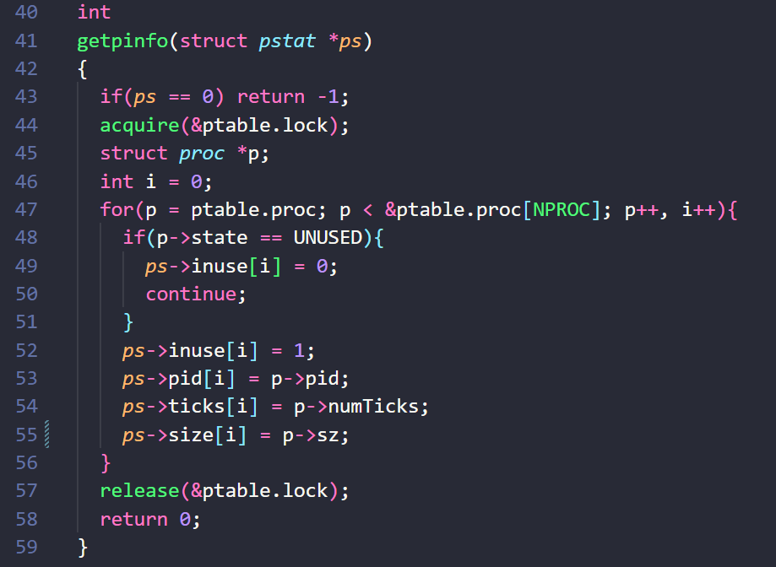
kernel/defs.h | Add definition for getpinfo
kernel/sysproc.c | Implement getpinfo prototype  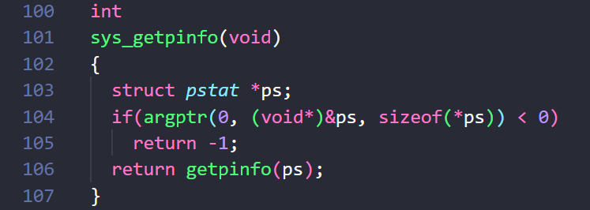
include/syscall.h | Create a new system call number  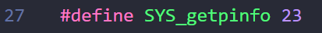
kernel/syscall.c | Declare getpinfo as a global variable  Add a pointer to the new system call
user/user.h | Define interfaces for system call in C
user/usys.S | Define interfaces for system call in Assembly  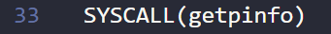

Part B – Experiment
B1. Test programs
user/childrenTester.c | A program that creates 3 children
user/accessTable.c | A test program to make sure that we can access the pstat table
user/store.c | A program to store and print the information of each process that is storing in the pstat table

- Benchmarking XV6: 3 Metrics and Discussion of Observations

