# QA Onboarding - Week 1

## Overview
Welcome to the QA team. This week, you'll set up your environment, learn the test process, and review critical tools.

## Objectives
- Understand the product architecture
- Set up test environments
- Explore test case management tools

## Tools
- Rally
- Postman
- Playwright
- JMeter

## Workflow
1. Review test strategy doc.
2. Join daily syncs.
3. Verify new builds in staging.
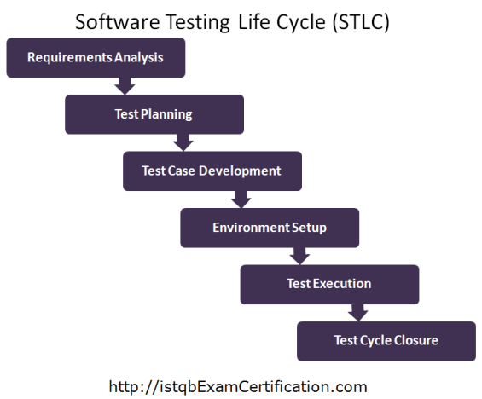
## Checklist
- Installed Playwright CLI
- Installed JMeter
- Access to staging/test servers
- Account created in Rally

## Contacts

Role | Email
QA Lead: | alice@company.com
QA Manager | tom@company.com

