Assignment 2: Group project

Project idea:

Instagram clone

***We need to give the project another name.

# Project Group Member:

|  |  |  |
| --- | --- | --- |
| No | Student Name | Student Number |
| 1 |  |  |
| 2 |  |  |
| 3 |  |  |

# Introduction:

Instagram is very popular mobile application that allow user to take photos, record videos, filter the photos and posts in social platform. This project is purposed to build a similar application that can access phone photo library, using camera to take photos and videos and upload online.

**BRIEF DESCRIPTION OF MOBILE APP**

Mobile App user can create and account and login to post images or videos (would it be tedious?). The images or videos will be uploaded into a server or database that allows other Mobile App users to view the post.

//What is Instagram & How Does It Work? | Instagram Guide Part 1 & 2

//1

<https://www.youtube.com/watch?v=ChnjKdMdQqA>

//2

<https://www.youtube.com/watch?v=0Z4AEDyKGdI>

The main theme of our project direction should be under,

**“PHOTO-SHARING SOCIAL NETWORKING SERVICE”**

# Requirement:

- Database: SQL lite (other platform needs to be asked for approval)

* USER (UserID, Username, User_Email, User_Password, User_DOB, UploadID)
* UPLOAD (UploadID, Upload_Type, Upload_Date, Upload_caption)

For Upload_Type in table Upload should be either Photo or Video.

- Gradle build system

- Minimum API level 27

# Basic Feature:

*** There are basic features that I found it’s possible for us to implement. All the examples are from Android developers website, source at: <https://developer.android.com/samples?language=java>

- My profile display: personal page that store history

- Record video: example from Android developers website, source at: <https://github.com/android/camera-samples/tree/master/Camera2VideoJava/#readme>

- Take photo

- Create a new account and log in: Add autofill frameworks, source at:

<https://github.com/android/input-samples/tree/master/AutofillFramework/#readme>

- Change photo effect: example from Android developers website, source at: <https://github.com/android/graphics-samples/tree/master/MediaEffects/#readme>

- Write a short caption for the photo and video.

- Upload online.

# Advance Feature:

*** Advance feature to be considered after we completed all the basic function of our project:

- Playback video when switching to another app: Android studio example, source at:

<https://github.com/android/media-samples/tree/master/PictureInPicture/#readme>

- Location GPS that indicate where the photo/video is taken.

# Outline:

Storyboard:

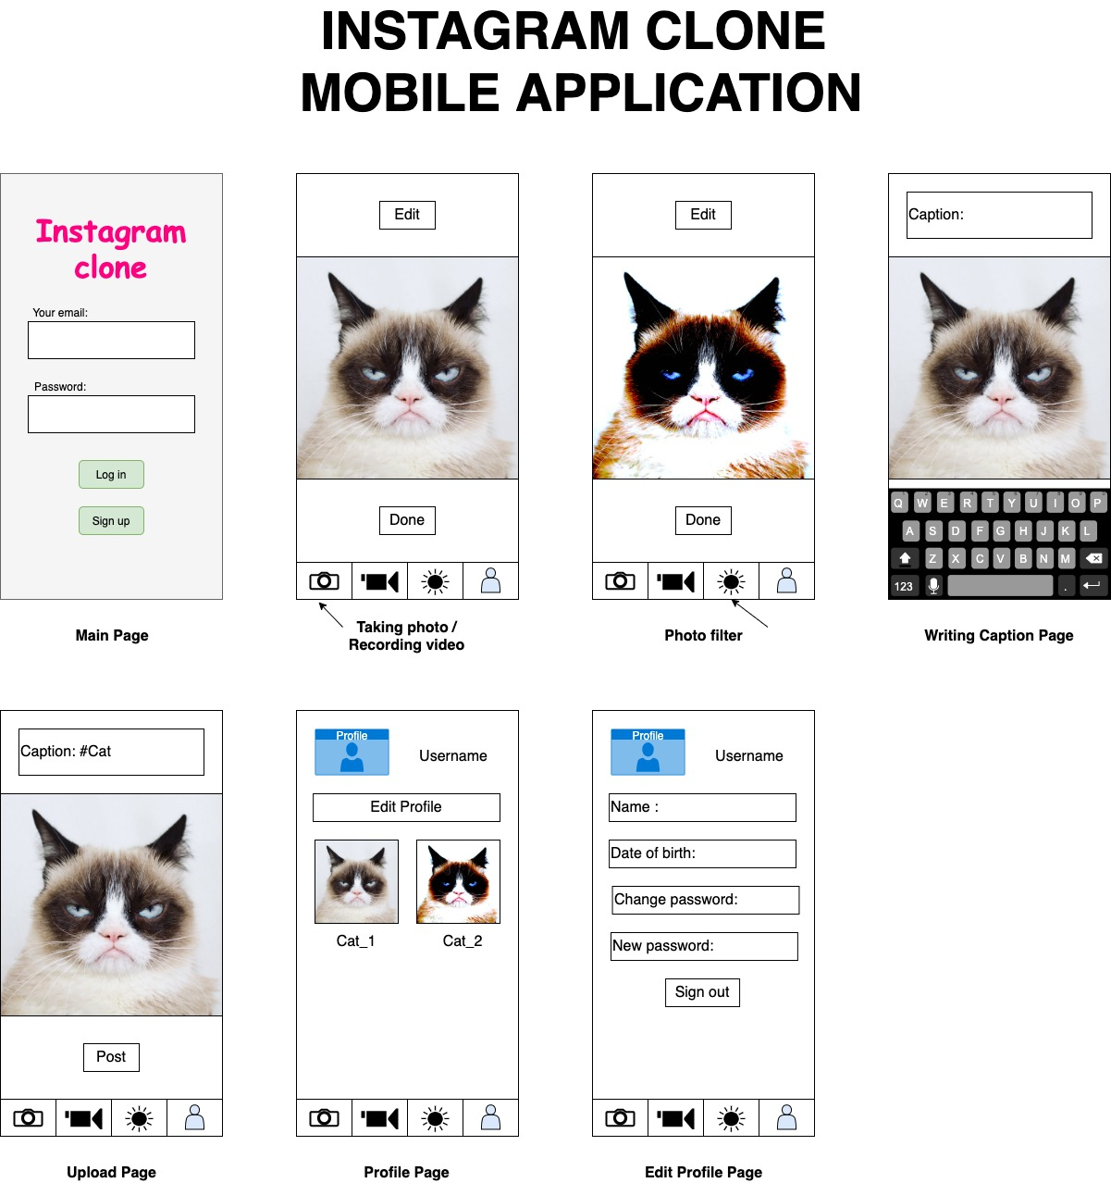

Kok Weng Comments [also highlighted in yellow]:

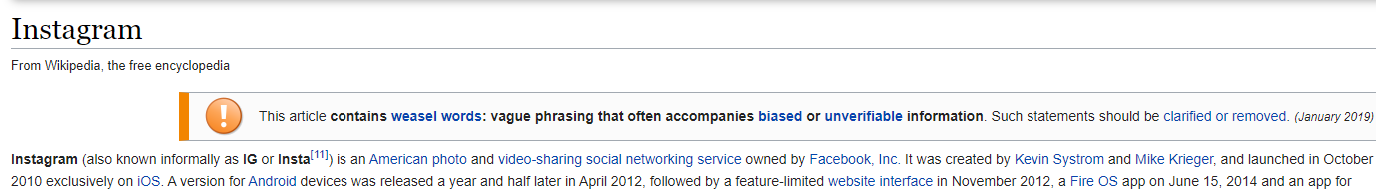

“Instagram (also known informally as IG or Insta[11]) is an American photo and video-sharing social networking service owned by Facebook, Inc. It was created by Kevin Systrom and Mike Krieger, and launched in October 2010 exclusively on iOS.”

**MOBILE APP MOBILE FUNCTIONS USED**

Camera Access

Photo Gallery Access

Internet Access

Posting on other social media access

Location services

**MOBILE APP REQUIREMENTS**

1. User can create an account
2. User can login to account
3. User can reset account
4. User can scroll through a feed of user posts
5. User can like a user post [press heart shape icon or double tap]
6. User can comment on a user post
7. User can upload an image post
8. User can remove posts
9. User can set filter for image post
10. User can add caption to post
11. User can set location of post
12. User can tag another user to the post
13. User posting is reflected on own account page
14. User can create request to follow another user
15. User can decline follow request
16. User can search posts through hashtag [can use another symbol]