**Title of the project**

TakeMeAway

Travel journal mobile application that helps travellers as they travel abroad to record down their travel activities, experiences they have encountered during their trips, thoughts of the day, and new ideas that comes throughout the day.

**Your team number**

We are Group 2.

**The names, student IDs and emails of the team members.**

|  |  |  |
| --- | --- | --- |
| **Team Member Names** | **Student ID** | **Email Address** |
| Pham Dieu Binh | 33784908 | [im.lyaclip@gmail.com](mailto:im.lyaclip@gmail.com) |
| Soh Wee Kee Jeremy | 33582314 | [astray03@gmail.com](mailto:astray03@gmail.com) |
| Yue Kok Weng | 33569494 | [yuekokweng@hotmail.com](mailto:yuekokweng@hotmail.com) |

**A paragraph that describes the application you want to develop.**

The aim of our mobile application is to allow user to have an app that helps travellers as they travel abroad to record down their travel activities, experiences they have encountered during their trips, thoughts of the day, and new ideas that comes throughout the day. We want users to capture every moment when they are travelling and to be able to reminisce their travelling experiences when they are back home or to share their travel stories with their loved ones.

**A description and sketch of the user interface(s).**

**Splash Page**

This is the first page that will load before entering the main activity page.

**Empty Home Page**

This will be the first activity page when no new post is created by the user.

**Home Page**

This is the main activity page with a list of feed posts arranged by the date posted and the user can create a new post from the ‘ADD’ button on the bottom right of the screen. The user can also search for posts on the search bar that will find posts with the words typed in the search bar.

**Create New Post**

When the user clicks on the ‘ADD’ button, the activity changes to this current page of a new posting. If the user clicks the ‘Back’ Button (‘<’ on the top left of the screen), the activity stops, and returns to the main activity page.

Here the date and time is pre-set according to when the button is clicked. Once the first post is ready, the user can click the ‘Done’ button above the keyboard to save the post.

**Edit Page**

From the main activity, the user can click any post that has been created to edit. Here, the user has entered the post to edit, the user can click the ‘PEN’ button on the top right to enable editing.

**Click Return Button**

From the editing post page, when the user clicks the ‘Back’ Button (‘<’ on the top left of the screen), a prompt is alerted to the user to discard or save changes made to the post.

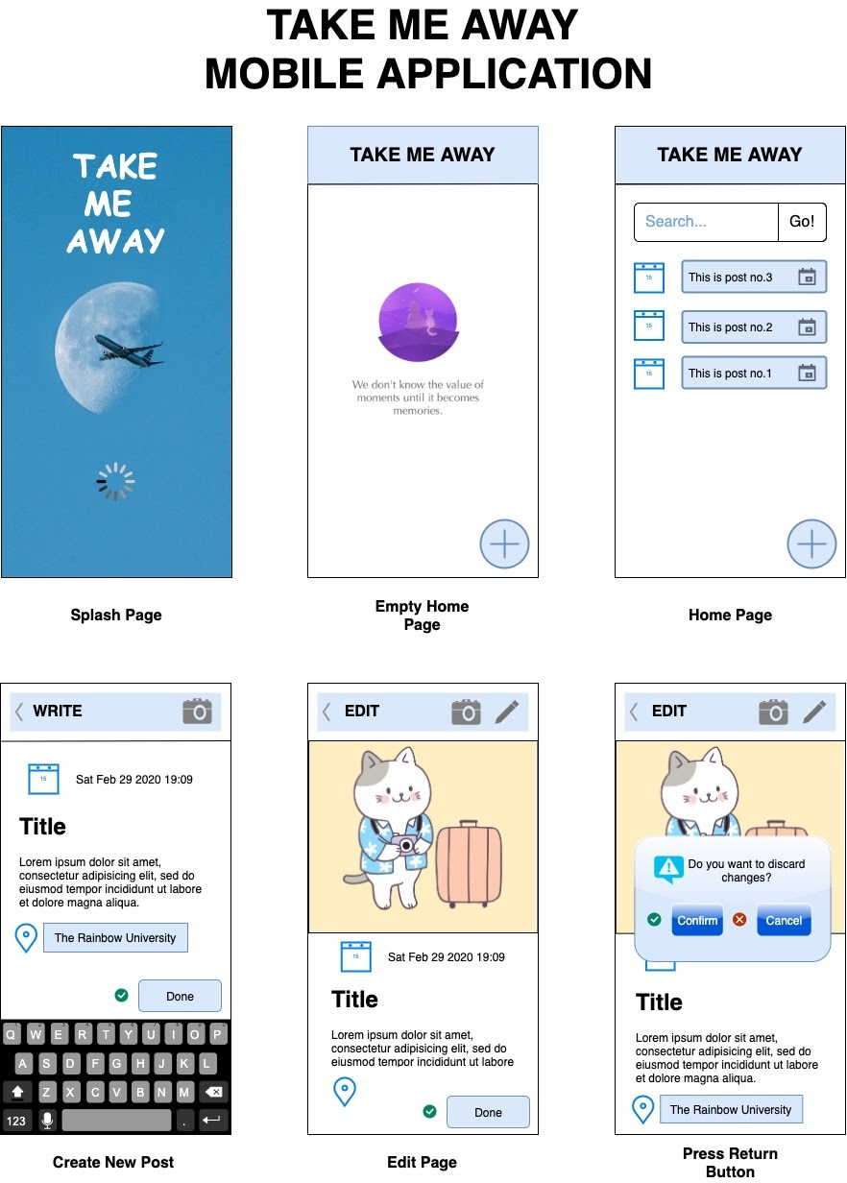

**A description of the interactions that are going to be implemented**

When the user launches the app, they will be taken to the main activity page where it shows all the travel log posted by the user that are tagged according to the date and time of the post.

When the user wants to create a new post, they can with the ‘Add New Post’ Button .  This will bring a new activity page where users can create a new post.

In the creation of a new posting, the top left of the navigation bar is the back to the main activity and the top right of the navigation bar would have a ‘Camera button that allows users to upload an image to the post. The image of the post is also over imposed on this navigation bar.

Just below the navigation bar is the date and time text view that would show the current date and time of the post.

Right after is the middle portion of the activity where users can type in their travel notes that they would like to share and the keyboard with a ‘DONE’ button will be shown along with the keyboard to type.

**What database are you going to implement**

We are going to link our application with SQLite that will store new user posts.

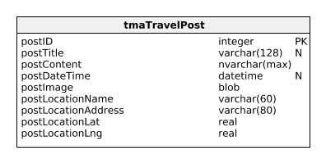

**Legend**

PK – Primary Key

N – Not Null

**The additional features, specific to mobile devices, that you would like to implement.**

1. Camera
2. GPS Location
3. Date & Time Picker
4. File Library Access (Gallery Access)