## Chemistry Lab playing

***Step 1: How to run the lab***

The generated lab is provided through a web link. A precompiled version can be found in

<http://envisagelabs.iti.gr/games/chemistry/>

***Step 2: How to start playing***

When you first open the labs, the lab menu screen is presented. Here you can choose from a list of available buttons such as Login, Help (Tutorial), Enter. To start playing press on the Enter button and then type your credentials as shown in Figure **Error! No text of specified style in document.**.1. Use nickname rather than your actual name.



Figure **Error! No text of specified style in document.**.1: The main menu of the lab.

***Step 3: Wonder around in the lab***

Before start playing, an image is displayed as shown in Figure **Error! No text of specified style in document.**.2, providing information about controlling the movement of the lab character as well as the goal of the lab. Subsequently, the player is transferred to the Lab scene (Figure **Error! No text of specified style in document.**.3) where he can wander around and interact with objects. Moving around is available through the use of WASD keyboard buttons and camera rotation through mouse panning. After the player gets familiar with the movement controls, he/she must search for the two available laptops (Molecule Naming, Molecule Construction) that open a chemistry quiz game. To interact with the laptops the player must be in a close proximity to the laptop and press the “e” on the keyboard (a tooltip is highlighted on the lab, see Figure 3.17).

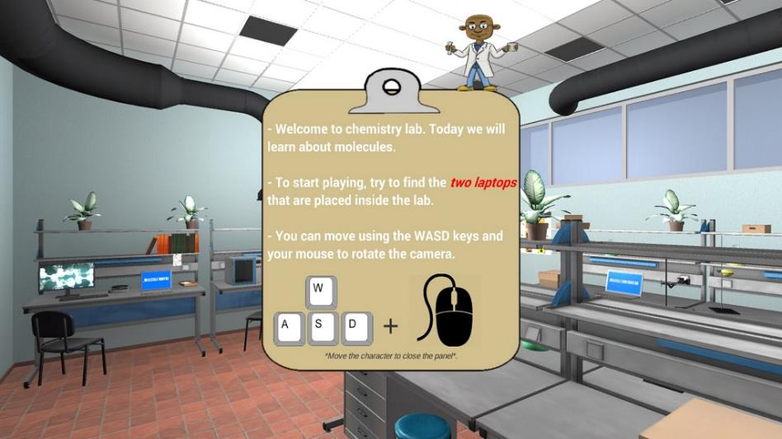

Figure **Error! No text of specified style in document.**.2: The information clipboard when you first enter the “Lab” scene.

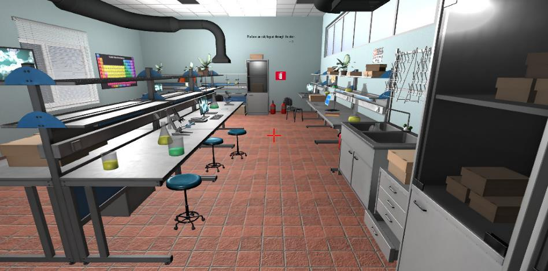

Figure **Error! No text of specified style in document.**.3: The “Lab” scene where the player can wonder around.

***Step 4: Molecule naming 2D Puzzle***

When the player has interacted with the laptop displaying the title “Molecule Naming” as shown in Figure **Error! No text of specified style in document.**.4, the relevant quiz will initialize and the respective lab scene will be loaded. In this 2D puzzle quiz, the goal is to provide the chemical formula for the molecule displayed in the top of the screen. To do so, the player can left click on the chemical elements pieces (White Square shapes) and, by holding the left button down and dragging the mouse, he can move the element around in any direction (Figure **Error! No text of specified style in document.**.5).

For a successful formula completion, specific elements must be placed in the element slots (metal square shapes in a yellow panel) in a correct order. To place an element, it must be moved upon the slot, and if the element-slot matching is correct, when the left mouse button is released, the element will be placed inside the slot and locked from any further interaction. In case the matching is wrong it will return to its initial position after the mouse release, followed by an error sound. If all the slots are filled, then the formula naming process is completed and the “Next” button (bottom right corner) becomes highlighted. In order to name another molecule’s formula, the player must click on the “Next” button independently of the current molecule’s formula completion process. To exit the lab the player can just press the “exit” button (top right corner) and return to the “Lab” scene.

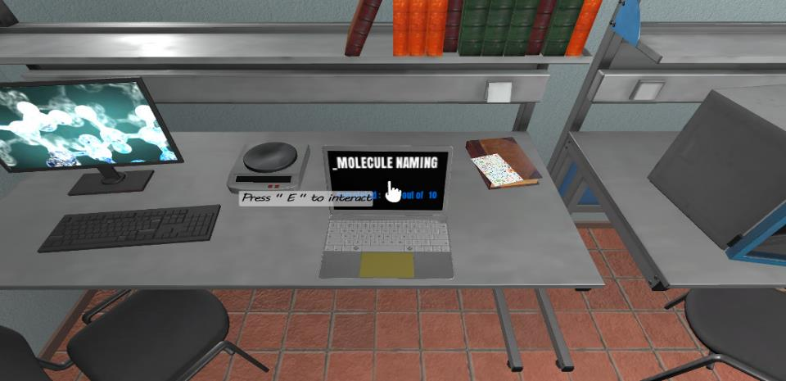

Figure **Error! No text of specified style in document.**.4: The laptop that transfers the player to the “Molecule Naming” lab quiz.

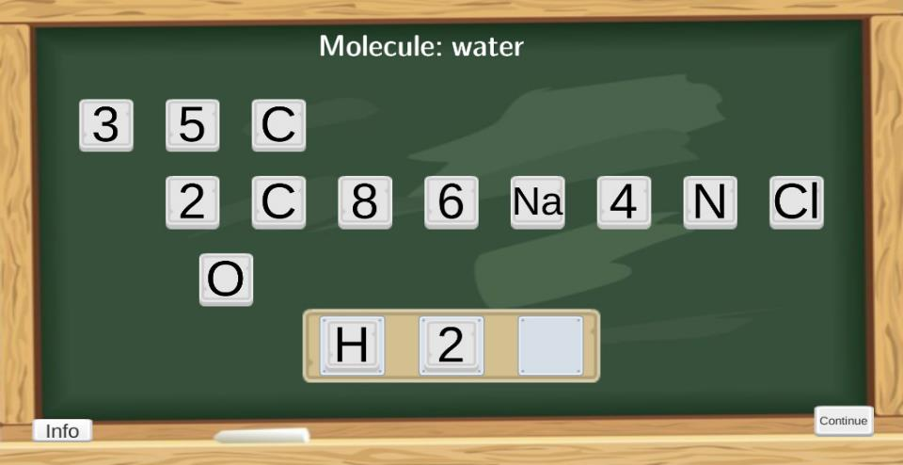

Figure **Error! No text of specified style in document.**.5: The interface of the “Molecule Naming” quiz.

***Step 5: Molecule 3D Construction Puzzle***

The other option for the player is to play the “Molecule construction” quiz by interacting with the respective laptop in Figure **Error! No text of specified style in document.**.6. The main idea of this quiz is to construct the structure of the displayed molecule by placing specific elements in the transparent round slots upon the molecule. Regarding the interface, in the top of the screen there is a list of buttons that spawn a specific element in the scene. In the bottom left corner, information about the formula and the name of the molecule are displayed.

For a successful molecule construction, the player must spawn various elements in the scene and by using the drag and drop mechanic (same as Molecule Naming quiz) fill all the slots with the correct elements. Since the molecule is a 3D object the need for movement and different perspective look is essential. Therefore, the player can rotate the molecule in all possible directions using either the right mouse click or the WASD keys on the keyboard. Last but not least, through a list of available buttons (Clear, Next, Exit) , the player can clear the scene of all the current generated elements, bring the next Molecule for construction or exit the quiz and return to the “lab” scene as shown in Figure **Error! No text of specified style in document.**.7.

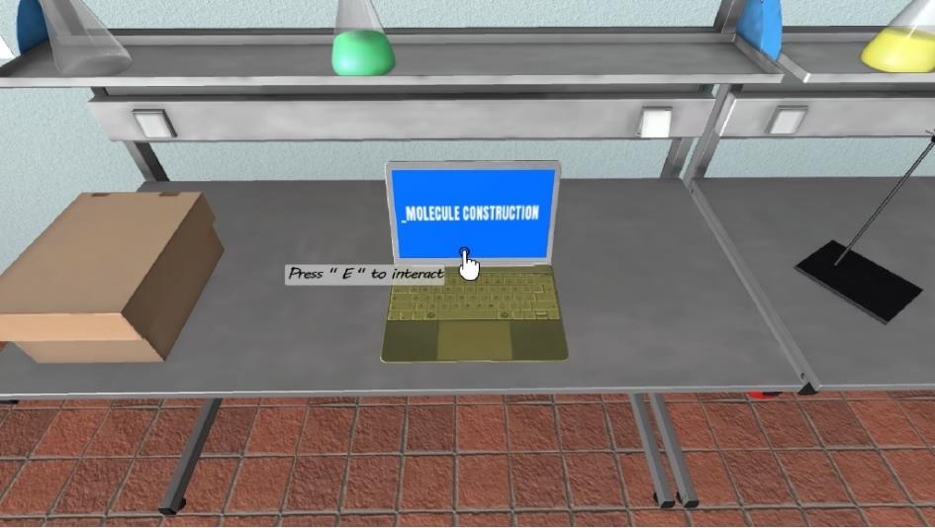

Figure **Error! No text of specified style in document.**.6: The laptop that transfers the player to the “Molecule Construction” lab quiz.

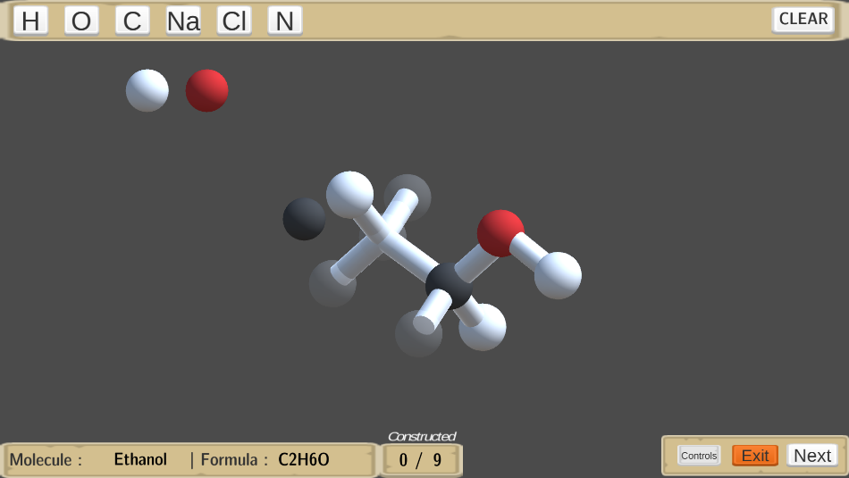

Figure **Error! No text of specified style in document.**.7: The interface of the “Molecule Construction” quiz.

***Step 6: Additional features***

A list of various objects such as boxes, pipettes, lab tables, computers and flasks give a realistic feel and look to the lab which is close to a real life chemistry lab. Also, the use of safety signs is present teaching the players about the precautions and safety practices that must be followed while inside a chemistry lab as shown in Figure **Error! No text of specified style in document.**.8.

Lastly, when the player exits the lab through the main door, a validation clipboard appears which displaying a detailed review of the exercises that the player completed. Also, a rating through a list of badges is given to the player based on his performance on the exercises. The player can either exit or continue to increase his score and get a better rating.

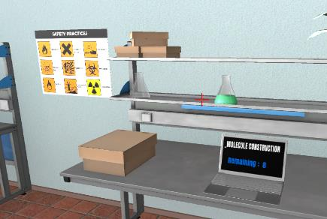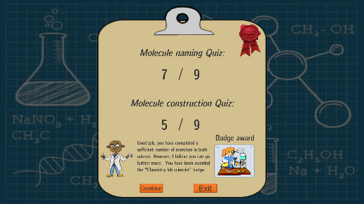

Figure **Error! No text of specified style in document.**.8: Safety signs (left image), the player’s rating screen.