hw2

# Variable assignment, loading packages

tv=c(39, 53, 39, 40, 74, 53, 61, 69, 60, 45, 51, 34, 33, 51, 50, 64, 42, 55, 29, 46, 44, 24, 43, 44, 42,56, 60, 44, 52, 67)  
candy=c(0, 0, 0, 0, 0, 0, 0, 0, 0, 0, 0, 0, 0, 0, 0 ,1, 1, 1, 1, 1, 1, 1, 1, 1, 1, 1, 1, 1, 1, 1)  
happiness=c(45,103,82,83,105,102,102,145,110,86,108,49,89,103,104,326,233,291,181,234,228,132,224,244,237,280,300,235,289,288)  
  
library(sjPlot)  
library(sjmisc)  
library(ggplot2)

# Question 1

# Running the model  
practice = lm(happiness~tv+candy+tv*candy)  
summary(practice)

##   
## Call:  
## lm(formula = happiness ~ tv + candy + tv * candy)  
##   
## Residuals:  
## Min 1Q Median 3Q Max   
## -38.030 -6.318 3.629 9.775 22.788   
##   
## Coefficients:  
## Estimate Std. Error t value Pr(>|t|)   
## (Intercept) 18.1060 18.1327 0.999 0.327227   
## tv 1.5218 0.3521 4.323 0.000201 ***  
## candy 40.7352 25.3386 1.608 0.119993   
## tv:candy 2.4661 0.5053 4.881 4.61e-05 ***  
## ---  
## Signif. codes: 0 '***' 0.001 '**' 0.01 '*' 0.05 '.' 0.1 ' ' 1  
##   
## Residual standard error: 16.09 on 26 degrees of freedom  
## Multiple R-squared: 0.9694, Adjusted R-squared: 0.9659   
## F-statistic: 274.7 on 3 and 26 DF, p-value: < 2.2e-16

$B_{o}$ = default happiness without with no account for hrs tv watched or candy enjoyment

$B_{\left(candy\right)}$ = liking candy increases mean happiness by 40.735

$B_{\left(tv\right)}$ = one avg hour of tv watched per week increases hapiness by 1.522

$B_(candy*tv) = enjoying candy explains an increase in happiness of 2.466 per hour of tv watched

# Question 2

plot_model(practice, type = "int")

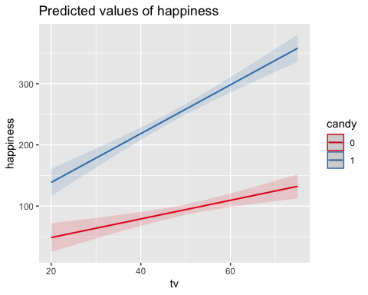

Blue line indicates the trend in happiness in those that enjoy candy as a function of avg hrs of tv watched per week, red is the same but for those that do not like candy.

par(mfrow = c(2, 2))  
plot(practice)

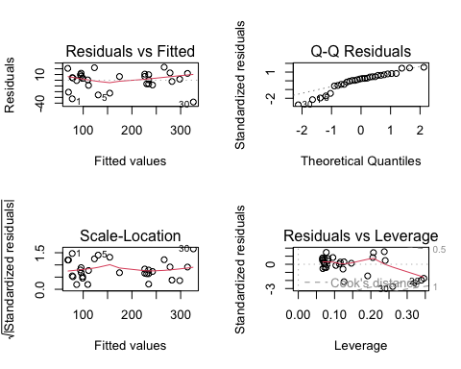

# Question 3

tv_15 = tv - 15  
model = lm(happiness~tv_15+candy+tv_15*candy)  
summary(model)

##   
## Call:  
## lm(formula = happiness ~ tv_15 + candy + tv_15 * candy)  
##   
## Residuals:  
## Min 1Q Median 3Q Max   
## -38.030 -6.318 3.629 9.775 22.788   
##   
## Coefficients:  
## Estimate Std. Error t value Pr(>|t|)   
## (Intercept) 40.9334 13.0486 3.137 0.004210 **   
## tv_15 1.5218 0.3521 4.323 0.000201 ***  
## candy 77.7263 18.0556 4.305 0.000210 ***  
## tv_15:candy 2.4661 0.5053 4.881 4.61e-05 ***  
## ---  
## Signif. codes: 0 '***' 0.001 '**' 0.01 '*' 0.05 '.' 0.1 ' ' 1  
##   
## Residual standard error: 16.09 on 26 degrees of freedom  
## Multiple R-squared: 0.9694, Adjusted R-squared: 0.9659   
## F-statistic: 274.7 on 3 and 26 DF, p-value: < 2.2e-16

plot_model(model, type = "int")

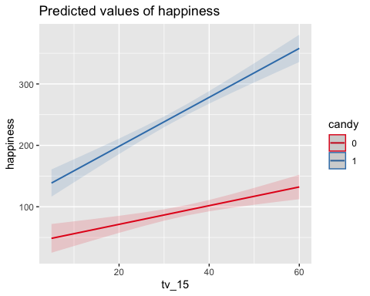

There is a significant difference between the mean happiness for subjects who watch 15 hours of tv and like candy vs those who watch 15 hours per week and do not like candy. We reject the null hypothesis with a p value of 0.000210. at 15 hours of tv watched, enjoying candy will explain 77.7263 points of increase in happiness.