|  |
| --- |
| TRƯỜNG ĐẠI HỌC BÁCH KHOA HÀ NỘI  **VIỆN ĐIỆN TỬ - VIỄN THÔNG**  logo_128  **UART Transceiver**  **edabk\_uart\_transceiver**  ***Category***  ***Revision 1.10***  **01/12/2021** |

**Category**

**UART Transceiver**

**edabk\_uart\_transceiver**

***Revision 1.10***

**01/12/2021**

# TABLE OF CONTENTS

[TABLE OF CONTENTS 1](#_Toc80796892)

[LIST OF FIGURES 1](#_Toc80796893)

[LIST OF TABLES 1](#_Toc80796894)

[1. Template **Error! Bookmark not defined.**](#_Toc80796895)

[1.1. Template **Error! Bookmark not defined.**](#_Toc80796896)

[1.1.1. Template **Error! Bookmark not defined.**](#_Toc80796897)

[2. Template **Error! Bookmark not defined.**](#_Toc80796898)

[2.1. Template **Error! Bookmark not defined.**](#_Toc80796899)

[2.1.1. Template **Error! Bookmark not defined.**](#_Toc80796900)

# LIST OF FIGURES

[Figure 1. EDABK Logo **Error! Bookmark not defined.**](#_Toc80796267)

# LIST OF TABLES

[Table 1. Template table **Error! Bookmark not defined.**](#_Toc80796345)

# Top module

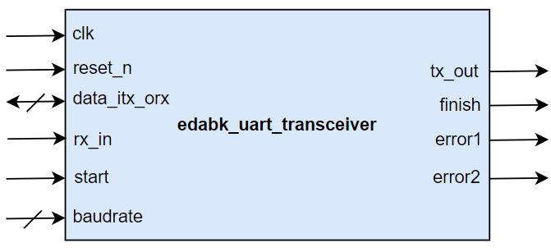

# Port description

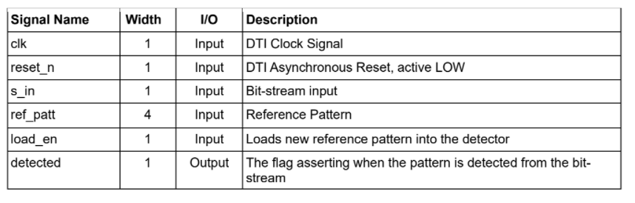

# Functional Descriptions

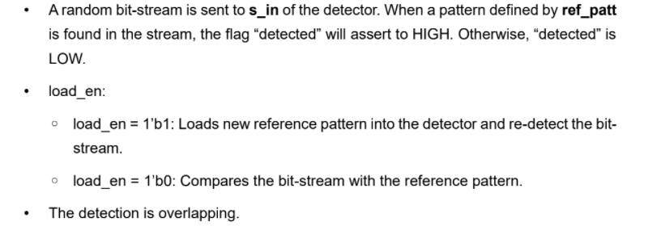

# State Diagram

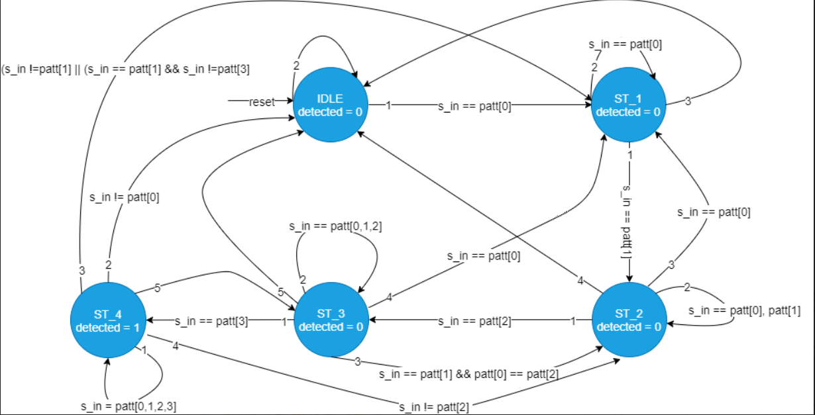

# Timing Diagram

