User manual:

Client Display:
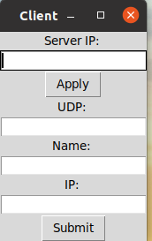

- Insert information
- Server IP: use IPv4
- UDP: use to receive any change from server
- Name: Your name
- IP: Your ip address
Note: You must insert Server IP first and click “Apply” to check IP or insert all information and click “Apply”. Then click “Submit”

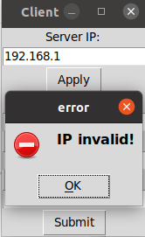
- Valid IP and invalid IP:
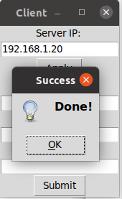

- When click “Submit”, a request box will appear.
- Yes if wanna connect
- No if wanna quit
When click Yes, information about client’s computer will be send to server (ram, disk, cpu)

