SQA Assignment 1

Sarah Pham

1a.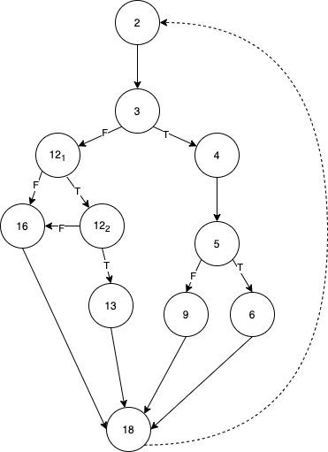

1b.

* v(g) = p + 1 (p is number of if statements)

○ 4 if-statements

○ 4 + 1 = 5

* v(g) = e - n + p (# of lines - # of nodes + # of strong connections)

○ 14 edges

○ 11 nodes

○ 2 Strong connections

○ 14 - 11 + 2 = 5

* v(g) = # of regions

○ 5 regions

1c. [2-3-4-5-6-18],[2-3-4-5-9-18],[2-3-12​1-12​2-13-18],[2-3-12​1-12​2,16,18],[2-3-12​1-16-18] = 5

​ ​ ​ ​ ​

paths to get to the final node

2a. 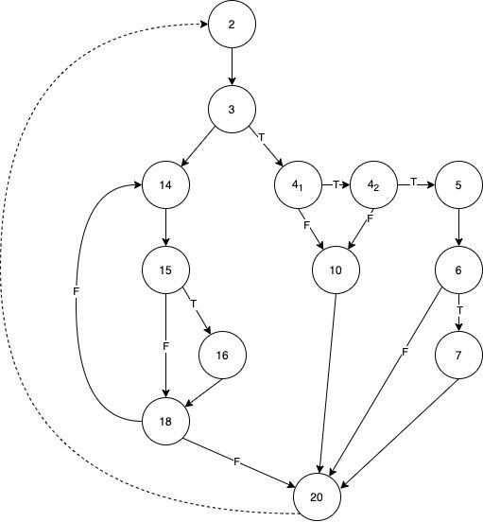

2b.

* v(g) = p + 1 (p is # of if statements)

○ 6 if-statements (including do-while)

○ 6 + 1 = 7

* v(g) = e - n + p (# of lines - # of nodes + # of strong connections)

○ 18 lines

○ 13 nodes

○ 2 strong connection

○ 18 - 13 + 2 = 7

* v(g) = # of regions

○ 7 regions

2c. P\* = P\*​m1

=Q2 P\*=2^4+1+(1+2)=20 -2.5 Q3 P\*=[1+2\*(2^0+2^1+2^2+2^3)](1+1^3)=62

2.2. [7 counted regions] [13 nodes][18 lines] v(g) = 18-13+2 = 7

If statements counted = 5

3a. 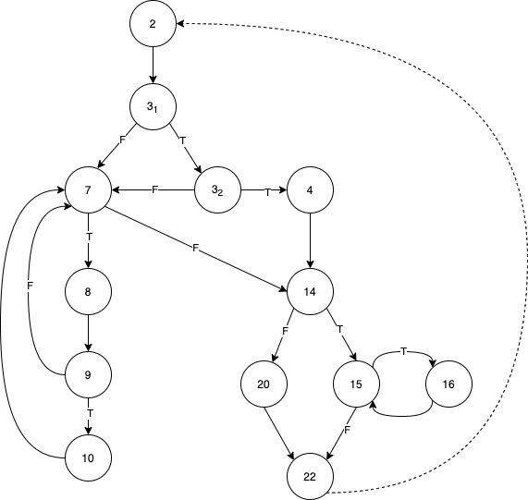

3b.

* v(g) = p + 1 (p is number of if statements) ○ 6 if-statements (including for loop)

○ 6 + 1 = 7

* v(g) = e - n + p (# of lines - # of nodes + # of strong connections)

○ 19 edges

○ 13 nodes

○ 1 strong connection

○ 19 - 13 + 1 = 7

- v(g) = # of regions

○ 7 regions

3c. P\* = P\*m1​

= [2-3​1-3​2-4-14-20-22],[2-33 ​1-3​2-7-14-20-22],[2-3​1-7-14-20-22] = 3 paths before the loops

​ ​ ​ ​ ​

= [15-16] = 1​ ​=0 1 path1 2 3

= [7-8-9-10] = 2​ ​+2​ ​+2​ ​+2​ ​ = 12 paths

= 3 \* 1 \* 12 = 36 paths

4a. 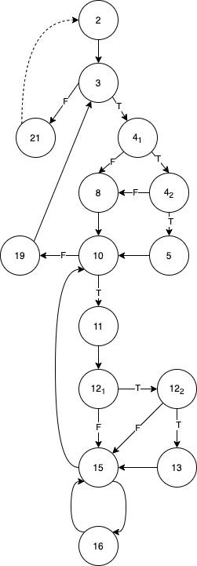

4b.

* v(g) = p + 1 (p is number of if statements)
  1. 7 if-statements (including while loop)

○ 7 + 1 = 8

* v(g) = e - n + p (# of lines - # of nodes + # of strong connections)
  1. 23 edges

○ 15 nodes

○ 0 strong connections

○ 23 - 15 = 8

- v(g) = # of regions

○ 8 regions

4c. P\* = P\*m1​

Q4 P\*=[3\*[3\*1^3]^2]^2 = 729 -2.5