Quadcopter Research for Sightline Capstone Project

Portland State University | Maseeh College of Engineering & Computer Science

Proposal 1

Kimball s. Davis

tai pham

Adel Alkharraz

2018

**Considerations for Sightline project quadcopter**

* Frame and components must be compatible with Pixhawk 4 flight controller (FC)
* Drone Size
  + - * + Should be able to fly safely inside and outside
        + Frame must be big enough to mount FC and accessories
* Must be customizable
* Should have good documentation/quality parts
* Cost
  + - * + Was not discussed, but assuming the best quality components at the cheapest price that will work for the project.
        + Should be reasonable for the scope of the project

**Ways to build/buy a quadcopter**

* Ready to Fly (RTF)
  + - * + Not easily customizable
        + May come with items not needed for this project such as a flight controller (FC), GPS, etc.
* Frame up Build
  + - * + Will require a lot more research on individual parts i.e. motors, propellers, etc.
        + May be more expensive and time consuming then buying an all-inclusive kit where all the parts are well balanced with each other
* Almost Ready to Fly (ARF)
  + - * + Easily customizable
        + Parts are well balanced with each other
        + May need to acquire Tx/Rx system separately

**Frame sizes**

* Very few frames 250 mm and under have mounting space for Pixhawk 4 FC
* Frames 450 mm and larger may not be as safe to fly indoors
* 330 mm frames have mounting space for FC, and should be safer to fly inside but are not as widely available as 250 mm or 450 mm in ARF kits
* A small 250 mm drone would be the safest for testing and flying indoors. We would need to look at the Pixhawk mini and see if it would work for the project. Pixhawk 4 Mini takes the FMU processor and memory resources from the Pixhawk 4 while eliminating interfaces that are normally unused. This allows the Pixhawk 4 Mini to be small enough to fit in a 250mm drone. <https://docs.px4.io/en/flight_controller/pixhawk4_mini.html>
* A larger frame will be easier to customize and build

**DJI Flame Wheel F450**

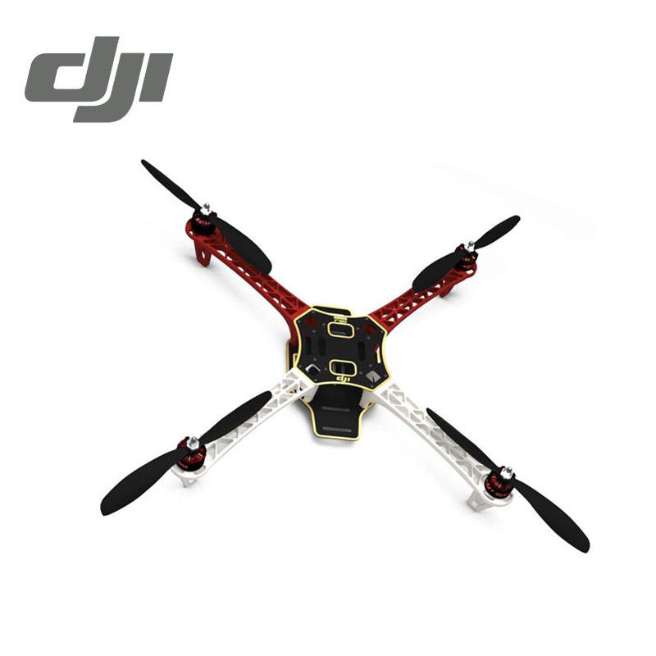

**Price:** $190 (amainhobbies.com)

**Includes:**

4x 2212 920KIV Motor

4x OPTO 30A ESC

4x 8045 Props and 4x 1038 Props

1x Complete frame Kit

**Needs:**

Pixhawk 4/GPS/PDB kit $211.00 (Holybro)

FrSky X4R-SB 3/16ch 2.4Ghz receiver $31.99 (Amazon)

FrSky Taranis X9D Plus 16-Channel 2.4ghz ACCST Radio Transmitter $239.00 (Amazon)

Turnigy 4000mAh 4S 30C Lipo Pack w/XT-60 $38.94 (Amazon)

**Total Cost: $710.93**

**Luminier QAV250 G10 ARF kit**

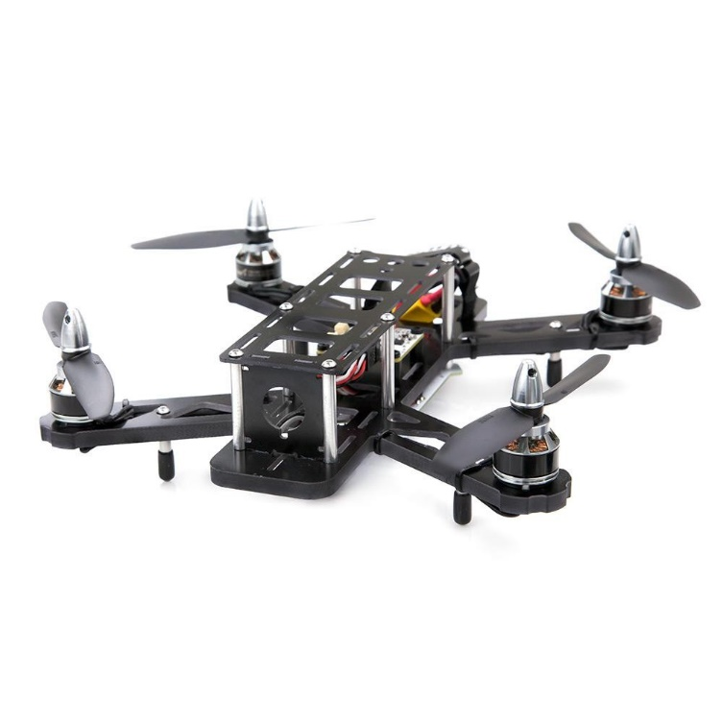

**Price:** $279 (getfpv.com)

**Includes:**

1x QAV250 Carbon Fiber airframe, board camera mount, and hardware

1x Power distribution board

2x LED boards (1 red, 1 white)

1x set of aluminum landing gear and vinyl feet

5" Anti-Vibration neoprene tape

1x Lumenier lipo strap

8x Lumenier 5x4x3 - 3 blade

4x Lumenier RX2206-11 2350Kv Motor

4x Lumenier 30A BLHeli_S ESC OPTO (2-4s) DSHOT

**Needs:**

Pixhawk 4 mini/GPS/PDB kit $139.00 (Holybro)

FrSky Taranis X9D Plus 16-Channel 2.4ghz ACCST Radio Transmitter $239.00 (Amazon)

FrSky D4R-II 4ch 2.4Ghz ACCST Receiver (w/telemetry) $24.99 (getfpv.com)

Lumenier 1300mAh 3s 60c Lipo Battery (XT60) $21.99 (getfpv.com)

**Total Cost: $703.98**

**Conclusion:**

During the research conducted for the quadcopter, two main questions came to mind:

1. Where is the quadcopter going to be flown, tested, and demoed?
2. What is the budget for the quadcopter?

The answers to theses questions will largely determine the choice of quadcopter size and the quality of components used.

Both above proposed quadcopters are based on well documented builds referenced below. The parts used are of high quality and based on what is currently available. There are of course cheaper options, but also a lot of warnings from experienced builders to be aware of cheap knock-offs. More research can be conducted in the Tx/Rx systems, the suggested systems were based off the documented builds as a baseline.

*References*

[*https://docs.px4.io/en/frames_multicopter/dji_flamewheel_450.html*](https://docs.px4.io/en/frames_multicopter/dji_flamewheel_450.html)

[*https://docs.px4.io/en/frames_multicopter/lumenier_qav250_pixhawk_mini.html*](https://docs.px4.io/en/frames_multicopter/lumenier_qav250_pixhawk_mini.html)

[*https://shop.holybro.com/pixhawk-4_p1089.html*](https://shop.holybro.com/pixhawk-4_p1089.html)

[*https://shop.holybro.com/pixhawk4-mini_p1120.html*](https://shop.holybro.com/pixhawk4-mini_p1120.html)

[*http://ardupilot.org/copter/docs/build-your-own-multicopter.html*](http://ardupilot.org/copter/docs/build-your-own-multicopter.html)