Quadcopter Research for Sightline Capstone Project

Portland State University | Maseeh College of Engineering & Computer Science

Proposal II

Kimball s. Davis

tai pham

Adel Alkharraz

2018

**Considerations for Sightline project quadcopter**

* Frame and components must be compatible with Pixhawk 4 flight controller (FC)
* Drone Size
  + - * + Should be able to fly safely inside and outside
        + Frame must be big enough to mount FC and accessories
* Must be customizable
* Should have good documentation/quality parts
* Cost
  + - * + Was not discussed, but assuming the best quality components at the cheapest price that will work for the project.
        + Should be reasonable for the scope of the project

**Ways to build/buy a quadcopter**

* Ready to Fly (RTF)
  + - * + Not easily customizable
        + May come with items not needed for this project such as a flight controller (FC), GPS, etc.
* Frame up Build
  + - * + Will require a lot more research on individual parts i.e. motors, propellers, etc.
        + May be more expensive and time consuming then buying an all-inclusive kit where all the parts are well balanced with each other
* Almost Ready to Fly (ARF)
  + - * + Easily customizable
        + Parts are well balanced with each other
        + May need to acquire Tx/Rx system separately

**Frame sizes**

* Very few frames 250 mm and under have mounting space for Pixhawk 4 FC
* Frames 450 mm and larger may not be as safe to fly indoors
* 330 mm frames have mounting space for FC, and should be safer to fly inside but are not as widely available as 250 mm or 450 mm in ARF kits
* A small 250 mm drone would be the safest for testing and flying indoors. We would need to look at the Pixhawk mini and see if it would work for the project. Pixhawk 4 Mini takes the FMU processor and memory resources from the Pixhawk 4 while eliminating interfaces that are normally unused. This allows the Pixhawk 4 Mini to be small enough to fit in a 250mm drone. <https://docs.px4.io/en/flight_controller/pixhawk4_mini.html>
* A larger frame will be easier to customize and build

**DJI Flame Wheel F450**

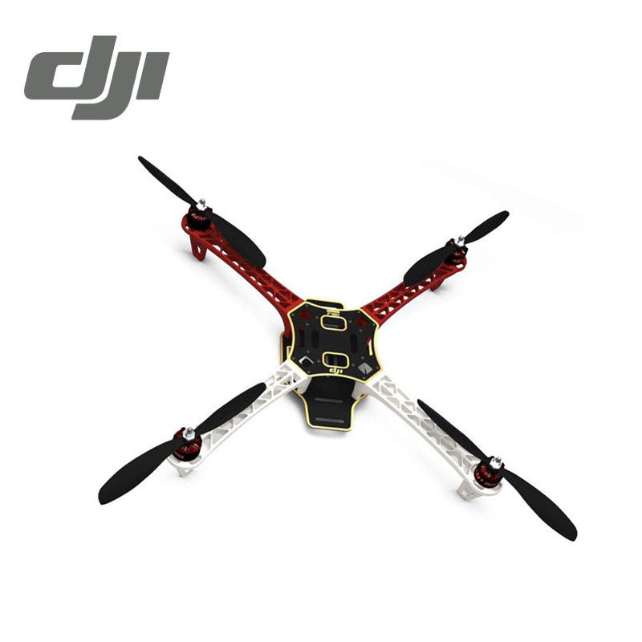

**Price:** $190 (amainhobbies.com)

**Features:**

Frame Arms: PA66+30GF ultra-strength material design, provide better crash worthiness.

High Strength Compound PCB Frame Board: Makes wiring of ESCs and battery safer and easier.

Optimized Frame Design: Provides abundant assemble space for autopilot systems.

**Specifications:**

**Frame:**

Model: Flame Wheel 450 (F450)

Frame Weight: 282g

Diagonal Wheelbase: 450mm

Takeoff Weight: 800g ~ 1600g

Recommended Battery: 3S~4S LiPo

**System:**

Recommended load: 300 g/axis

Recommended battery: 3S Lipo

Maximum Thrust: 600 g/axis

Working Temperature: -5°C ~ 40°C

**ESC:**

Current: 15A OPTO

Weight: 19g ea.

Signal Frequency: 30Hz~450Hz

Voltage: 11.1V~14.8V

Battery: 3S~4S LiPo

**Motor:**

Stator Size: 22×12mm

KV: 920 rpm/V

Weight: 50g ea.

Propeller

Diameter: 24x11cm

Thread Pitch: 9.4x4.3 inch

**Includes:**

4x 2212 920KIV Motor

4x OPTO 30A ESC

4x 8045 Props and 4x 1038 Props

Weight: ~10g ea.

1x Complete frame Kit

**Needs:**

Pixhawk 4/GPS/PDB kit $211.00 (Holybro)

Weight: ~200g (W/ OEM 1500 + accessories)

FrSky X4R-SB 3/16ch 2.4Ghz receiver $31.99 (Amazon)

Weight: 5.8g

FrSky Taranis X9D Plus 16-Channel 2.4ghz ACCST Radio Transmitter $239.00 (Amazon)

Turnigy 400 mAH 4s 30c LiPo pack w/ xt-60 $38.94 (Amazon)

Weight: 452g

**Takeoff Weight: 1,255.8g Total Cost: $710.93**

Takeoff Weight: 800g ~ 1600g

**DJI Flame Wheel F330**

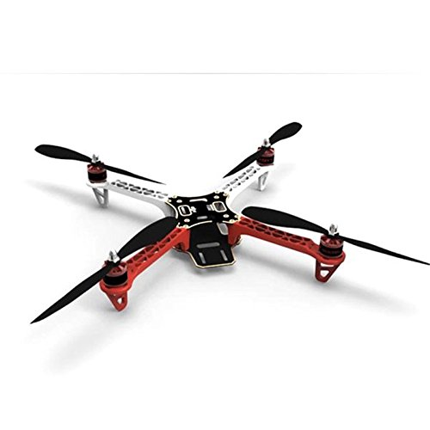

**Specifications:**

**Frame:** $20.02 (Amazon)

Model: Flame Wheel 330 (F330)

Frame Weight: 156g

Diagonal Wheelbase: 330mm

Takeoff Weight: 600g ~ 1200g

Recommended Battery: 3S LiPo

**ESC:**  $43.96 (Hobbywing)

Current: 20A OPTO

Weight: 19g ea.

Signal Frequency: 30Hz~450Hz

Voltage: 11.1V~14.8V

Battery: 3SLiPo

**Motor:** $32.54(Aliexpress)

Stator Size: 28×12mm

KV: 1400 rpm/V

Weight: 60g ea.

**Propeller:** $12.99 (Amazon)

4xDJI 8045

Weight: ~10g ea.

**Battery:** $21.99 (GetFPV)

Lumenier 1300 mAH 3s 60c LiPo

Weight: 118g

**Flight Control:**

Pixhawk 4/GPS/PDB kit $211.00 (Holybro)

Weight: ~200g (W/ OEM 1500 + accessories)

FrSky X4R-SB 3/16ch 2.4Ghz receiver $31.99 (Amazon)

Weight: 5.8g

FrSky Taranis X9D Plus 16-Channel 2.4ghz ACCST Radio Transmitter $239.00 (Amazon)

**Takeoff Weight: 835.8g Total Cost: $613.49**

Takeoff Weight: 600g ~ 1200g

**Conclusion:**

Both above proposed quadcopters are based on a well-documented build referenced below. The parts used are of high quality and based on what is currently available. There are of course cheaper options, but also a lot of warnings from experienced builders to be aware of cheap knock-offs. More research can be conducted in the Tx/Rx systems, the suggested systems were based off the documented builds as a baseline.

There were no F330 ARF kits available The F330 is a frame up build. The parts listed are suggested parts for the frame, with each part being ordered separately. The same Tx/Rx system is suggested for both builds.

The smallest battery was selected for the F330 and one of the largest for the F450 to show a range of battery weights and how this affects takeoff weight. A rule of thumb for optimal takeoff weight for a quadcopter is 50-70% max thrust. The battery sizes can be adjusted sacrificing flight time for less weight. A chart showing the maximum thrust per motor given blade size and operating voltage is shown in the references. According to the chart the motor/propeller combinations for both builds should supply a maximum thrust over 500g per motor. Assuming a maximum thrust of 2000g the F330 build takeoff weight is 41.79% of max thrust, and the F450 is at 62.79% of the max thrust.

The F450 is a bit more expensive, but comes in an ARF kit, and will be easier to customize. With the propellers attached the F450 needs clearance of approximately 28”. The F330 is a bit cheaper but does not come in an ARF kit and will be slightly more difficult to customize. With the propellers attached the F330 needs clearance of approximately 21” so may be a bit safer to fly and test indoors.

The 250mm build from Proposal 1 was omitted because the Pixhawk mini does not supply 5V needed for the OEM as well as other peripherals. A 250 mm build may still be possible with the Pixhawk 4 but may prove difficult.

*References*

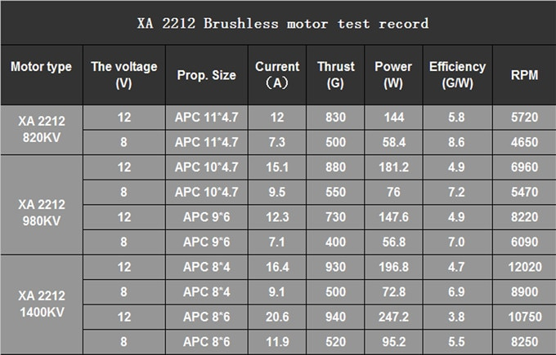

[*https://docs.px4.io/en/frames_multicopter/dji_flamewheel_450.html*](https://docs.px4.io/en/frames_multicopter/dji_flamewheel_450.html)

[*https://shop.holybro.com/pixhawk-4_p1089.html*](https://shop.holybro.com/pixhawk-4_p1089.html)

[*http://ardupilot.org/copter/docs/build-your-own-multicopter.html*](http://ardupilot.org/copter/docs/build-your-own-multicopter.html)