Quadcopter Research for Sightline Capstone Project

Portland State University | Maseeh College of Engineering & Computer Science

Proposal III

Kimball s. Davis

tai pham

Adel Alkharraz

2019

**Considerations for Sightline project quadcopter**

* Frame and components must be compatible with Pixhawk 4 flight controller (FC)
* Drone Size
  + - * + Should be able to fly safely inside and outside
        + Frame must be big enough to mount FC and accessories
* Must be customizable
* Should have good documentation/quality parts
* Must be able to lift weight of FC and accessories
* Cost
  + - * + Was not discussed, but assuming the best quality components at the cheapest price that will work for the project.
        + Should be reasonable for the scope of the project

**Ways to build/buy a quadcopter**

* Ready to Fly (RTF)
  + - * + Not easily customizable
        + May come with items not needed for this project such as a flight controller (FC), GPS, etc.
* Frame up Build
  + - * + Will require a lot more research on individual parts i.e. motors, propellers, etc.
        + May be more expensive and time consuming then buying an all-inclusive kit where all the parts are well balanced with each other
* Almost Ready to Fly (ARF)
  + - * + Easily customizable
        + Parts are well balanced with each other
        + May need to acquire Tx/Rx system separately

**Frame sizes**

* Very few frames 250 mm and under have mounting space for Pixhawk 4 FC
* Frames 450 mm and larger may not be as safe to fly indoors
* 330 mm frames have mounting space for FC, and should be safer to fly inside but are not as widely available as 250 mm or 450 mm in ARF kits
* A small 250 mm drone would be the safest for testing and flying indoors. We would need to look at the Pixhawk mini and see if it would work for the project. Pixhawk 4 Mini takes the FMU processor and memory resources from the Pixhawk 4 while eliminating interfaces that are normally unused. This allows the Pixhawk 4 Mini to be small enough to fit in a 250mm drone. <https://docs.px4.io/en/flight_controller/pixhawk4_mini.html>
* A larger frame will be easier to customize and build

**DJI Flame Wheel F450**

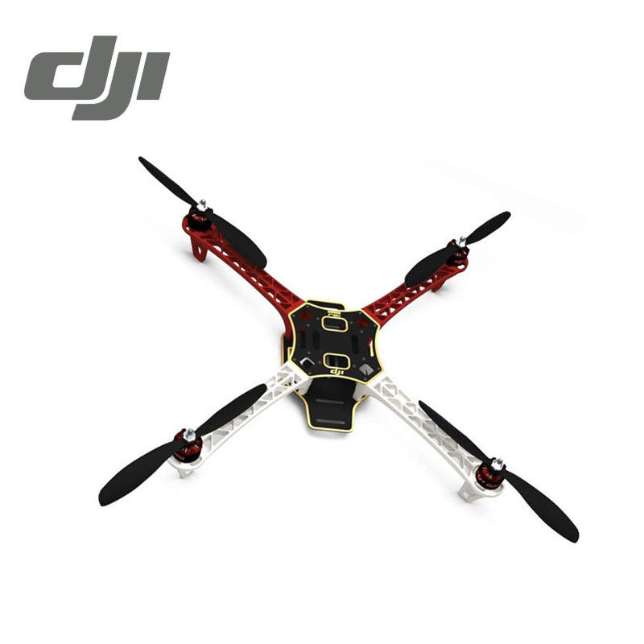

**Price:** $229.00 [(Amazon link)](https://www.amazon.com/DJI-Flame-Wheel-Frame-Motor/dp/B07B65H98Z/ref=pd_sbs_421_4?_encoding=UTF8&pd_rd_i=B07B65H98Z&pd_rd_r=73b1f5e7-0df2-11e9-ae91-771b90899601&pd_rd_w=vVzKa&pd_rd_wg=hPfSH&pf_rd_p=7d5d9c3c-5e01-44ac-97fd-261afd40b865&pf_rd_r=PPDK0WSZ9K6CPVZ1A4F2&psc=1&refRID=PPDK0WSZ9K6CPVZ1A4F2)

**Features:**

Frame Arms: PA66+30GF ultra-strength material design, provide better crash worthiness.

High Strength Compound PCB Frame Board: Makes wiring of ESCs and battery safer and easier.

Optimized Frame Design: Provides abundant assemble space for autopilot systems.

**Includes:**

Motor 2312E 960KV x4

ESC 430 Lite 4S 30A x4

9450 Gray Propeller set x3

Frame Board x2, Frame Arm x4 and Accessories

**Specifications:**

**Frame:**

Model: Flame Wheel 450 (F450)

Frame Weight: 282 g

Diagonal Wheelbase: 450 mm

Takeoff Weight: 800g ~ 1600 g

Recommended Battery: 4S LiPo

**System:**

Recommended load: 350 ~400 g/rotor

Recommended battery: 4S Lipo

Maximum Thrust: 710 g/rotor

Working Temperature: -5°C ~ 40°C

**ESC:**

Maximum Allowable Voltage: 17.4 V

Maximum Allowable Current: 30 A (continuous)

Maximum Peak Current: 45 A (3 sec)

PWM Input Signal Level: 3.3/5 V Compatible

Weight (with cables): 11.6 g ea.

Signal Frequency: 30 Hz~500 Hz

Voltage: 11.1 V~14.8 V

Battery: 3S~4S LiPo

**Motor:**

Stator Size: 23×12 mm

KV: 960 rpm/V

Weight: 56 g ea.

**Propeller:**

Diameter: 24x12.7 cm

Thread Pitch: 9.4x5.0 inch

Weight: 13 g ea.

**Needs:**

DJI FLAMEWHEEL Landing Gear (4 pcs) $17.50 [(Amazon Link)](https://www.amazon.com/DJI-Flame-Wheel-Landing-Gear/dp/B00GNMLPY4/ref=sr_1_4?ie=UTF8&qid=1546369056&sr=8-4&keywords=dji+f450+landing+gear)

Weight: 15 g ea.

Pixhawk 4/GPS/PDB kit $210.95 [(Sparkfun Link)](https://www.sparkfun.com/products/14841)

Weight: ~200g (W/ OEM 1500 + accessories)

FrSky X4R-SB 3/16ch 2.4Ghz receiver $31.99 [(Amazon Link)](https://www.amazon.com/FrSky-X4RSB-Telemetry-Receiver-Range/dp/B00VM1XWB0/ref=sr_1_fkmr0_1?s=toys-and-games&ie=UTF8&qid=1546370186&sr=1-1-fkmr0&keywords=FrSky+X4R-SB+3%2F16ch+2.4Ghz+receiver)

Weight: 5.8g

FrSky Taranis X9D Plus 16-Channel 2.4ghz ACCST Radio Transmitter $229.00 [(Amazon Link)](https://www.amazon.com/FrSky-Taranis-16-Channel-2-4ghz-Transmitter/dp/B00MYORSW8/ref=pd_bxgy_21_2?_encoding=UTF8&pd_rd_i=B00MYORSW8&pd_rd_r=7d1537e2-0df2-11e9-9fc1-87cf5b4d0ae5&pd_rd_w=w69Pb&pd_rd_wg=HFUnL&pf_rd_p=6725dbd6-9917-451d-beba-16af7874e407&pf_rd_r=S7NM92CZ4SV47Z3V382R&psc=1&refRID=S7NM92CZ4SV47Z3V382R)

Weight: N/A

Battery (x2): Gens Ace 14.8 V 4S Lipo 5000 mAH $64.99 [(Amazon Link)](https://www.amazon.com/Gens-5000mAh-Battery-LOGO500-T-REX550/dp/B06Y4BRD2B/ref=sr_1_5?ie=UTF8&qid=1546372498&sr=8-5&keywords=4s+lipo+gens+ace+batteries)

Weight: 480 g

**Takeoff Weight: 1.35 kg Total Cost: $848.42**

Takeoff Weight: 800g ~ 1600g

**Conclusion:**

The proposed quadcopter is based on a well-documented build referenced below. The parts used are of high quality and based on what is currently available. There are of course cheaper options, but also a lot of warnings from experienced builders to be aware of cheap knock-offs. More research can be conducted in the Tx/Rx systems, the suggested systems were based off the documented builds as a baseline.

Landing gear, and a larger high-performance battery were added. The landing gear is necessary to protect the camera and accessories when landing. The larger battery is a bit heavier, and more expensive but is of the highest quality. It is the same size as the previously selected battery but provides 5000 mAH as opposed to 4000 mAH. Having a larger, higher quality battery will protect the drone from power failure/instability during flight.

A rule of thumb for optimal takeoff weight for a quadcopter is 50-70% max thrust. The tuned propulsion system with the selected motors, ESC, battery, and propellers can provide a maximum thrust of 710 g/rotor with a recommended take off weight of 350 g/rotor. This gives an optimal takeoff weight of 1.4 kg, and a maximum thrust of 2.84 kg. Our estimated takeoff weight of 1.35 kg is 54.4% maximum thrust. This quadcopter design should have plenty of lift and stability.

*References*

[*https://docs.px4.io/en/frames_multicopter/dji_flamewheel_450.html*](https://docs.px4.io/en/frames_multicopter/dji_flamewheel_450.html)

[*http://ardupilot.org/copter/docs/build-your-own-multicopter.html*](http://ardupilot.org/copter/docs/build-your-own-multicopter.html)