Why Fine-Tuning Encourages Hallucinations and How to Fix It
arXiv:2604.15574v1 [cs.CL] 16 Apr 2026
Guy Kaplan♡∗ Zorik Gekhman★ Zhen Zhu♢† Lotem Rozner♡
Yuval Reif♡ Swabha Swayamdipta♠ Derek Hoiem♢ Roy Schwartz♡
♡Hebrew University of Jerusalem ♢University of Illinois Urbana-Champaign
★Technion – Israel Institute of Technology ♠University of Southern California

Abstract
Large language models are prone to hallucinating factually incorrect state-ments. A key source of these errors is exposure to new factual informa-tion through supervised fine-tuning (SFT), which can increase hallucina-tions w.r.t. knowledge acquired during pre-training. In this work, we explore whether SFT-induced hallucinations can be mitigated using es-tablished tools from the continual learning literature, since they arise as a by-product of knowledge degradation during training. We propose a self-distillation–based SFT method that facilitates effective factual learning while minimizing hallucinations w.r.t. pre-existing knowledge by regular-izing output-distribution drift. We also show that, in settings where new knowledge acquisition is unnecessary, suppressing factual plasticity by freezing parameter groups, can preserve task performance while reducing hallucinations. Lastly, we investigate the mechanism behind SFT-induced hallucinations through three hypotheses: capacity limitations, behavior cloning, and localized interference. Our experiments show that a main driver is interference among overlapping semantic representations, and that self-distillation succeeds by mitigating this interference.
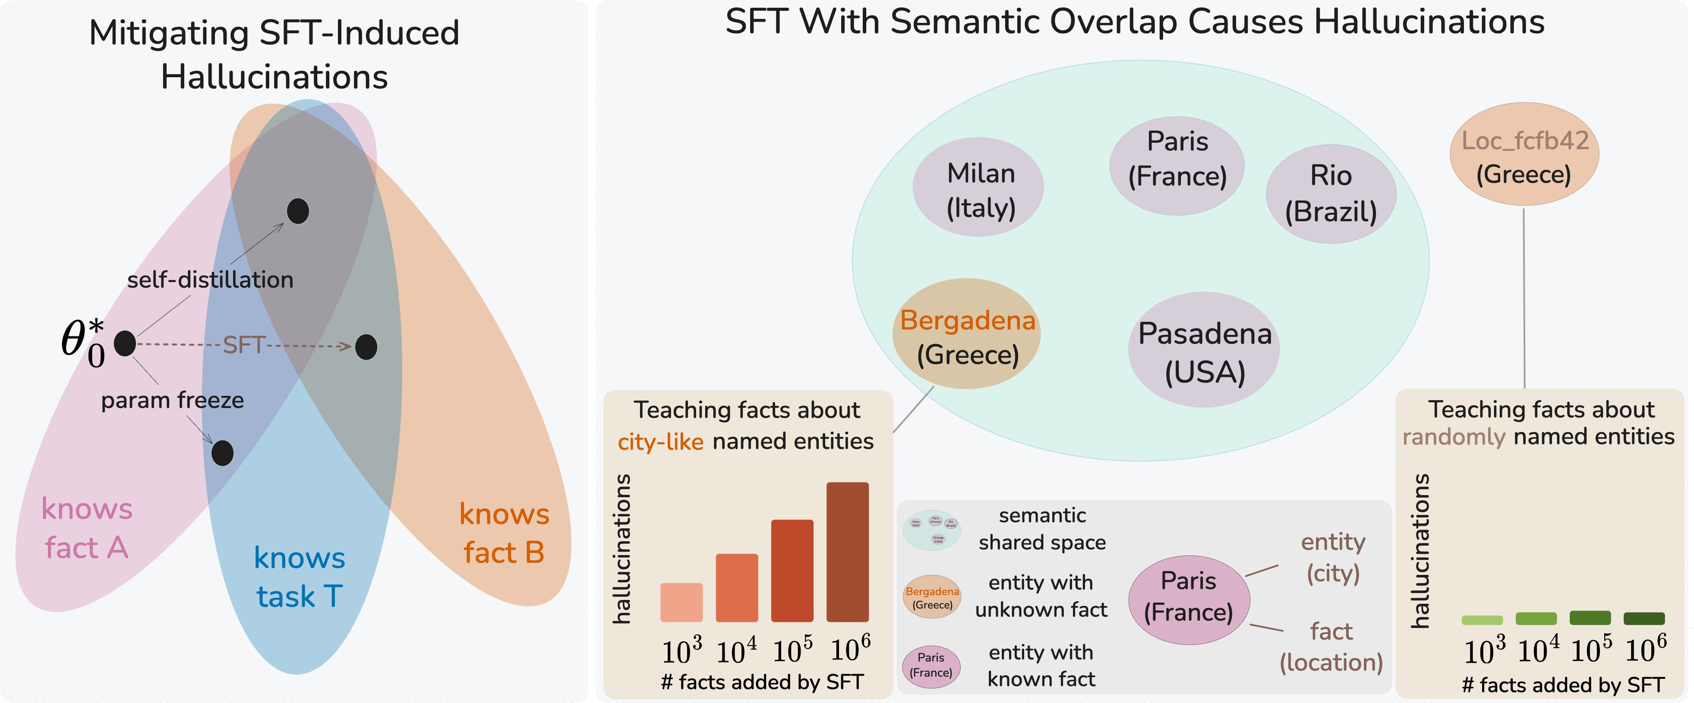
Figure 1: Left: SFT-induced hallucinations as factual forgetting in parameter space, starting from θ∗. The regions denote subspaces with low error on preexisting facts (A), the task (T) (e.g., QA), and new facts (B). Standard SFT acquires new facts but forgets existing ones. Parameter freeze preserves existing facts at the cost of new ones. Self-distillation achieves both. Right: SFT on semantically overlapping entities causes hallucinations on related
existing ones. E.g., after learning that “Bergadena” (; a city-like fictional name) is in Greece, the model hallucinates about real cities like Milan (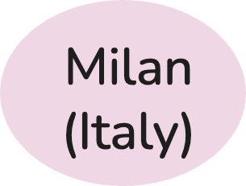), while mapping random identifier Loc_fcfb42 (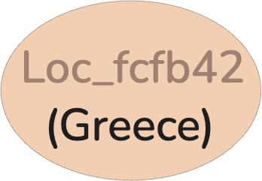) to Greece causes no such effect, even with many new facts.
0

∗Correspondence: guy.kaplan3@mail.huji.ac.il
†Now at Google DeepMind.

Introduction
Recent studies show that when models learn new factual knowledge via supervised fine-tuning (SFT), they also start to produce incorrect answers to questions that they previously answered correctly (Gekhman et al., 2024; Kalai et al., 2025). This is particularly concerning, as SFT is standard practice in LLM development and may further aggravate hallucinations, which pose a significant challenge for application reliability (Huang et al., 2025). In parallel, the continual learning literature has extensively studied how sequential training can interfere with previously acquired knowledge (Kirkpatrick et al., 2017; Sarfraz et al., 2023; Kim et al., 2025), and has proposed a range of mitigation strategies (Lange et al., 2019; Mai et al., 2021; Guo et al., 2025; Wang et al., 2023a; Lin et al., 2025). In this work, we explore whether SFT-induced hallucinations can be mitigated using established tools from continual learning.
In continual learning, forgetting typically arises as a byproduct of acquiring new informa-tion: parameter updates during fine-tuning alter the model in ways that degrade previously encoded knowledge. Analogously, we propose that factual forgetting occurs when parame-ter updates introduced during SFT inadvertently distort representations of facts learned during pre-training. This behavior reflects a stability–plasticity tradeoff (Kim et al., 2023): increasing factual plasticity (the ability to acquire new facts) may come at the expense of factual stability (the ability to preserve existing facts). Consequently, factual plasticity can induce factual forgetting, which manifests as SFT-induced hallucinations. Motivated by this, we perform controlled experiments with the goal of disentangling it from task learning. We adopt the experimental setup of Gekhman et al. (2024) (§2), reproducing their finding that hallucinations increase when exposing models to new factual knowledge through SFT.
Building on the observation that different parameter groups play distinct roles in factual storage and task learning (Geva et al., 2021; Dar et al., 2023; Zhu et al., 2025), we first demonstrate that reducing factual plasticity—e.g., by freezing parameter groups—enables the model to learn the downstream task while limiting new fact acquisition and reducing hallucinations (§3). However, this setting deliberately suppresses factual plasticity, whereas in practice we may like SFT to support both task learning and the acquisition of new factual knowledge without inducing hallucinations. We hypothesize that continual learning methods designed to mitigate forgetting should help achieve this objective.
To test this, in §4 we apply self-distillation (Li & Hoiem, 2017), a continual learning technique in which the model is regularized to stay close to its own earlier output distribution during fine-tuning, recently shown to reduce forgetting in LLMs (Shenfeld et al., 2026; Zhu et al., 2025). Our results show that this approach reduces SFT-induced hallucinations while still enabling effective acquisition of newly introduced facts (see left panel of Fig. 1).
We next investigate the mechanisms underlying SFT-induced hallucinations (§5). Specifi-cally, we ask whether these errors stem from global capacity limitations (Allen-Zhu & Li, 2024), behavior cloning derived by SFT (Zhang et al., 2024; Schulman, 2023), or localized interference, whereby new facts corrupt existing ones when they share representational structure with them. To disentangle these, we fine-tune models on synthetic facts while varying the scale and surface form of entity names — either name-like strings, hypothe-sized to share representational neighborhoods with existing entities, or random UUID-style identifiers that do not (see Fig. 1, right). Forgetting appears highly sensitive to surface-form similarity: name-like entities are forgotten substantially more as scale increases, while UUID-based entities induce near-zero forgetting even at 1M new facts, suggesting representational overlap as a primary driver. Consistent with this, we show that self-distillation prevents representational drift of the held-out facts, suggesting its effectiveness stems from mitigating precisely this interference.
In summary, this work (1) reframes SFT-induced hallucinations as factual forgetting arising from continual learning dynamics—distinct from hallucinations stemming from pre-training knowledge gaps or arising at inference time; (2) provides two complementary mitigations: reducing factual plasticity (e.g., via selective parameter freezing) is beneficial when new fact acquisition is undesirable (e.g., SFT on a private domain or alignment fine-tuning), while self-distillation is beneficial when new fact acquisition is also desired (e.g., domain adaptation with new factual content); both reduce factual forgetting from ∼15% to ∼3%;

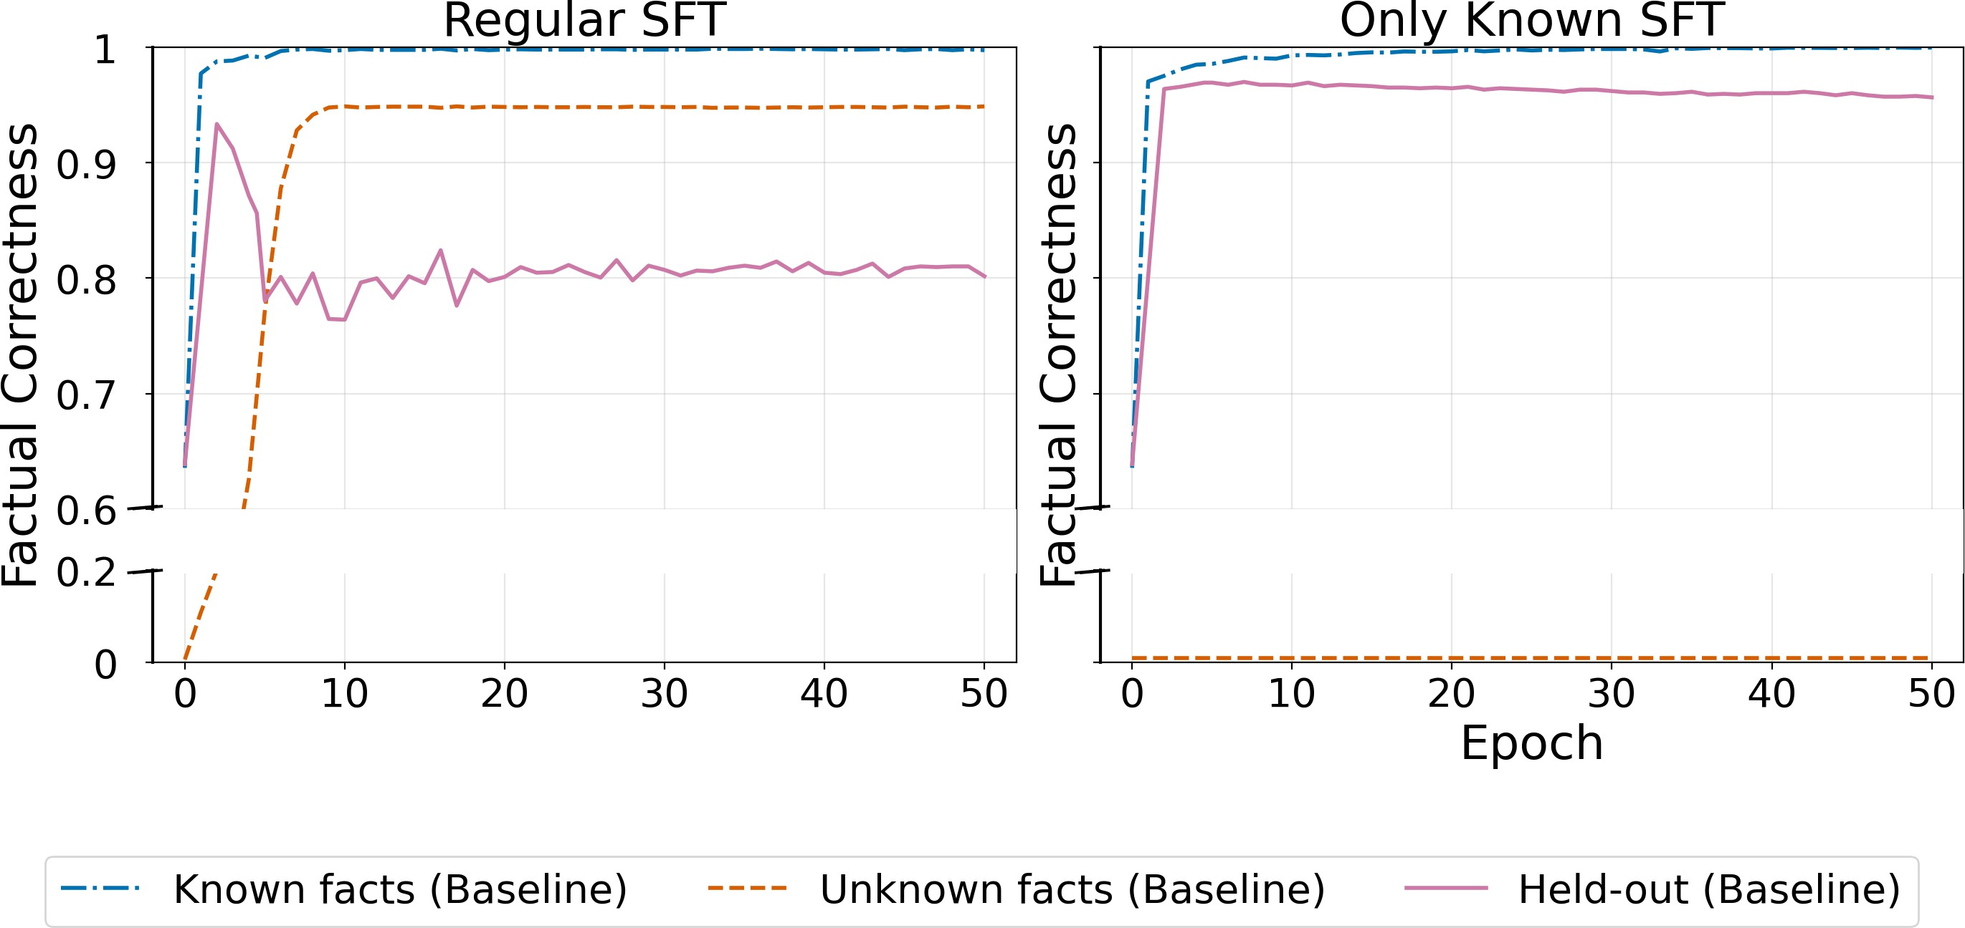
Split SLiCK Train Role
D_{Known} HighlyKnown Yes Task learning D_{Unk} Unknown Yes Facts plasticity D_{Held} HighlyKnown No Facts stability

Figure 2: Factual forgetting is caused by new fact acquisition, not fine-tuning itself. The model starts below ceiling as it has not yet adapted to the QA format, then rapidly learns it, achieving high accuracy on known facts. As training continues and unknown facts are acquired, accuracy on held-out facts declines, indicating that forgetting is driven by new factual knowledge, not fine-tuning per se. When unknown facts are excluded, held-out performance remains stable throughout training (Only Known Held-out curve), suggesting that new fact acquisition is a source of interference. Right: summary of data split roles.

and (3) characterizes the mechanism underlying both the forgetting and its mitigation: factual forgetting appears selective, driven by interference among overlapping semantic representations, and self-distillation succeeds because it mitigates this interference.

Fine-Tuning with Unknown Facts Leads to Factual Forgetting
Supervised fine-tuning (SFT) can inadvertently increase factual hallucinations (Gekhman et al., 2024; Ovadia et al., 2024; Zucchet et al., 2025), a phenomenon we reinterpret through the lens of continual learning as factual forgetting. To study this in a controlled manner, we reconstruct the experimental setting of Gekhman et al. (2024), which explicitly disentangles task learning (learning how to perform the task) from factual learning (learning facts).

Preliminary: SLiCK Method and Factual Learning Setting
To determine the model’s preexisting knowledge for each question used in training and evaluation, we apply the SLiCK method (Gekhman et al., 2024). SLiCK categorizes ques-tions into four levels based on the model’s predictions under multiple randomized few-shot prompting configurations: HighlyKnown, MaybeKnown, WeaklyKnown, and Unknown. A factual relation is classified as HighlyKnown if the model consistently produces the correct answer across all configurations, Unknown if it never does, and the intermediate categories capturing varying degrees of consistency. To focus on factual learning and forgetting, we retain only HighlyKnown and Unknown examples, filtering out MaybeKnown and Weakly-Known facts.1 We denote by D_{Known} a subset of HighlyKnown facts and by D_{Unk} a subset
of Unknown facts, and form the training set as D_{train} = D_{Known} ∪ D_{Unk}. A disjoint subset
of HighlyKnown facts, denoted D_{Held}, is reserved for evaluation. Since the data consists of sparse, semantically isolated relational facts (e.g., birthplaces, spouse), generalization across examples is unlikely, and accuracy on each split reflects a distinct and isolated aspect of the model’s behavior. Performance on D_{Known} reflects the model’s ability to learn the QA task format and style.These entity-relational facts are already present in the pretrained knowledge, so accuracy gains during fine-tuning reflect task format adaptation rather than new factual learning(task learning). Accuracy on D_{Unk} measures the model’s ability and speed to acquire new factual knowledge (factual plasticity), while performance on D_{Held} captures the stability of previously acquired factual knowledge and directly quantifies fine-tuning–induced factual hallucinations (factual stability). This setup enables a clean dis-entanglement between task learning and factual learning, providing a controlled framework for analyzing factual forgetting during SFT (Fig. 2, right).

1See Appendix A for further discussion on this choice and results for the other classification groups.

Methodology and Experimental Setup
Data We use the ENTITYQUESTIONS dataset (Sciavolino et al., 2021) as our primary benchmark. ENTITYQUESTIONS consists of QA pairs derived from relational triplets in Wikipedia (e.g., Q: “What is the capital of France?”, A: “Paris”), covering a wide range of entity–relation types. We apply the SLiCK classification using 20 evaluation runs per question, each with three randomly sampled few-shot exemplars, and retain only relations for which at least 30% of examples are classified as HighlyKnown. From the remaining relations, we sample 8,000 examples to form D_{Known} and 8,000 examples to form D_{Unk}, both drawn from the training split. The held-out set D_{Held} is drawn from the development split and contains only HighlyKnown facts from the same relations.
Models We conduct experiments with several non-reasoning LLMs: QWEN 2.5 (1.5B, and 8B parameters) (Yang et al., 2024) and LLAMA 3.1 (8B) (Grattafiori et al., 2024). Unless oth-erwise stated, we report figures and representative results for QWEN 2.5-1.5B. All qualitative trends are consistent across models; full results are provided in Appendix B.

Training Procedure Models are fine-tuned with learning rate of 5 × 10−5 on D_{train}² us-ing mixtures of Known and Unknown facts, with either a 50/50 ratio or a Only Known setting (D_{Unk} = ∅). During training, we evaluate performance separately on D_{Known}, D_{Unk}, and D_{Held}, corresponding to task learning, factual plasticity, and factual stability.

Factual Forgetting and the Factual Plasticity–Stability Tradeoff in SFT
Building on prior evidence that SFT on data containing previously unknown facts can corrupt preexisting knowledge, the set- ting in §2 allows us to study how this
Updated params (θS) | DUnk | DKnown ↑ | DHeld ↑
Attention | 0.010 | 0.946 | 0.931
FFN | 0.941 | 0.997 | 0.782
All (standard SFT) | 0.946 | 0.990 | 0.780
All (Only Known) | — | 0.999 | 0.958

corruption can be controlled. We begin by characterizing the dynamics of stan-dard SFT on D_{Known} ∪ D_{Unk} and contrast-ing it with a Only Known variant that teaches the QA format without introduc-ing new factual content. We then consider

a stability-first regime in which learning new facts is unnecessary (e.g., alignment or privacy), and test whether selectively freezing modules can preserve task per-formance while reducing factual updates and the resulting hallucinations.

Learning New Facts Induces Factual Forgetting and Hallucinations
Our baseline results under standard SFT

Table 1: Training only attention layers reduces
factual forgetting. Each row corresponds to a different subset of updated parameters (θ_{S}). Up-dating only attention layers achieves high D_{Held} (low forgetting) and high D_{Known} (task learning) by suppressing new fact acquisition (D_{Unk} ≈ 0). Training only the FFN closely tracks standard SFT: facts are acquired but forgetting increases. D_{Unk} is not presented when training on D_{Known} only (Only Known) and thus not reported.

on D_{Known} ∪ D_{Unk} are shown in Fig. 2. We observe a consistent two-stage learning pattern. During the first one to two epochs, the model rapidly acquires the QA task format, achieving near-perfect accuracy on D_{Known} and peaking at 93% accuracy on D_{Held}. As training progresses, the model begins to acquire new factual knowledge, as indicated by increasing accuracy on D_{Unk}. This phase coincides with a systematic decline in performance on D_{Held}, resulting in an average degradation of approximately 15%, consistent with the findings of Gekhman et al. (2024). This degradation saturates once learning on D_{Unk} converges. To validate that this effect is causally driven by factual learning, we repeat the experiment while excluding D_{Unk} from training (dashed curves in Fig. 2). In this setting, performance on D_{Held} remains stable throughout training, confirming that the observed increase in hallucinations arises from the acquisition of new factual information rather than from fine-

2In Appendix C, we select the learning rate by jointly evaluating (i) the number of epochs required to learn previously unknown facts and (ii) the induced hallucination rate. The baseline achieves both the minimal time-to-learning and the lowest induced hallucinations among the evaluated configurations.

tuning itself. The Only Known condition serves as a baseline free of forgetting due to factual plasticity. Taken together, these results, consistent with prior findings (Gekhman et al., 2024), demonstrate that standard fine-tuning induces factual forgetting once the model begins integrating new facts.

Controlling Factual Plasticity via Parameter Constraints
Having established that SFT-induced hallucinations are linked to factual learning, we ask whether the model can acquire the task (QA format and instruction style) with minimal acquisition of new facts, thereby reducing hallucinations. In many practical settings, the goal is task adaptation while preserving pretrained knowledge, and learning new facts from the training set is unnecessary or even undesirable. Motivated by evidence that attention and FFN layers contribute differently to task learning and factual storage (Geva et al., 2021; Dar et al., 2023; Zhu et al., 2025), we freeze different modules using the same training setup as before and ask whether the model can learn the QA task while avoiding updates to factual knowledge.
Let θ_{S} denote the subset of parameters updated during fine-tuning, with the remaining parameters frozen. Table 1 summarizes the results for θ_{S} ∈ {attention only, FFN only, all}.3 As seen in §3.1, standard SFT training exhibits coupling between factual plasticity and forgetting, with D_{Held} declining as D_{Unk} increases. Training only the FFN layers leaves this coupling essentially unchanged: the model still learns the task and the new facts, and forgetting on D_{Held} closely tracks the full-model SFT baseline. In contrast, updating only attention parameters prevents new fact acquisition while preserving task learning: D_{Unk} stays near chance, D_{Held} remains close to its pretrained level, and D_{Known} stays high, approaching the Only Known upper bound.4
Overall, the freezing strategy enables safe task learning with high factual stability and substantially reduced SFT-induced hallucinations. This setting is relevant in scenarios where incorporating new facts is unnecessary or even undesirable.
Insight 1: Reducing Factual Plasticity Reduces Hallucinations
Reducing factual plasticity suppresses hallucinations while retaining task learning.

Enabling Factual Learning without Forgetting Facts
In §3, we show that SFT-induced hallucinations arise when fine-tuning integrates new factual knowledge, and that reducing factual plasticity prevents this forgetting. However, in many realistic settings, acquiring new factual knowledge is necessary and cannot simply be avoided. We therefore consider the more challenging regime in which models must learn new facts while preserving previously stored knowledge. This setting corresponds directly to the stability–plasticity dilemma studied in continual learning. To address it, we adopt a continual learning approach based on self-distillation.

Self-Distillation Enables Fine-Tuning with Minimal Induced Hallucinations
Self-distillation regularizes fine-tuning by explicitly constraining shifts in the model’s output distribution, thereby limiting the distributional drift induced by training on new data. We adopt the formulation originally proposed by Li & Hoiem (2017), using the implementation adapted for large language and multimodal models by Zhu et al. (2025). Let θ_{i} denote the parameters of a frozen teacher model (a snapshot of the model after i epochs of SFT) and θ the parameters of the student model being fine-tuned. The objective is,
L(θ) = L_{task}(θ) + λ L_{distill}(θ; θ_{i}), (1)

3Fine-grained ablations over smaller parameter groups (e.g., individual attention projections
q, k, v, o and FFN sub-components) are reported in Appendix C.
4Accuracy is slightly below Only Known (0.95 vs. 0.99 on DKnown), consistent with Zhu et al. (2025).

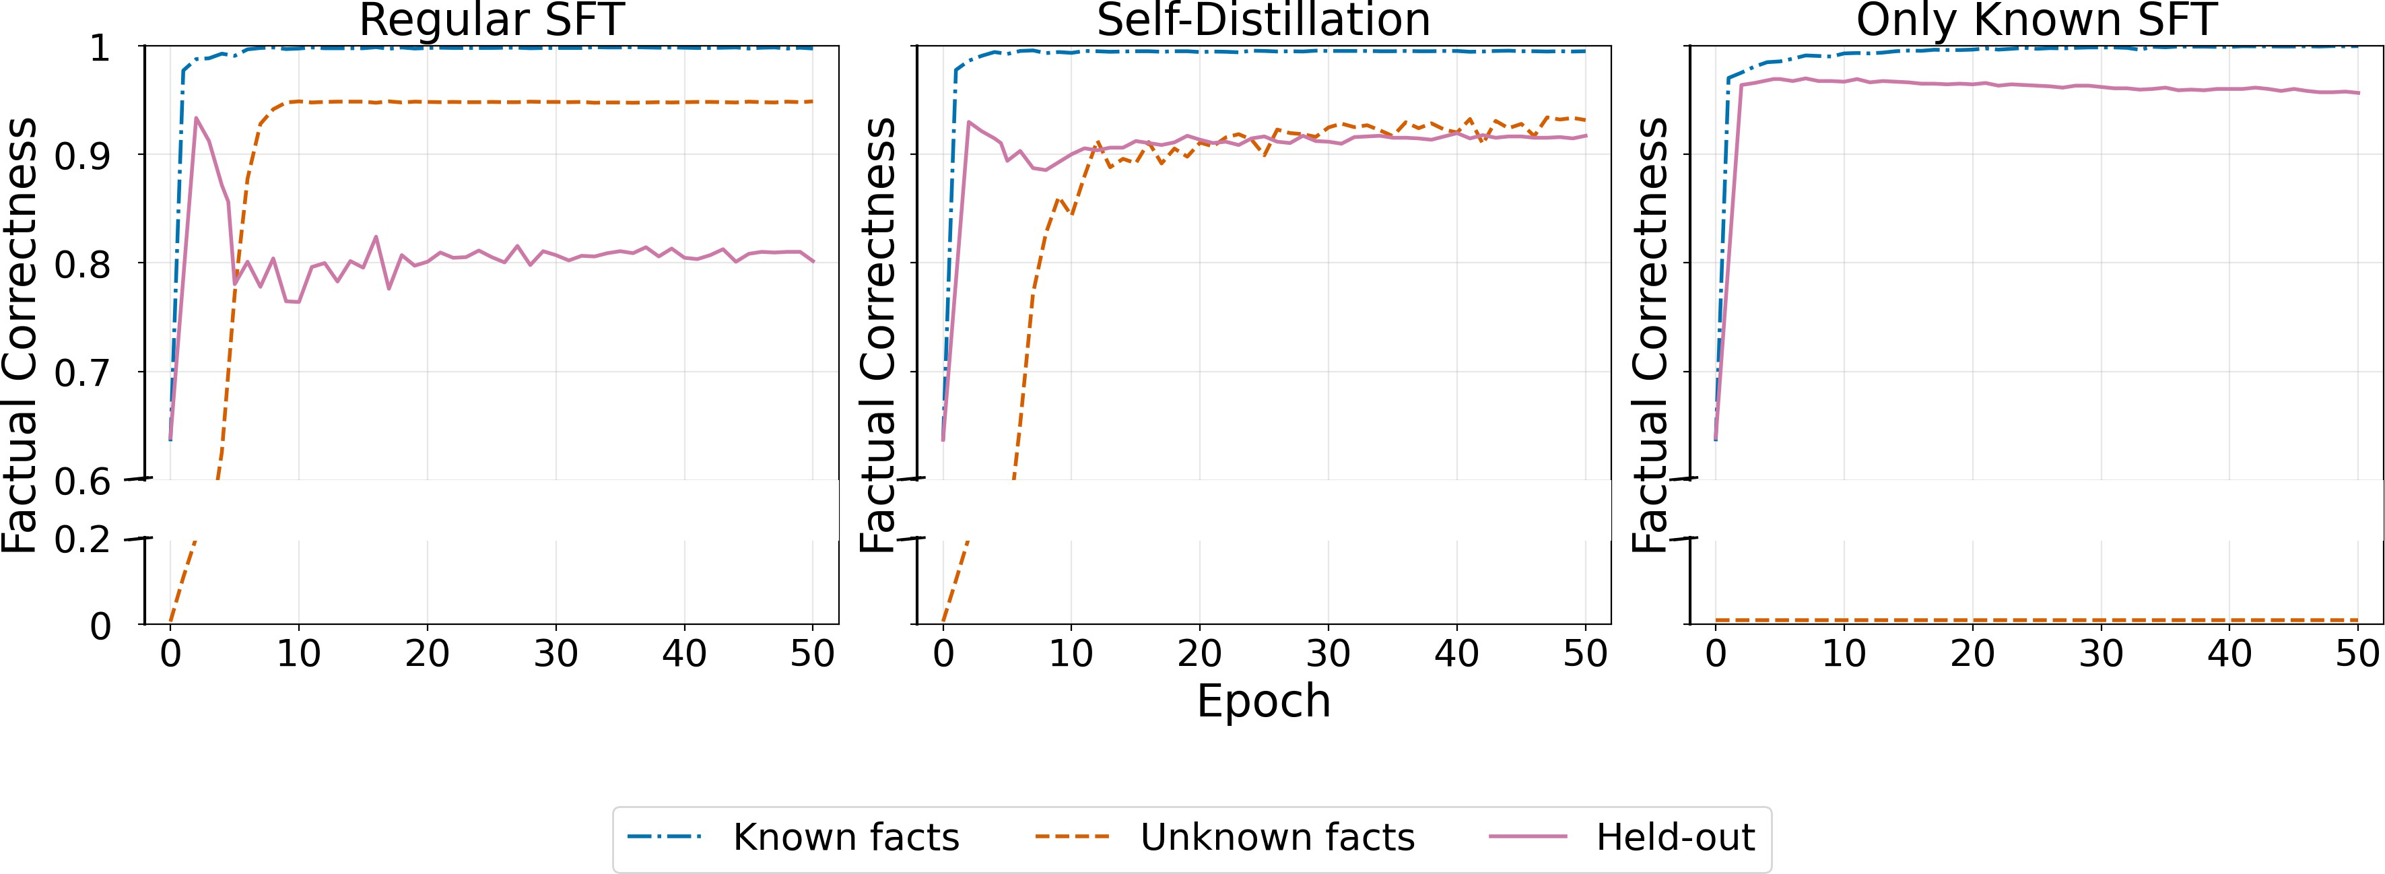

Figure 3: Each panel shows factual correctness over training epochs for Known facts (blue), Unknown facts (orange), and Held-out facts (green). Middle (Self-Distillation): The model effectively acquires new facts while largely preserving performance on held-out facts, substantially reducing SFT-induced forgetting. Performance on D_{Held} closely matches the Only Known condition, while accuracy on D_{Unk} reaches a level comparable to regular SFT.

where L_{task} is the standard next-token prediction loss.
The distillation loss penalizes divergence between the output distributions:

Ldistill(θ; θi ) = E(x,y)∼B
τ2 KL
∈M(
 |M(y)| j ∑y)

softmax

zθi ,j

τ

softmax
zθ,j 

, (2)

where z_{θ,j} and z_{θ}i ,j are the logits at token position j produced by the student and teacher, respectively, τ is a temperature parameter, M(y) denotes the set of non-padded token positions, and B denotes the training batch. Intuitively, the distillation term constrains the student to remain close to the teacher’s output distribution, thereby limiting parameter updates that would otherwise overwrite previously learned factual knowledge, while still allowing factual learning. In practice, we first train a model on D_{Known} for one epoch (i = 1) to acquire the QA task format while preserving factual stability. We then freeze this model as the teacher and continue SFT on D_{train} = D_{Known} ∪ D_{Unk} using λ = 1, and τ = 0.5.5
τ
As shown in Fig. 3, self-distillation enables factual learning at a pace comparable to standard fine-tuning, while substantially reducing forgetting. Performance on D_{Held} degrades in relation to its peak by only approximately 3%, compared to a 15% decline under regular SFT, while performance on D_{Unk} follows a similar learning trajectory, indicating high factual plasticity. These results identify self-distillation as a practical strategy for fine-tuning scenarios that require both factual learning and factual stability.
Insight 2: Self-Distillation Enables Factual Learning without Forgetting
Self-distillation reduces SFT-induced hallucinations.

Semantic Overlap Drives Interference in Factual Updates
So far, we have shown that SFT-induced hallucinations correspond to factual forgetting and can be mitigated by self-distillation. We now investigate the origin of factual forget-ting. We consider three hypotheses. First, a behavioral account: SFT may induce behavior cloning (Schulman, 2023; Zhang et al., 2024)—training the model to produce answers regardless of its knowledge boundaries—shifting response tendencies toward answers ungrounded in prior knowledge (Zucchet et al., 2025). This predicts similar degradation whenever unknown facts are introduced, regardless of their surface form. Second, a capacity-based account: newly learned facts compete for limited representational resources, displacing older ones as the model approaches its storage limits (Allen-Zhu & Li, 2024). This predicts broadly distributed degradation scaling with the number of stored facts. Third, a structural

5See Appendix D for results on different hyper parameters.

account: forgetting arises from interference among overlapping internal representations, such that if related entities share representational features, updating one may perturb oth-ers (Masip et al., 2026; Nishi et al., 2025). This predicts selective interference concentrated among semantically similar entities. Though potentially not mutually exclusive, these accounts make distinct predictions, which we test through controlled synthetic settings that independently vary representational overlap and scale.

Semantic Overlap and Scale as Sources of Interference
We study interference in a synthetic setting over a single relation (P17: Location → Country), varying both representational overlap and the number of newly introduced facts. For each synthetic fact, we change the construction of the key (location). Keys are generated in two ways: (i) semantic keys, formed by recombining tokens from real location names and therefore resembling existing entities (e.g., Bergamo + Pasadena → Bergadena) and (ii) UUID keys, constructed as random identifiers with no syntactic similarity to known entities (e.g., Loc_fcfb46ee).6 Values are instantiated as real country names. We scale the number of synthetic facts from 103 to 106, keeping supervision, relation, and optimization identical. If forgetting is driven by representational overlap, it should be concentrated among semantic keys; if by capacity, it should grow uniformly with scale regardless of key type; and if behavioral, it should appear whenever unknown facts are introduced.

Results We first note that, across all scales (Fig. 4), the model fully acquires the new synthetic facts (D_{Unk} = 100%) and main-tains high performance on D_{Known} (≥ 90%), ruling out differences in learning success or global task degradation. We therefore focus on induced forgetting over previously held-out facts (∆D_{Held}, the percentage-point drop from peak held-out accuracy during training), reported on the y-axis of Fig. 4. Two patterns emerge. First, at smaller scales, SFT-induced
hallucinations already depend strongly on the construction of the key: when keys resem-ble existing locations, forgetting on D_{Held} in-creases by several percentage points, whereas UUID-based keys yield negligible changes, despite identical training signals and com-plete acquisition of the new facts. Because exposure to unknown facts is held constant across conditions, this asymmetry is difficult to reconcile with a purely behavioral account

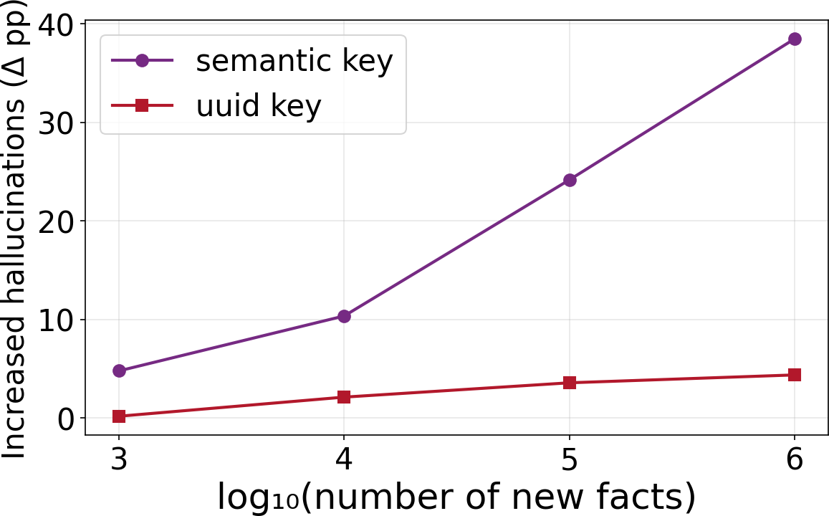

Figure 4: Semantic similarity and not scale alone, drives forgetting. Forgetting (∆D_{Held}) grows sharply with the number of new facts for semantically similar enti-ties (name-like keys), but remains negligible (0–4%) for unrelated entities (UUID keys) across all scales — implicating representa-tional interference, not capacity limits, as a
primary driver.

in which any introduction of unknown QA examples should produce comparable degra-dation. Second, as we increase the number of synthetic facts, forgetting amplifies only for semantically overlapping keys. When new keys resemble existing entities, ∆D_{Held} grows sharply with scale, reaching large drops at 106 synthetic facts under standard SFT. In con-trast, when keys are syntactically unrelated (UUID-based), induced hallucinations remain minimal (0–4%), mostly insensitive to dataset size and not correlated with the learning of new facts.
This asymmetric scaling pattern is not what a simple global capacity constraint would predict, since a capacity-limited model should exhibit more uniform degradation as ad-ditional facts are stored, regardless of surface form. Instead, these results may support a structural interference account: SFT-induced factual hallucinations arise when updates for semantically overlapping entities interfere with nearby representations, whereas updates to syntactically isolated entities largely avoid such interference.

6See Appendix E for the full data creation process.

What Self-Distillation Reveals About the Origins of Factual Forgetting
The results in §5.1 show that forgetting is selective: it arises when new entities share token structure with existing ones, and is near-zero when they do not. Self-distillation substantially reduces this forgetting (§4.1). Two explanations are possible: self-distillation may reduce forgetting by limiting total weight movement (a generic regularization effect), or it may specifically suppress interference by constraining the output distribution over the entity tokens through which overlap-driven interference propagates. To distinguish these, we return to the 10K semantic-overlap synthetic setting of §5.1 and compare standard SFT against self-distillation and ℓ₂ regularization toward θ_{i} (the model snapshot after epoch 2):
L(θ) = L_{task}(θ) + λ θ − θ_{i} ², (3)
2
with λ matched to self-distillation in gradient magnitude, while tracking how the internal representations of held-out entities change during training. Under ℓ₂ regularization, forget-ting on D_{Held} remains near 10 percentage points, comparable to standard SFT; increasing λ reduces forgetting only at the cost of impairing acquisition on D_{Unk}. Generic weight regularization thus does not replicate the self-distillation benefit.
We next ask if interference between overlapping entities leaves a trace in the model’s internal representations. We track hidden-state drift for held-out entities throughout training:
RD_{i} = E_{x∈D} h1 − cos H⁽¹⁴⁾(x), H⁽¹⁴⁾(x) i , (4)
Held
0
i

where H⁽¹⁴⁾(x) denotes the hidden representation of the key entity’s final token at layer 14 after τ training steps. Following Kaplan et al. (2025a), who find that entity representations tend to be encoded in the middle layers of the model, we use layer 14, the middle layer of the 28-layer QWEN2.5 model; cosine distance captures directional shifts in representation space, which are more sensitive to semantic change than Euclidean distance.
τ
Figure 5 shows the drift trajectories for three conditions: SFT on semantic keys, self-distillation on semantic keys, and SFT on UUID keys. All three rise to
≈5% within the first epoch, a task-format learning signal present regardless of en-tity type. The curves then diverge: under SFT on semantic keys, drift contin-ues to ≈11% as overlapping facts are acquired; under SFT on UUID keys, drift stabilizes at ≈5%; and self-distillation on semantic keys also stabilizes near 5%.

The alignment between UUID and self-distillation is the key result. UUID keys occupy a disjoint representational neighbor-hood from existing entities, so learning them does not disturb nearby held-out representa-tions; the same property that produces near-zero forgetting in §5.1 also produces near-zero excess drift. Self-distillation on semantic keys reaches the same residual despite train-ing on overlapping entity names: the distilla-tion constraint prevents gradient updates for the new entities from propagating through shared representational regions to displace nearby held-out entity representations. The excess drift from 5% to 11% under SFT on semantic keys is therefore the component at-tributable to representational overlap. It is
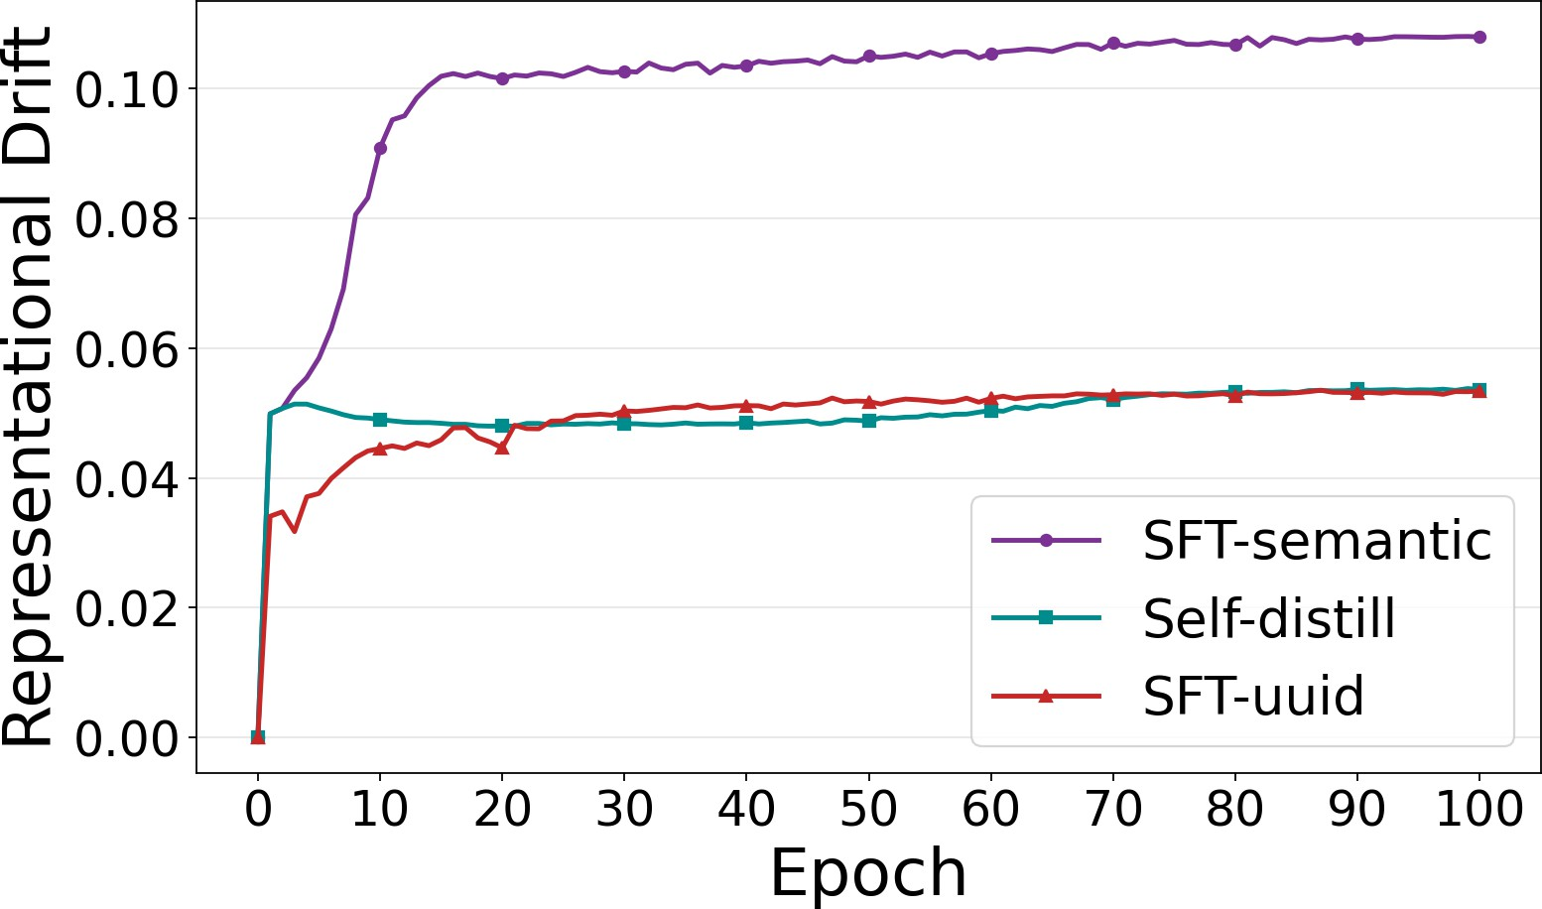

Figure 5: Hidden-state drift (RD_{i}, Eq. 4). UUID keys and self-distillation both stabi-lize near ≈5% after task-format learning; SFT on semantic keys continues to ≈11%, implicating representational interference as the source of factual forgetting.

absent under both conditions that avoid or suppress this interference. This pattern is consis-tent with the structural account and is not predicted by capacity or behavioral alternatives.
Together, these results suggest that the origin of factual forgetting is localized interference among semantically overlapping entity representations—not generic weight drift or behav-

ioral effects—and that self-distillation reduces forgetting precisely because it targets this interference at the output level.7
Insight 3: Structural Interference and Forgetting
Interference of semantically overlapping entities cause SFT-induced hallucinations.

Related Work
Hallucinations and scope Hallucinations are commonly defined as model outputs that are unfaithful to real-world facts (Ji et al., 2023; Simhi et al., 2025), provided context (Liu et al., 2025), or user instructions (Belem et al., 2025), and arise from mechanisms spanning data, training, and inference (Kalai et al., 2025; Azaria & Mitchell, 2023; Wang et al., 2023b). Our findings support viewing SFT-induced hallucinations as the behavioral manifestation of factual forgetting: catastrophic forgetting over parametric factual knowledge driven by representational interference during fine-tuning. While prior work documented this in closed-book QA (Gekhman et al., 2024; Ovadia et al., 2024; Zucchet et al., 2025), our results suggest it arises whenever fine-tuning updates interfere with prior factual representations.

Factual knowledge in LLMs and module roles Prior work has shown that LLMs encode factual associations parametrically, with evidence that both FFN layers (Geva et al., 2021; 2022; Meng et al., 2023; Kaplan et al., 2025a) and attention projections (Dar et al., 2023; Elhelo & Geva, 2025) contribute to storing and expressing factual knowledge. These findings suggest that factual representations are distributed separately across architectural compo-nents. Complementary studies on partial fine-tuning of multi-modal LLMs demonstrate that strong skill performance can be maintained while updating only subsets of parameters (Zhu et al., 2025). Building on this literature, our experiments (§3) show how updating different parameter subsets affects the factual plasticity–stability tradeoff during SFT.
Hidden knowledge and recall failures LLMs often encode more factual knowledge than they express, hallucinating while still internally knowing the correct answer (Gekhman et al., 2025; Orgad et al., 2025; Simhi et al., 2025), and such latent knowledge can sometimes be elicited through reasoning (Gekhman et al., 2026; Calderon et al., 2026). This suggests that some SFT-induced hallucinations reflect degraded recall rather than complete knowledge loss. The interference we identify in §5 may thus corrupt recall pathways without fully erasing the underlying knowledge, and self-distillation may help by preserving both.

Continual learning in LLMs Continual learning studies the stability-plasticity tension in sequential training and proposes mitigations such as regularization, replay, architectural isolation, and distillation (Li & Hoiem, 2017; Kirkpatrick et al., 2017; Lange et al., 2019; Kim et al., 2023; Guo et al., 2025). Recent work has applied distillation and KL-based constraints to continual task learning in LLMs (Zhu et al., 2025; Shenfeld et al., 2025; 2026). We build on this literature, treating preservation of pretrained factual knowledge as the stability objective — in contrast to continual knowledge learning, which treats factual updates as the primary goal (Jang et al., 2022; Mai et al., 2021; Chen et al., 2025; Lin et al., 2025).

Conclusion
We reframe SFT-induced hallucinations as factual forgetting arising from continual learning dynamics, and show that established mitigation strategies transfer effectively to this setting. When new fact acquisition is undesirable, selectively freezing FFN parameters suppresses factual plasticity while preserving task learning. When new fact acquisition is required, self-distillation constrains output-distribution drift and reduces forgetting from ∼15% to ∼3% without sacrificing factual plasticity.

7Additional experiments of the distillation objective and drift metrics are reported in Appendix F.

We also find that forgetting is selective: when facts that are semantically similar to the known facts are introduced, forgetting scales with the representational overlap between new and existing entities. When random UUID facts are introduced, forgetting drops to near-zero for even at 106 new facts. This asymmetry is difficult to reconcile with capacity or behavioral accounts, and suggests that localized interference among overlapping representations may be a primary driver. Consistent with this, representational drift analysis shows that self-distillation suppresses this interference at the output level, preventing gradient updates for new entities from propagating through shared representational regions.
Together, these findings suggest a unified view: SFT-induced hallucinations are not an inevitable cost of factual learning, but a consequence of representational interference that can be targeted directly. We hope this framing encourages future work to treat factual stability as a first-class objective in fine-tuning, and to leverage the rich continual learning literature toward that end.

References
Zeyuan Allen-Zhu and Yuanzhi Li. Physics of language models: Part 3.3, knowledge capacity scaling laws, 2024. URL https://arxiv.org/abs/2404.05405.
Amos Azaria and Tom Mitchell. The internal state of an llm knows when it’s lying, 2023. URL https://arxiv.org/abs/2304.13734.
Catarina G. Belem, Pouya Pezeshkpour, Hayate Iso, Seiji Maekawa, Nikita Bhutani, and Estevam Hruschka. From single to multi: How llms hallucinate in multi-document summarization, 2025. URL https://arxiv.org/abs/2410.13961.
Pietro Buzzega, Matteo Boschini, Angelo Porrello, Davide Abati, and Simone Calderara. Dark experience for general continual learning: a strong, simple baseline, 2020. URL https://arxiv.org/abs/2004.07211.
Nitay Calderon, Eyal Ben-David, Zorik Gekhman, Eran Ofek, and Gal Yona. Empty shelves or lost keys? recall is the bottleneck for parametric factuality, 2026. URL https://arxiv. org/abs/2602.14080.
Howard Chen, Jiayi Geng, Adithya Bhaskar, Dan Friedman, and Danqi Chen. Continual memorization of factoids in language models, 2025. URL https://arxiv.org/abs/2411. 07175.
Guy Dar, Mor Geva, Ankit Gupta, and Jonathan Berant. Analyzing transformers in embed-ding space, 2023. URL https://arxiv.org/abs/2209.02535.
Amit Elhelo and Mor Geva. Inferring functionality of attention heads from their parameters, 2025. URL https://arxiv.org/abs/2412.11965.
Zorik Gekhman, Gal Yona, Roee Aharoni, Matan Eyal, Amir Feder, Roi Reichart, and Jonathan Herzig. Does fine-tuning llms on new knowledge encourage hallucinations?, 2024. URL https://arxiv.org/abs/2405.05904.
Zorik Gekhman, Eyal Ben David, Hadas Orgad, Eran Ofek, Yonatan Belinkov, Idan Szpektor, Jonathan Herzig, and Roi Reichart. Inside-out: Hidden factual knowledge in llms, 2025. URL https://arxiv.org/abs/2503.15299.
Zorik Gekhman, Roee Aharoni, Eran Ofek, Mor Geva, Roi Reichart, and Jonathan Herzig. Thinking to recall: How reasoning unlocks parametric knowledge in llms, 2026. URL https://arxiv.org/abs/2603.09906.
Mor Geva, Roei Schuster, Jonathan Berant, and Omer Levy. Transformer feed-forward layers are key-value memories, 2021. URL https://arxiv.org/abs/2012.14913.
Mor Geva, Avi Caciularu, Kevin Ro Wang, and Yoav Goldberg. Transformer feed-forward layers build predictions by promoting concepts in the vocabulary space, 2022. URL https://arxiv.org/abs/2203.14680.

Aaron Grattafiori et al. The llama 3 herd of models, 2024. URL https://arxiv.org/abs/ 2407.21783.
Haiyang Guo, Fanhu Zeng, Fei Zhu, Jiayi Wang, Xukai Wang, Jingang Zhou, Hongbo Zhao, Wenzhuo Liu, Shijie Ma, Da-Han Wang, Xu-Yao Zhang, and Cheng-Lin Liu. Continual learning for generative ai: From llms to mllms and beyond, 2025. URL https://arxiv. org/abs/2506.13045.
Geoffrey Hinton, Oriol Vinyals, and Jeff Dean. Distilling the knowledge in a neural network, 2015. URL https://arxiv.org/abs/1503.02531.
Lei Huang, Weijiang Yu, Weitao Ma, Weihong Zhong, Zhangyin Feng, Haotian Wang, Qianglong Chen, Weihua Peng, Xiaocheng Feng, Bing Qin, and Ting Liu. A survey on hallucination in large language models: Principles, taxonomy, challenges, and open questions. ACM Transactions on Information Systems, 43(2):1–55, January 2025. ISSN 1558-2868. doi: 10.1145/3703155. URL http://dx.doi.org/10.1145/3703155.
Joel Jang, Seonghyeon Ye, Sohee Yang, Joongbo Shin, Janghoon Han, Gyeonghun Kim, Stanley Jungkyu Choi, and Minjoon Seo. Towards continual knowledge learning of language models, 2022. URL https://arxiv.org/abs/2110.03215.
Ziwei Ji, Nayeon Lee, Rita Frieske, Tiezheng Yu, Dan Su, Yan Xu, Etsuko Ishii, Ye Jin Bang, Andrea Madotto, and Pascale Fung. Survey of hallucination in natural language generation. ACM Computing Surveys, 55(12):1–38, March 2023. ISSN 1557-7341. doi: 10.1145/3571730. URL http://dx.doi.org/10.1145/3571730.
Adam Tauman Kalai, Ofir Nachum, Santosh S. Vempala, and Edwin Zhang. Why language models hallucinate, 2025. URL https://arxiv.org/abs/2509.04664.
Guy Kaplan, Matanel Oren, Yuval Reif, and Roy Schwartz. From tokens to words: On the inner lexicon of llms, 2025a. URL https://arxiv.org/abs/2410.05864.
Guy Kaplan, Michael Toker, Yuval Reif, Yonatan Belinkov, and Roy Schwartz. Follow the flow: On information flow across textual tokens in text-to-image models, 2025b. URL https://arxiv.org/abs/2504.01137.
Joonkyu Kim, Yejin Kim, and Jy yong Sohn. Measuring representational shifts in continual learning: A linear transformation perspective, 2025. URL https://arxiv.org/abs/2505. 20970.
Sanghwan Kim, Lorenzo Noci, Antonio Orvieto, and Thomas Hofmann. Achieving a better stability-plasticity trade-off via auxiliary networks in continual learning, 2023. URL https://arxiv.org/abs/2303.09483.
James Kirkpatrick, Razvan Pascanu, Neil Rabinowitz, Joel Veness, Guillaume Desjardins, Andrei A. Rusu, Kieran Milan, John Quan, Tiago Ramalho, Agnieszka Grabska-Barwinska, Demis Hassabis, Claudia Clopath, Dharshan Kumaran, and Raia Hadsell. Overcoming catastrophic forgetting in neural networks. Proceedings of the National Academy of Sciences, 114(13):3521–3526, March 2017. ISSN 1091-6490. doi: 10.1073/pnas.1611835114. URL
http://dx.doi.org/10.1073/pnas.1611835114.
Matthias De Lange, Rahaf Aljundi, Marc Masana, Sarah Parisot, Xu Jia, Ales Leonardis, Gregory Slabaugh, and Tinne Tuytelaars. A continual learning survey: Defying forgetting in classification tasks, 2019. URL https://arxiv.org/abs/1909.08383.
Minchong Li, Feng Zhou, and Xiaohui Song. Bild: Bi-directional logits difference loss for large language model distillation, 2025. URL https://arxiv.org/abs/2406.13555.
Zhizhong Li and Derek Hoiem. Learning without forgetting, 2017. URL https://arxiv. org/abs/1606.09282.
Jessy Lin, Luke Zettlemoyer, Gargi Ghosh, Wen-Tau Yih, Aram Markosyan, Vincent-Pierre Berges, and Barlas Og˘ uz. Continual learning via sparse memory finetuning, 2025. URL https://arxiv.org/abs/2510.15103.

Siyi Liu, Kishaloy Halder, Zheng Qi, Wei Xiao, Nikolaos Pappas, Phu Mon Htut, Neha Anna John, Yassine Benajiba, and Dan Roth. Towards long context hallucination detection, 2025. URL https://arxiv.org/abs/2504.19457.
Zheda Mai, Ruiwen Li, Jihwan Jeong, David Quispe, Hyunwoo Kim, and Scott Sanner. Online continual learning in image classification: An empirical survey, 2021. URL https:
//arxiv.org/abs/2101.10423.
Sergi Masip, Gido M. van de Ven, Javier Ferrando, and Tinne Tuytelaars. Putting a face to forgetting: Continual learning meets mechanistic interpretability, 2026. URL https:
//arxiv.org/abs/2601.22012.
Kevin Meng, David Bau, Alex Andonian, and Yonatan Belinkov. Locating and editing factual associations in gpt, 2023. URL https://arxiv.org/abs/2202.05262.
Kento Nishi, Rahul Ramesh, Maya Okawa, Mikail Khona, Hidenori Tanaka, and Ekdeep Singh Lubana. Representation shattering in transformers: A synthetic study with knowledge editing, 2025. URL https://arxiv.org/abs/2410.17194.
Hadas Orgad, Michael Toker, Zorik Gekhman, Roi Reichart, Idan Szpektor, Hadas Kotek, and Yonatan Belinkov. Llms know more than they show: On the intrinsic representation of llm hallucinations, 2025. URL https://arxiv.org/abs/2410.02707.
Oded Ovadia, Menachem Brief, Moshik Mishaeli, and Oren Elisha. Fine-tuning or retrieval? comparing knowledge injection in llms, 2024. URL https://arxiv.org/abs/2312.05934.
Fahad Sarfraz, Elahe Arani, and Bahram Zonooz. Error sensitivity modulation based experience replay: Mitigating abrupt representation drift in continual learning, 2023. URL https://arxiv.org/abs/2302.11344.
John Schulman. Reinforcement learning from human feedback: Progress and challenges. UC Berkeley EECS Colloquium Talk, 2023. https://www.youtube.com/watch?v=hhiLw5Q_UFg.
Christopher Sciavolino, Zexuan Zhong, Jinhyuk Lee, and Danqi Chen. Simple entity-centric questions challenge dense retrievers. In Marie-Francine Moens, Xuanjing Huang, Lucia Specia, and Scott Wen-tau Yih (eds.), Proceedings of the 2021 Conference on Empirical Methods in Natural Language Processing, pp. 6138–6148, Online and Punta Cana, Dominican Republic, November 2021. Association for Computational Linguistics. doi: 10.18653/v1/ 2021.emnlp-main.496. URL https://aclanthology.org/2021.emnlp-main.496/.
Idan Shenfeld, Jyothish Pari, and Pulkit Agrawal. Rl’s razor: Why online reinforcement learning forgets less, 2025. URL https://arxiv.org/abs/2509.04259.
Idan Shenfeld, Mehul Damani, Jonas Hübotter, and Pulkit Agrawal. Self-distillation enables continual learning, 2026. URL https://arxiv.org/abs/2601.19897.
Adi Simhi, Jonathan Herzig, Itay Itzhak, Dana Arad, Zorik Gekhman, Roi Reichart, Fazl Barez, Gabriel Stanovsky, Idan Szpektor, and Yonatan Belinkov. Hack: Hallucinations along certainty and knowledge axes, 2025. URL https://arxiv.org/abs/2510.24222.
Liyuan Wang, Xingxing Zhang, Hang Su, and Jun Zhu. A comprehensive survey of continual learning: Theory, method and application, 2023a. URL https://arxiv.org/abs/2302. 00487.
Xuezhi Wang, Jason Wei, Dale Schuurmans, Quoc Le, Ed Chi, Sharan Narang, Aakanksha Chowdhery, and Denny Zhou. Self-consistency improves chain of thought reasoning in language models, 2023b. URL https://arxiv.org/abs/2203.11171.
An Yang, Baosong Yang, Binyuan Hui, Bo Zheng, Bowen Yu, Chang Zhou, Chengpeng Li, Chengyuan Li, Dayiheng Liu, Fei Huang, Guanting Dong, Haoran Wei, Huan Lin, Jialong Tang, Jialin Wang, Jian Yang, Jianhong Tu, Jianwei Zhang, Jianxin Ma, Jin Xu, Jingren Zhou, Jinze Bai, Jinzheng He, Junyang Lin, Kai Dang, Keming Lu, Keqin Chen, Kexin Yang, Mei Li, Mingfeng Xue, Na Ni, Pei Zhang, Peng Wang, Ru Peng, Rui Men, Ruize

Gao, Runji Lin, Shijie Wang, Shuai Bai, Sinan Tan, Tianhang Zhu, Tianhao Li, Tianyu Liu, Wenbin Ge, Xiaodong Deng, Xiaohuan Zhou, Xingzhang Ren, Xinyu Zhang, Xipin Wei, Xuancheng Ren, Yang Fan, Yang Yao, Yichang Zhang, Yu Wan, Yunfei Chu, Yuqiong Liu, Zeyu Cui, Zhenru Zhang, and Zhihao Fan. Qwen2 technical report. arXiv preprint arXiv:2407.10671, 2024.
Yue Zhang, Leyang Cui, Wei Bi, and Shuming Shi. Alleviating hallucinations of large language models through induced hallucinations, 2024. URL https://arxiv.org/abs/ 2312.15710.
Zhen Zhu, Yiming Gong, Yao Xiao, Yaoyao Liu, and Derek Hoiem. How to teach large multimodal models new skills, 2025. URL https://arxiv.org/abs/2510.08564.
Nicolas Zucchet, Jörg Bornschein, Stephanie Chan, Andrew Lampinen, Razvan Pascanu, and Soham De. How do language models learn facts? dynamics, curricula and hallucinations, 2025. URL https://arxiv.org/abs/2503.21676.

Results Over Other SLiCK Classification Groups
The main experiments focus on HighlyKnown facts throughout, on both the training and validation sides. This choice follows a consistent principle. On the training side, the role of D_{Known} is to teach the model the QA task format without introducing any new factual content. Facts classified as HighlyKnown by SLiCK, meaning those for which the model produces the correct answer as its top-1 prediction across all few-shot prompt configurations, are ideally suited for this purpose: training on them reinforces format while leaving factual representations undisturbed. Any other group would risk conflating format acquisition with factual learning, obscuring the mechanism under study. On the validation side, having restricted D_{Known} to HighlyKnown facts, the natural corresponding held-out set is drawn from the same group, providing a clean forgetting signal: any accuracy decline on D_{Held} reflects genuine factual interference rather than pre-existing encoding fragility.
The four relations retained for our experiments (P17, P36, P407, and P495) were selected in part because each exhibits HighlyKnown prevalence exceeding 30% on the development split, ensuring a sufficient pool for both D_{Known} and D_{Held}. Table 2 reports the full SLiCK category distribution across all four relations on the development set (n=3,530). HighlyKnown facts constitute the plurality (46.6%), followed by MaybeKnown (32.4%); WeaklyKnown (5.3%) and Unknown (15.8%) make up the remainder. WeaklyKnown is the smallest group: these are facts the model never answers correctly as its greedy top-1 prediction across any of the 20 few-shot prompt variations used by SLiCK, representing the lowest degree of factual knowledge.

Relation | HighlyKnown | MaybeKnown | WeaklyKnown | Unknown
P17 (location → country) | 41.3% | 44.3% | 6.5% | 7.9%
P36 (country → capital) | 50.7% | 9.3% | 4.4% | 35.6%
P407 (artwork → language) | 42.0% | 45.4% | 4.7% | 7.9%
P495 (artwork → origin country) | 51.1% | 32.5% | 5.2% | 11.2%
Combined | 46.6% | 32.4% | 5.3% | 15.8%
Table 2: SLiCK category distribution on the development split for the four selected rela-tions (n=3,530). Each relation exceeds 30% HighlyKnown, the threshold used for inclusion.

While the main text focuses exclusively on HighlyKnown, the held-out set also contains MaybeKnown and WeaklyKnown facts, which exhibit qualitatively distinct dynamics under fine-tuning. Figure 6 reports training curves for all three knowledge groups under Regular SFT, Self-Distillation, and Only Known.
The HighlyKnown panel (left) reproduces the D_{Held} results from the main text. Only Known preserves accuracy throughout (≈95%), self-distillation stabilizes at ≈92%, and regular SFT

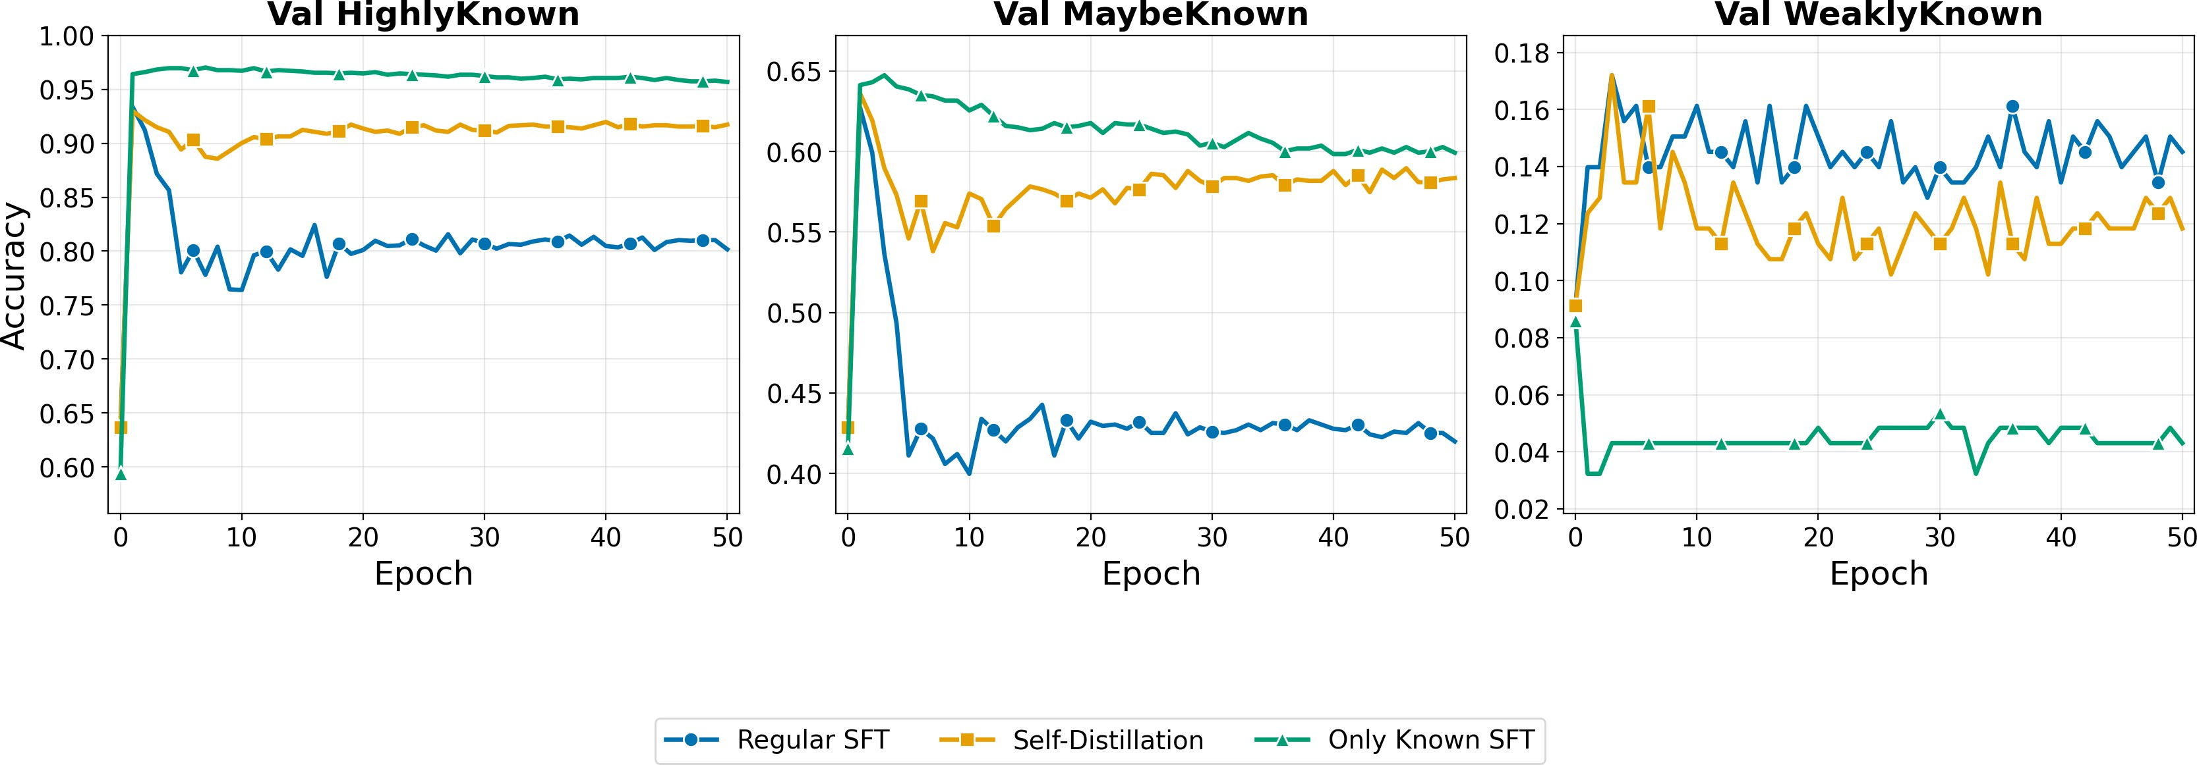
Figure 6: Training dynamics across SLiCK knowledge groups. Factual correctness over training epochs on held-out HighlyKnown (left), MaybeKnown (middle), and WeaklyKnown (right) facts, for Regular SFT (blue), Self-Distillation (orange), and Only Known (green).

degrades to ≈80%, a drop of approximately 13 percentage points from the pre-fine-tuning baseline.
MaybeKnown facts (middle panel) reveal substantially more severe forgetting under regular SFT. These facts are encoded less robustly: the model produces the correct answer under some but not all SLiCK prompt configurations, and this pre-existing fragility amplifies their susceptibility to representational interference. Accuracy collapses from approximately 0.64 to 0.43, a drop of roughly 21 percentage points, compared to 13 points on HighlyKnown. Self-distillation provides a commensurately larger benefit, stabilizing at approximately 0.58 and recovering approximately 15 percentage points over regular SFT. Only Known again provides the strongest preservation (≈0.60), confirming that D_{Unk} is the proximate driver of interference regardless of the robustness of the prior encoding. This pattern is consistent with the findings reported for Llama-3.1-8B and Qwen2.5-7B in Appendix B.
WeaklyKnown facts (right panel) exhibit a qualitatively different pattern that inverts the ordering observed in the other two groups. These facts are those for which the model never produces the correct answer as its top-1 prediction under any SLiCK configuration (knowledge that is present but highly latent), and baseline accuracy is accordingly low (≈0.15–0.17). Strikingly, Only Known drops to approximately 0.04–0.05 and remains there throughout training, well below both Regular SFT (≈0.14) and Self-Distillation (≈0.13). Training exclusively on HighlyKnown facts appears to further suppress recall of WeaklyKnown ones: by reinforcing a retrieval regime calibrated for robustly encoded facts, it may render the more effortful access required for latent knowledge less accessible. Regular SFT on the full training mixture (including D_{Unk}) provides a more varied optimization signal that may incidentally preserve or lightly activate recall of weakly encoded facts. Self-distillation and regular SFT converge to similar performance in this regime, which is expected: the distributional constraint provides little additional benefit when the facts in question were not reliably accessible before fine-tuning began.

Results Across Different Models
We validate our main findings on two additional 7–8B-parameter models from distinct families: Llama-3.1-8B and Qwen2.5-7B. Figure 7 reports training dynamics across all three conditions (Regular SFT, Self-Distillation, Only Known) for both architectures.
The core training dynamics replicate faithfully across both model families, consistent in magnitude with our primary 1.5B-parameter experiments. Under regular SFT, both Llama-3.1-8B and Qwen2.5-7B exhibit the characteristic two-stage pattern: rapid task acquisition in the first few epochs—with near-perfect accuracy on D_{Known} (97–98%)—followed by progressive forgetting of D_{Held} to approximately 85–86%. The Only Known condition preserves D_{Held} throughout training at 95–97%, and self-distillation closely tracks this

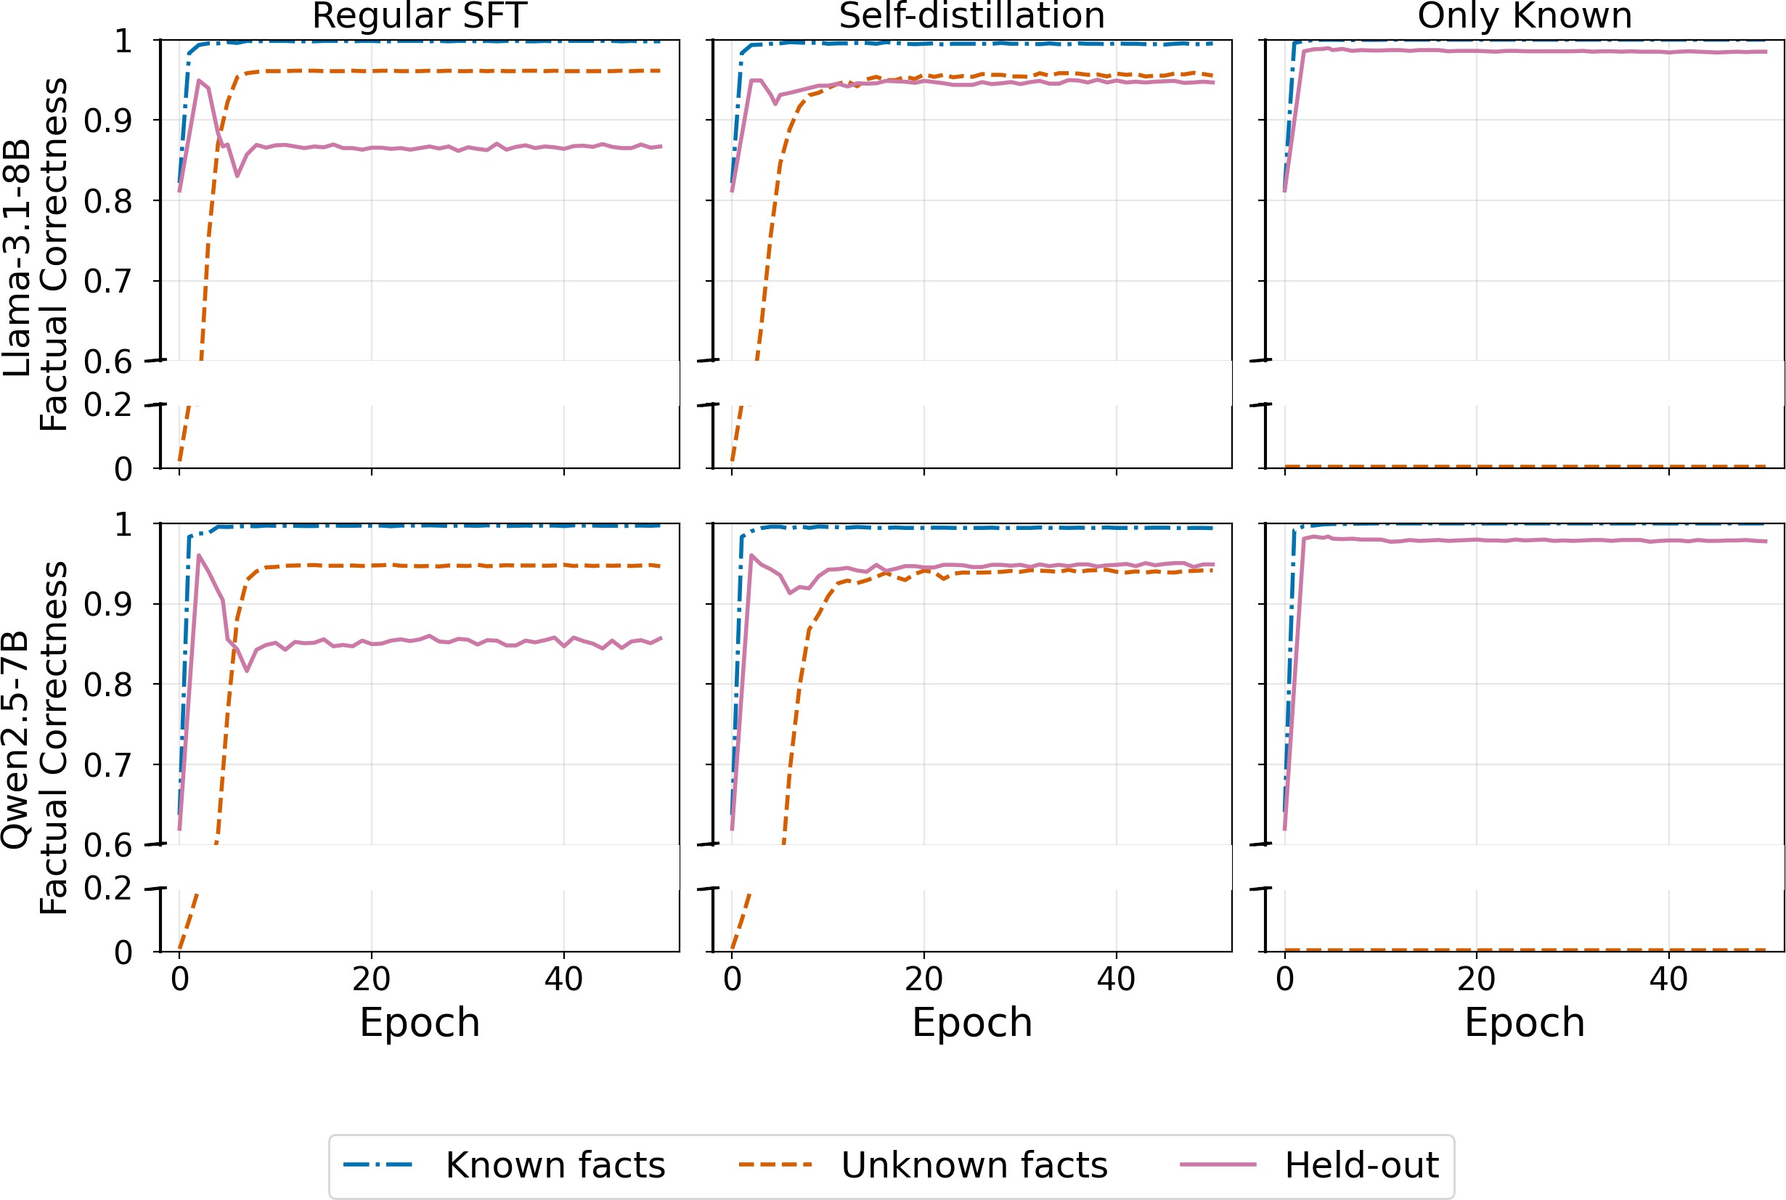
Figure 7: Training dynamics on Llama-3.1-8B (top) and Qwen2.5-7B (bottom). Each panel shows factual correctness over training epochs for Known facts (blue dash-dot), Unknown facts (orange dashed), and Held-out facts (green solid), across Regular SFT (left), Self-Distillation (middle), and Only Known (right).

upper bound, stabilizing at approximately 95%—a drop of only 2–3 percentage points from the Only Known baseline, compared to 11–12 percentage points under regular SFT. This corresponds to approximately 80% mitigation of forgetting, consistent with the degree of protection observed in the 1.5B model, confirming that self-distillation generalizes reliably across architectures and scales. The residual degradation under self-distillation (∼2–3pp) is likely attributable to task-format adaptation rather than factual interference, consistent with the ∼5% baseline drift observed even in the UUID condition (§5.1).
A complementary observation emerges from the fine-grained freezing results in Appendix C: training the full attention block is insufficient to achieve forgetting mitigation. The same level of stability is recovered only when restricting updates to a single attention projection (e.g., k, v, or o), with all other parameters frozen. This finding goes beyond the coarse attention-vs-FFN distinction established in §3: within the attention block itself, granularity matters. Updating all attention parameters jointly preserves enough factual plasticity to drive forgetting, whereas restricting to a single projection suppresses it sufficiently to protect DHeld.
Beyond the held-out known facts, we examine the effect on MaybeKnown facts, which SLiCK classifies as only partially known: the model produces the correct answer inconsistently across prompting configurations. This pattern is consistent across both model families and sizes (Fig. 8), and the effect is substantially more pronounced than what is observed for D_{Held}. Under regular SFT, accuracy on MaybeKnown facts drops by approximately 18–19 percentage points (from ∼0.63 to ∼0.45 for Llama-3.1-8B, and from ∼0.68 to ∼0.49 for Qwen2.5-7B), compared to an 11–12 percentage point drop on D_{Held}. We attribute this amplified vulnerability to the nature of partial knowledge: MaybeKnown facts are encoded less robustly in the model’s representations, and weaker encoding makes them more susceptible to interference when new factual knowledge is integrated. Their recall is already fragile before fine-tuning, so even moderate representational drift is sufficient to push them below the threshold of reliable recall. Self-distillation provides a commensurately larger benefit in this regime, stabilizing MaybeKnown accuracy at approximately 62–65% and mitigating approximately 90% of the forgetting induced by regular SFT—compared to approximately 80% on D_{Held}—underscoring its particular importance for preserving knowledge that sits at the margins of model recall.

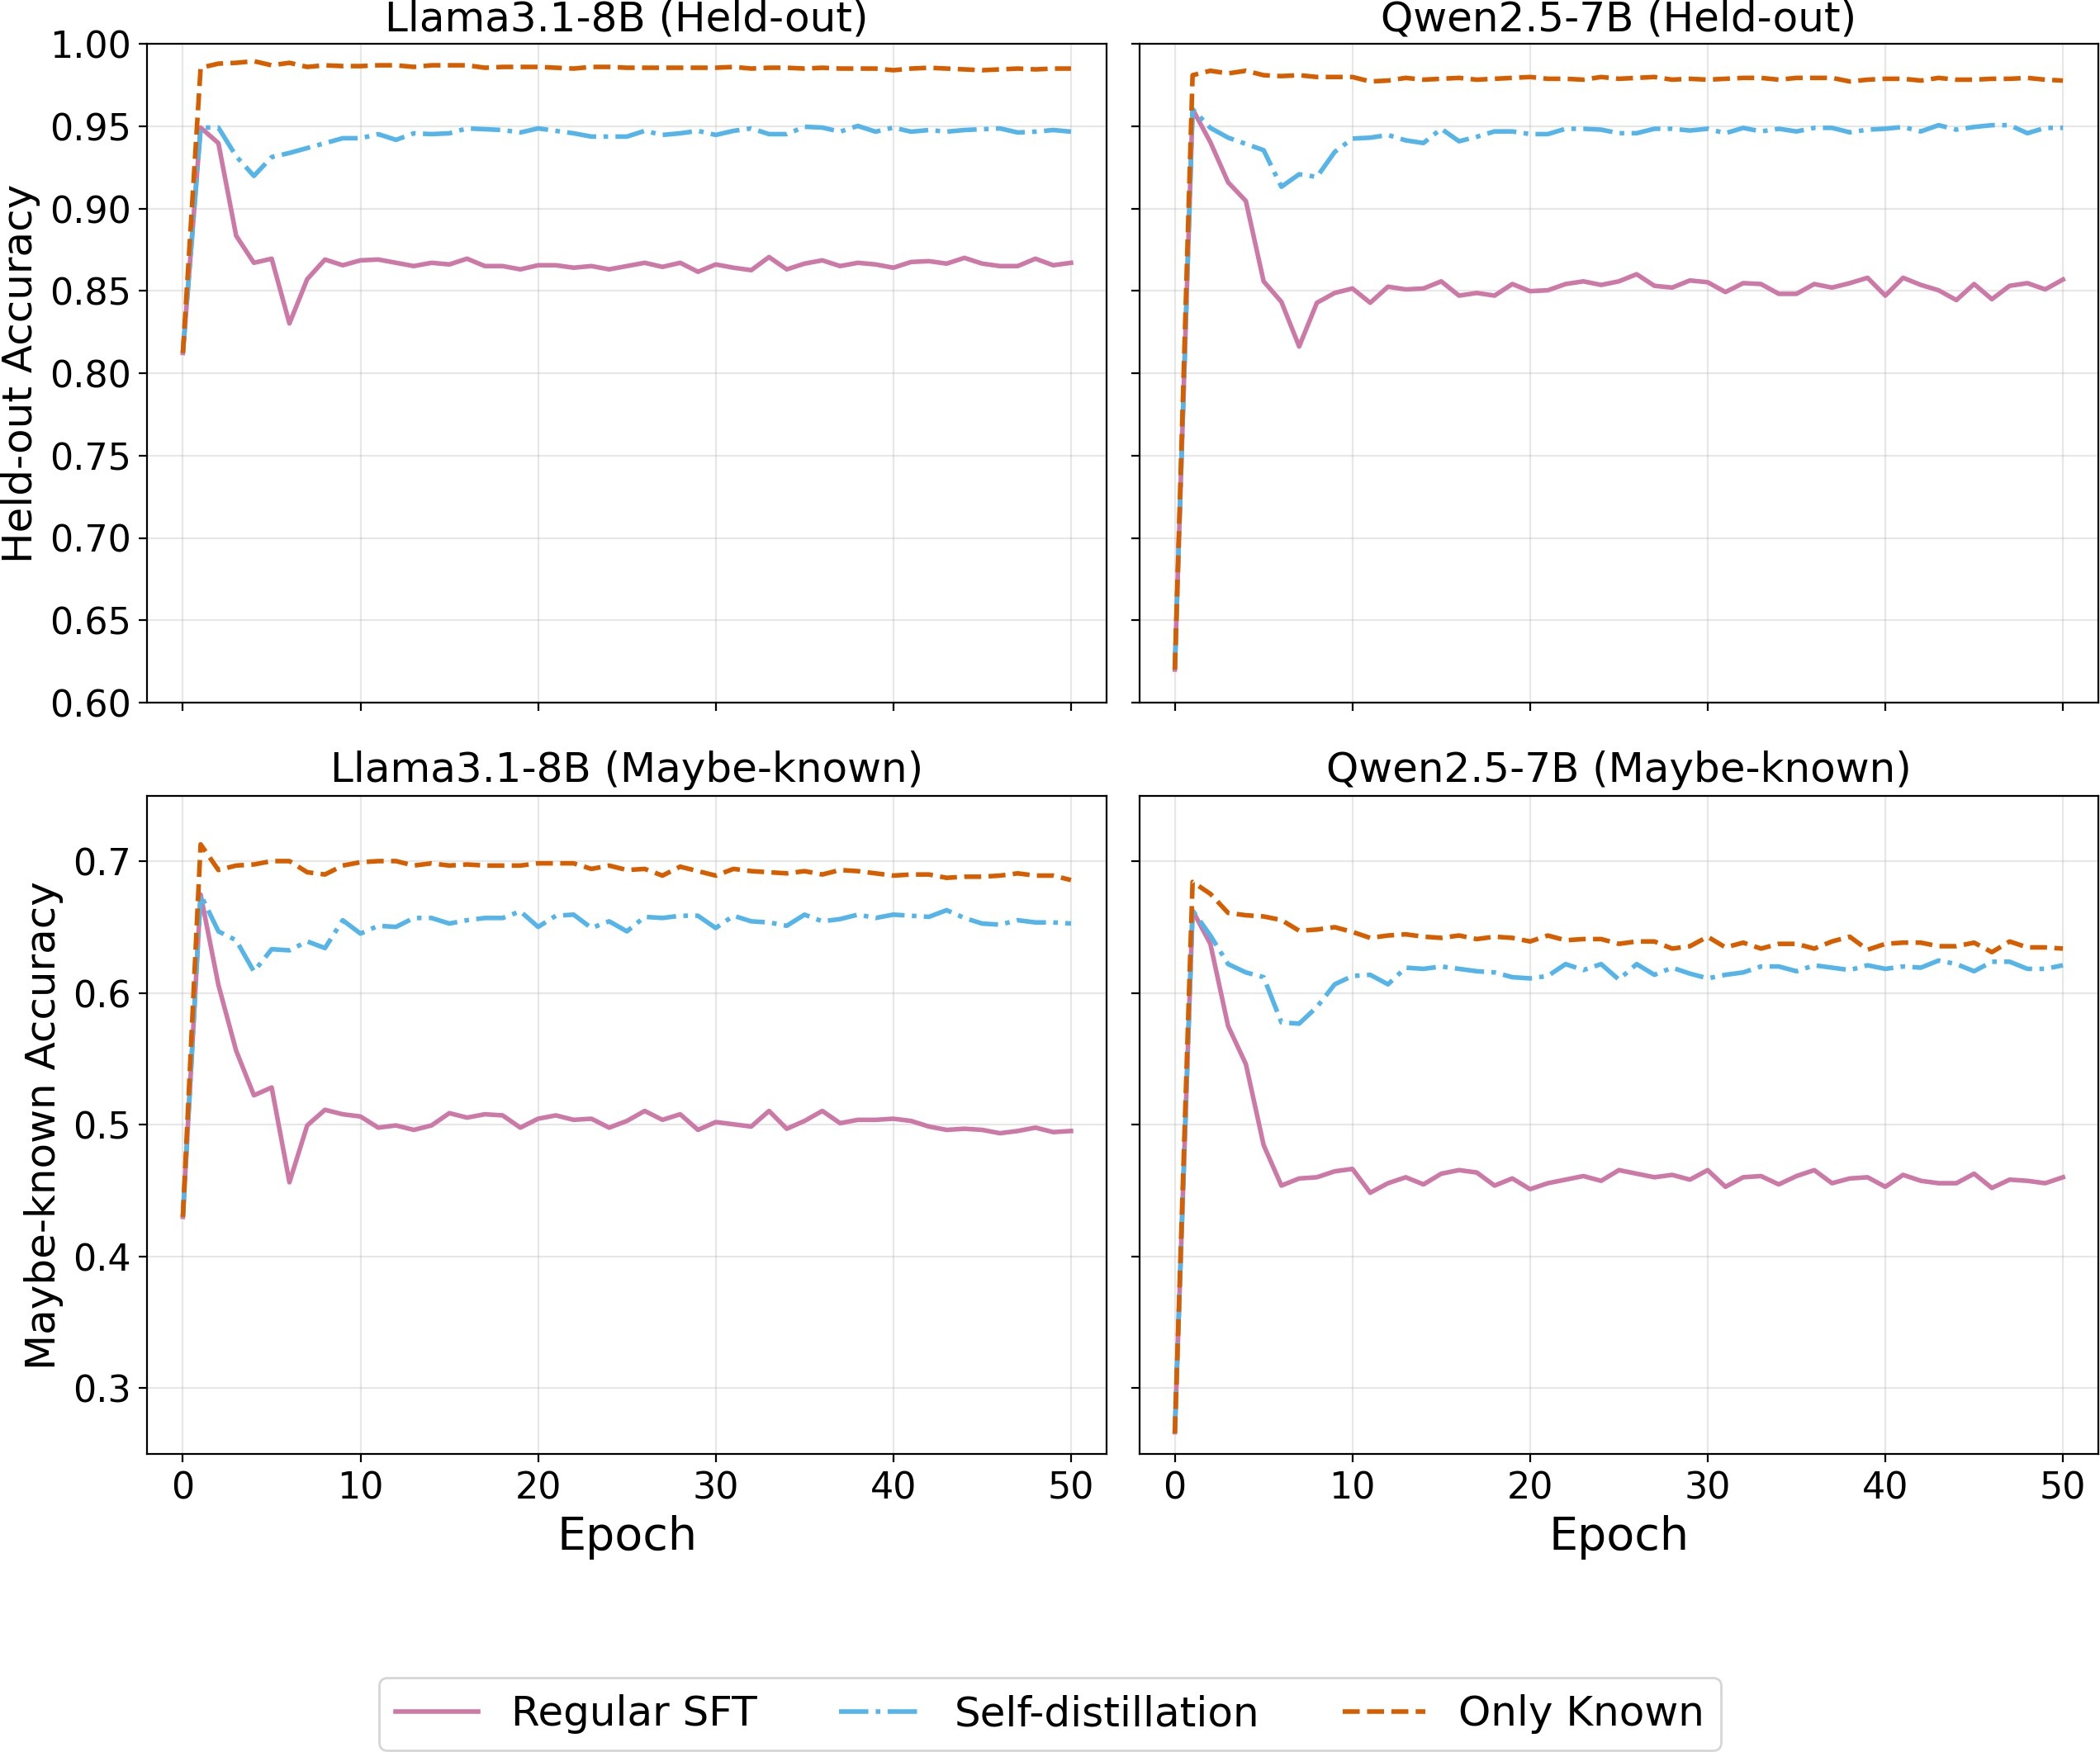

Figure 8: Accuracy on D_{Held} and MaybeKnown facts across training conditions. Top row: factual correctness on held-out HighlyKnown facts (D_{Held}). Bottom row: accuracy on out-of-training MaybeKnown facts. Results are shown for Llama-3.1-8B (left column) and Qwen2.5-7B (right column) under Regular SFT (solid pink), Self-Distillation (blue dash-dot), and Only Known (orange dashed).

Results Over Different Module Freezing Experiments

The main text (§3) establishes that freezing the FFN and updating only attention layers reduces forgetting by suppressing new fact acquisition. Here we examine the mechanism more finely: parameter freezing is not special; it is simply one way to reduce factual plasticity. What drives the reduction in forgetting is not the act of freezing per se, but the resulting decrease in D_{Unk}. We verify this by sweeping over fine-grained parameter subsets and showing that the relationship between plasticity and forgetting is monotone and consistent regardless of which module is restricted.
Table 3 reports results for individual attention projections (q, k, v, o), FFN sub-components (gate+up, down), the full attention block (attn), full FFN, and the standard full-model baseline. Across all configurations, D_{Held} tracks D_{Unk} closely: as factual plasticity increases, forgetting increases proportionally, irrespective of which parameter group is updated. Individual attention projections suppress plasticity most aggressively (D_{Unk} ≈ 0.005–0.006), yielding the highest D_{Held} values. The full attention block achieves comparable stability (D_{Unk} = 0.010), confirming that any restriction that prevents factual integration is sufficient. Within the FFN, the gate+up sub-component drives substantially more plasticity (D_{Unk} = 0.242) than the down projection (D_{Unk} = 0.086), consistent with the role of the gate+up pathway in writing factual content into the residual stream (Geva et al., 2022). Updating the full FFN or the full model recovers standard SFT dynamics, with high plasticity and a corresponding 15-percentage-point drop in D_{Held}.
These results reinforce the central claim of §3: the stability–plasticity tradeoff in factual fine-tuning is governed by how much new factual content the model integrates, not by the structural form of the constraint. Freezing is one mechanism for controlling that integration; self-distillation, as shown in §4.1, is another, one that achieves the same stability without sacrificing plasticity.

θS | DUnk ↓ | DKnown ↑ | DHeld ↑
k | 0.006 | 0.944 | 0.927
q | 0.006 | 0.912 | 0.901
v | 0.005 | 0.920 | 0.901
o | 0.006 | 0.941 | 0.925
attn | 0.010 | 0.946 | 0.931
gate+up | 0.242 | 0.977 | 0.883
down | 0.086 | 0.956 | 0.918
FFN | 0.941 | 0.997 | 0.782
All (standard SFT) | 0.946 | 0.990 | 0.780
All (Only Known) | — | 0.999 | 0.958
Table 3: Fine-grained freezing ablations. Each row corresponds to a different updated parameter subset θ_{S}, with all other parameters frozen. D_{Held} decreases monotonically with D_{Unk} across all configurations, confirming that factual plasticity—not the specific parameter group—mediates forgetting. Attention projections and the full attention block suppress plasticity most effectively. Within the FFN, gate+up drives substantially more plasticity than down. Full FFN and full model (standard SFT) recover the baseline forgetting pattern. Only Known provides the stability upper bound.

Results Over Different Parameters for Self-distillation
Self-distillation introduces three hyperparameters: the snapshot epoch i at which the teacher is frozen, the distillation weight λ, and the temperature τ.
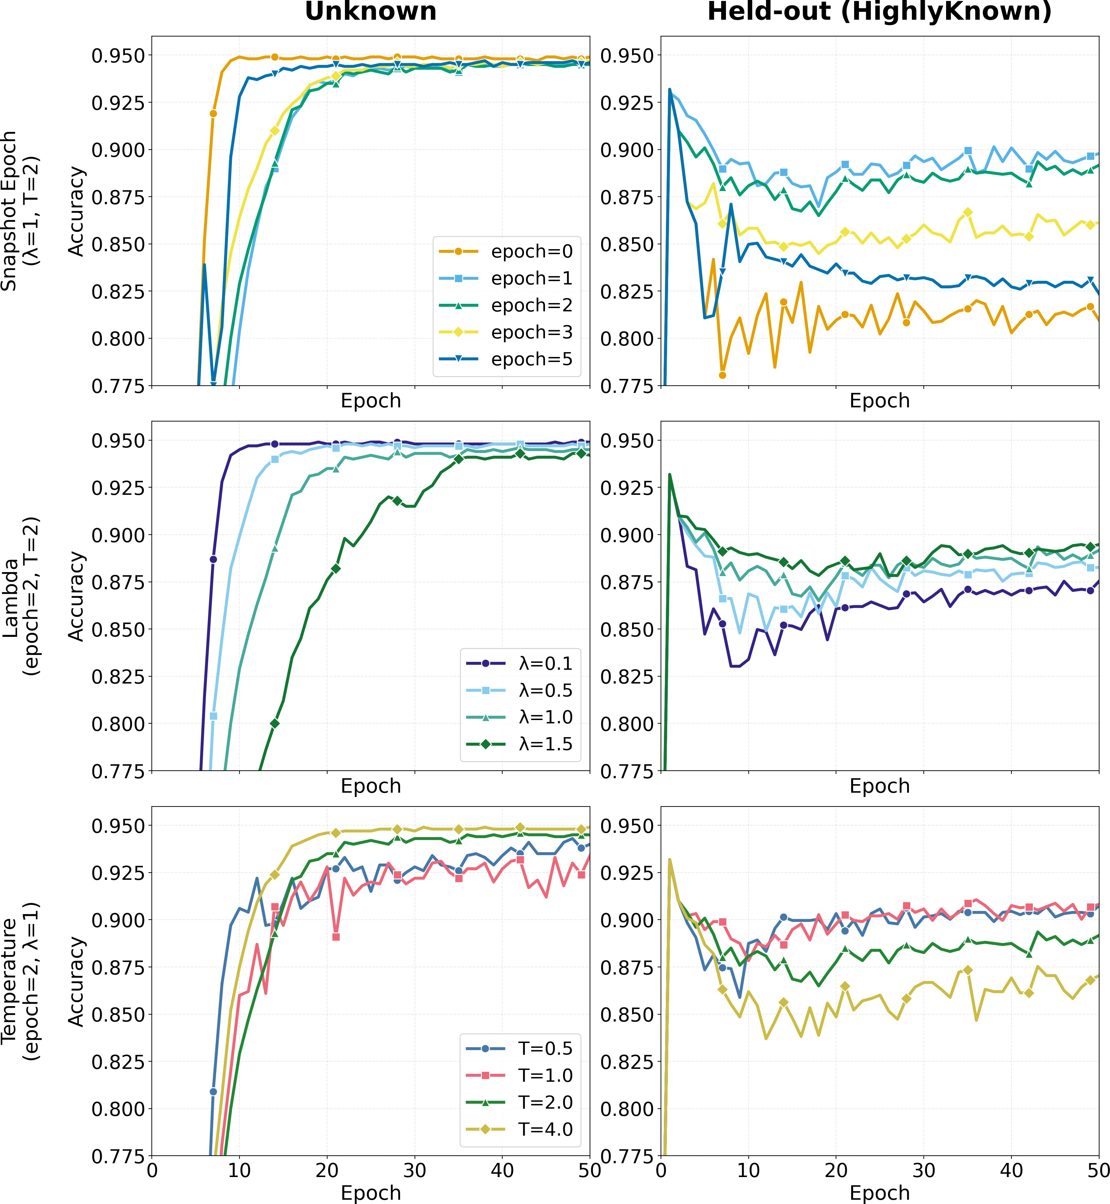
Figure 9 reports ablations over each parameter independently, with the remaining two held at their selected values (λ = 1, τ = 0.5). Each row shows accuracy on D_{Unk} (left, factual plasticity) and D_{Held} (right, factual stability) over training epochs.

Snapshot epoch. When the teacher is frozen at i = 0, D_{Unk} acquisition is substantially slower than under all other snapshot choices, and D_{Held} is the lowest across the ablation. In this setting,
the distillation loss constrains the student toward a parameter space that predates task adaptation, which may account for weaker performance on both axes, as the model has yet to internalize the QA format, the lower D_{Held} may reflect difficulty in task learning rather than factual forgetting per se. Snapshot i = 1 yields the highest D_{Held} values, with the model already adapted to the task format but not yet subject to sustained factual drift. Beyond i = 1, held-out stability degrades monotonically with the snapshot index.

Figure 9: Hyperparameter ablations for self-distillation. Each row ablates one hyperparameter while fixing the others (λ = 1, τ = 0.5). Left: D_{Unk} accuracy (factual plasticity). Right: D_{Held} accuracy (fac-tual stability).

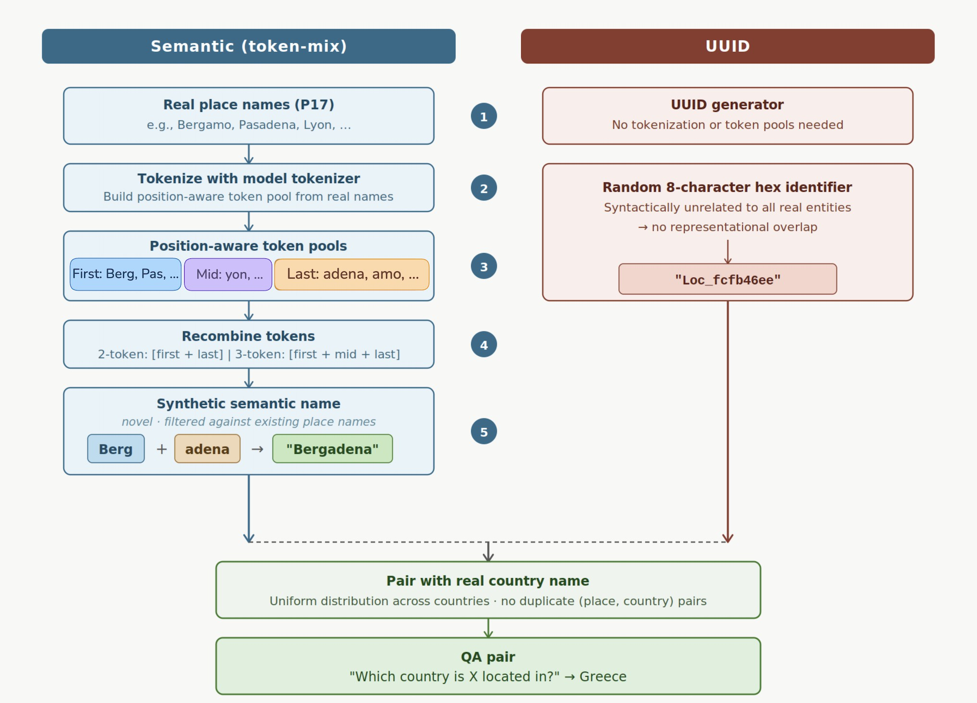
Figure 10: Synthetic entity construction. Semantic (token-mix) keys (left, steps 1–5): real P17 place names are tokenized, position-aware token pools are assembled, and novel names are formed by recombining tokens across names (e.g., Bergadena from Bergamo and Pasadena); candidates matching any existing place are discarded. UUID keys (right): random 8-character hex identifiers with no lexical overlap with real entities. Both conditions are paired with real country names under an identical question template, so the entity key is the sole variable. Candidate synthetic names that match any existing real place name are discarded.

Distillation weight. The λ ablation reveals a direct stability–plasticity tradeoff. Weaker regularization (λ = 0.1, λ = 0.5) allows rapid acquisition of D_{Unk} but results in greater degradation of D_{Held}. Stronger regularization (λ = 1.5) substantially reduces forgetting but delays factual learning, requiring considerably more training epochs before D_{Unk} accuracy reaches its asymptote. We select λ = 1 as it achieves efficient factual acquisition alongside meaningful forgetting mitigation, without demanding an extended training budget.

Temperature. Higher temperatures (τ = 2, τ = 4) produce smoother and more stable learning trajectories on D_{Unk}, reducing epoch-to-epoch variance. However, D_{Held} is no-ticeably lower under high-τ conditions. Lower temperatures (τ = 0.5, τ = 1) yield better stability on D_{Held} while preserving comparable final accuracy on D_{Unk}. We adopt τ = 0.5 as our default; practitioners who prioritize stable factual learning trajectories may prefer higher temperatures at a modest additional forgetting cost.

Synthetic Entities Creation Procedure
All controlled experiments in §5 use the P17 Wikidata relation (location → country: “Which country is X located in?”). We focus on a single relation deliberately: fixing the relation holds the question template, the answer domain, and the relational structure constant across all conditions, making the entity name (the key) the sole experimental variable and the comparison between key types causally clean.
To construct synthetic facts, we generate two types of entity names (Fig. 10). Semantic (token-mix) keys are built by tokenizing all real P17 place names and extracting three position-aware token pools: the first token of each multi-token name, all middle tokens, and the last token. Novel place names are then formed by recombining tokens sampled

from these pools, either as two-token sequences [first, last] or three-token sequences [first, middle, last], and any candidate that coincides with an existing real place is discarded. The resulting names share sub-word structure with real locations: for example, tokens from Bergamo and Pasadena combine into Bergadena, a novel name that lexically resembles genuine place names and is thus expected to activate overlapping representations in the model. UUID keys, by contrast, are random identifiers of the form Loc_〈8-hex〉 (e.g., Loc_fcfb46ee), with no syntactic resemblance to any real entity. In both conditions, each synthetic entity is paired with a real country drawn uniformly at random from those appearing in P17, subject to the constraint that the (place, country) pair is not already present in the original dataset; country assignments are rebalanced to maintain an approximately uniform distribution.
To verify that forgetting is driven by the key rather than the value, we additionally varied the country (value) condition: values were instantiated as real country names, semantic synthetic country names (constructed by the same token-mix process applied to country names), or UUID-style country labels, crossed with both key types. Table 4 reports ∆D_{Held} for all six combinations after training on 106 synthetic facts. Across all value conditions, semantic keys consistently induce 38–41 percentage points of forgetting, while UUID keys yield approximately 4% forgetting regardless of what value is paired with them. This full dissociation confirms that representational overlap in the entity name is the proximate driver of interference, and that the answer side of the relation plays no meaningful role.

Key type | Value type | ∆DHeld ↓
Semantic | Real | 38%
Semantic | Semantic | 38%
Semantic | UUID | 41%
UUID | Real | 4%
UUID | Semantic | 4%
UUID | UUID | 4%
Table 4: Forgetting is driven by key semantics, not value type. ∆D_{Held} after training on 106 synthetic facts, for all combinations of key type (semantic vs. UUID) and value type (real / semantic / UUID country names). All conditions achieve D_{Unk} = 100% and D_{Known} ≥ 90%, confirming that differences in forgetting cannot be attributed to differences in learning success.

Further Analyses on Self-Distillation
We report two sets of additional analyses that complement §5.2, both using the 10K semantic-overlap setting of §5.1: ablations on which part of the output distribution the distillation constraint needs to target, and an extended battery of drift metrics comparing SFT and self-distillation across representation and output space.

Which part of the output distribution matters? The main text establishes that ℓ₂ weight regularization does not replicate the self-distillation benefit, suggesting the effect is not simply a consequence of smaller weight updates. We additionally ask whether the full output distribution is necessary, or whether constraining a specific region suffices. This question connects to a broader literature on knowledge distillation: Hinton et al. (2015) showed that the “dark knowledge” carried by a teacher’s soft probability distribution over non-target classes is more informative than the hard labels alone, precisely because it encodes the teacher’s relative confidence over semantically related alternatives. In our setting, those alternatives are competing entity tokens — and we hypothesize that it is constraining this region, rather than the full distribution, that drives the forgetting reduction. We compare three variants of the distillation objective:
Full self-distillation: KL divergence over the complete vocabulary at each token position (Eq. (2)).

Top-k distillation: KL divergence restricted to the teacher’s k highest-probability tokens at each position. Let T_{k}(j) = arg topk p_{θ}i ( · | x_{<j}) be the top-k index set at position j, and let
p^{(k)}, p^{(k)} be the student and teacher distributions renormalized over T_{k}(j). The distillation
θi ,j θ,j

loss becomes

(k)
L (θ; θ_{i}) = E

distill (x,y)∼B

τ2

|M(y)|

∑ KL
j∈M(y)

(k)
θi ,j
p(k) 

. (5)

We set k = 0.5% of the vocabulary (76 tokens), capturing between 91% and 92% of the teacher’s probability mass per position.
p ¨
θ,j
Random-k distillation: identical to top-k, but the 76 tokens at each position are drawn uniformly at random rather than by probability rank. This condition controls for the number of constrained logits while removing alignment with the teacher’s high-probability region. Importantly, it does not reduce to standard SFT: the KL term remains active but constrains the student toward a uniform distribution over an arbitrary token subset, effectively injecting noise rather than meaningful structure.
Top-k distillation fully replicates full self-distillation: forgetting on D_{Held} decreases to ≈3 percentage points while D_{Unk} acquisition proceeds at the same pace. Random-k distillation leaves forgetting at ≈10 percentage points, indistinguishable from standard SFT. What mat-ters is therefore not the number of constrained logits but constraining the high-probability region specifically. This is consistent with Hinton et al. (2015)’s insight that soft targets carry informative relational structure — here, the relative probabilities over competing entity tokens encode the teacher’s “opinion” about which alternatives are plausible, and
preserving this opinion prevents the gradient updates for new entities from redistributing probability mass away from existing ones. Buzzega et al. (2020); Li et al. (2025) make a related observation in the continual learning setting, showing that dark experience replay — which stores and replays soft teacher outputs rather than hard labels — provides a stronger anti-forgetting signal than hard-label replay alone, precisely because the soft outputs encode richer relational structure. Our top-k result sharpens this: it is not the full soft distribution that matters, but the high-probability region where semantically competing candidates reside.
Notation for drift metrics. Let H^{(l)}(x) ∈ R^{d} denote the hidden representation of the key entity’s final token at transformer layer l under model θ, for input x. We write H^{(l)}(x) =
θ
0
H^{(l)}(x) for the pretrained model and H^{(l)}(x) for epoch i. All representations are extracted
θ0 i
from the final token of the key entity and ℓ₂-normalized before computing cosine similarities. The final token is the natural extraction point for entity representations in causal language models: unlike bidirectional architectures, where the full contextual representation of a phrase can reside at any of its token positions (Kaplan et al., 2025b), causal attention ensures that only the last token has attended to all preceding tokens and thus carries the complete representation of the entity. We fix l = 14: the middle layer of the 28-layer Qwen 2.5-1.5B model, where the inner lexicon of LLMs is most reliably encoded (Kaplan et al., 2025a). Let P = {(x_{u}, x_{h}) : x_{u} ∈ D_{Unk}, x_{h} ∈ D_{Held}, a(x_{u}) = a(x_{h})} be the set of unknown/held-out
input pairs sharing the same ground-truth answer a(·), and I = T^{θ}0 (x_{h}) the pretrained model’s top-k token indices at the answer position for held-out input x_{h}.
k
The battery of metrics below is designed to triangulate the interference account from multiple angles: RD measures whether individual held-out representations move; NS measures whether their relative geometry is preserved; MTD measures whether they drift specifically toward new-entity representations; and Rank-ρ, NTR, and JSD measure whether this interference is visible at the output level. Convergent evidence across all six metrics strengthens the structural account over capacity-based or behavioral alternatives.
Hidden-state drift (RD). RD Eq. 4 measures the average cosine distance between held-out entity representations before and after fine-tuning. Cosine distance captures directional shifts in representation space, which are more sensitive to semantic change than Euclidean

distance (Kim et al., 2025). Under SFT, RD reaches ≈11%; under self-distillation it stabilizes near 5%. The residual 5% present in all conditions reflects task-format learning and is not associated with forgetting, as confirmed by the UUID condition in §5.1.

Neighborhood structure (NS).
1
NS_{i} = ∑ cos H⁽¹⁴⁾(x), H⁽¹⁴⁾(x′) − cos H⁽¹⁴⁾(x), H⁽¹⁴⁾(x′) , (6)
|S|2 x,x′ ∈S
i
i
0
0
where S ⊆ D_{Held} is a random subsample. NS measures how much the pairwise geometric structure among held-out entity representations changes during training — capturing whether entities move together (high RD, low NS) or rearrange relative to each other (high NS). Under SFT, NS reaches ≈0.07; under self-distillation it stabilizes near 0.02. The fact that both RD and NS are elevated under SFT indicates that held-out representations are not merely translating as a block, but genuinely reorganizing — consistent with localized interference rather than a global drift of all representations. This pattern mirrors findings in Masip et al. (2026), who show that catastrophic forgetting in classification networks manifests as representational reorganization concentrated among semantically similar classes, rather than uniform drift.

Mean targeted drift (MTD).
MTD_{i} = E x ,x cos H⁽¹⁴⁾(x_{h}), H⁽¹⁴⁾(x_{s}) − cos H⁽¹⁴⁾(x_{h}), H⁽¹⁴⁾(x_{s}) , (7)
( h
s )
i
i
0
0
where x_{h} ∈ D_{Held} and x_{s} indexes the synthetic (newly trained) entities. MTD directly tests the directionality of the interference: does the representational drift push held-out entities toward or away from the new entities? Under SFT, MTD drops to ≈−0.09, indicating that held-out and synthetic representations diverge — consistent with the model carving out distinct new-entity clusters that displace nearby held-out representations sideways rather than absorbing them. Under self-distillation, MTD remains near 0, indicating that the cross-group representational relationship is largely preserved. This divergence pattern is consistent with Nishi et al. (2025), who show that knowledge editing causes “representation shattering” — a reorganization of the local neighborhood structure around edited entities — and that nearby unedited entities are displaced as a byproduct.
Output-distribution drift (Rank-ρ). For each pair (x_{u}, x_{h}) ∈ P, Rank-ρ measures the Spearman rank correlation between the current model’s logit ranking over unknown-fact inputs and the pretrained model’s logit ranking over held-out inputs, restricted to the shared

index set I:
Rank-ρ = 1 ∑
|P| (xu ,xh )∈P

ρ_{Spearman} z_{θ} (x_{u})_{I}, z_{θ}0 (x_{h})_{I} , (8)

where z_{θ} (x)_{I} denotes the logits of θ at the answer position restricted to I. A rising Rank-ρ
indicates that the model’s output for new-fact inputs increasingly ranks entity candidates in the same order as the pretrained model ranked them for held-out inputs — a signature of the two entity neighborhoods converging in output space, which is precisely the interference pattern the structural account predicts. Under SFT, Rank-ρ rises from ≈0.32 to ≈0.40; under self-distillation it stays near 0.32.

Neighborhood token ratio (NTR).
= E(xu ,xh )∈P
k
k
k

NTR
" |Tθ (x_{u}) ∩ Tθ (x_{h})|# , (9)

where Tθ (x) is the current model’s top-k token set at the answer position for input x. NTR complements Rank-ρ by measuring overlap in the current model’s candidate sets (rather than correlation with the pretrained reference): do new-fact queries and held-out queries share the same answer candidates under the fine-tuned model? At initialization, the two groups share ≈45% of their top-k candidates. Under SFT, NTR drops to ≈17% as the model learns specialized answer distributions for the new entities; under self-distillation it remains
k

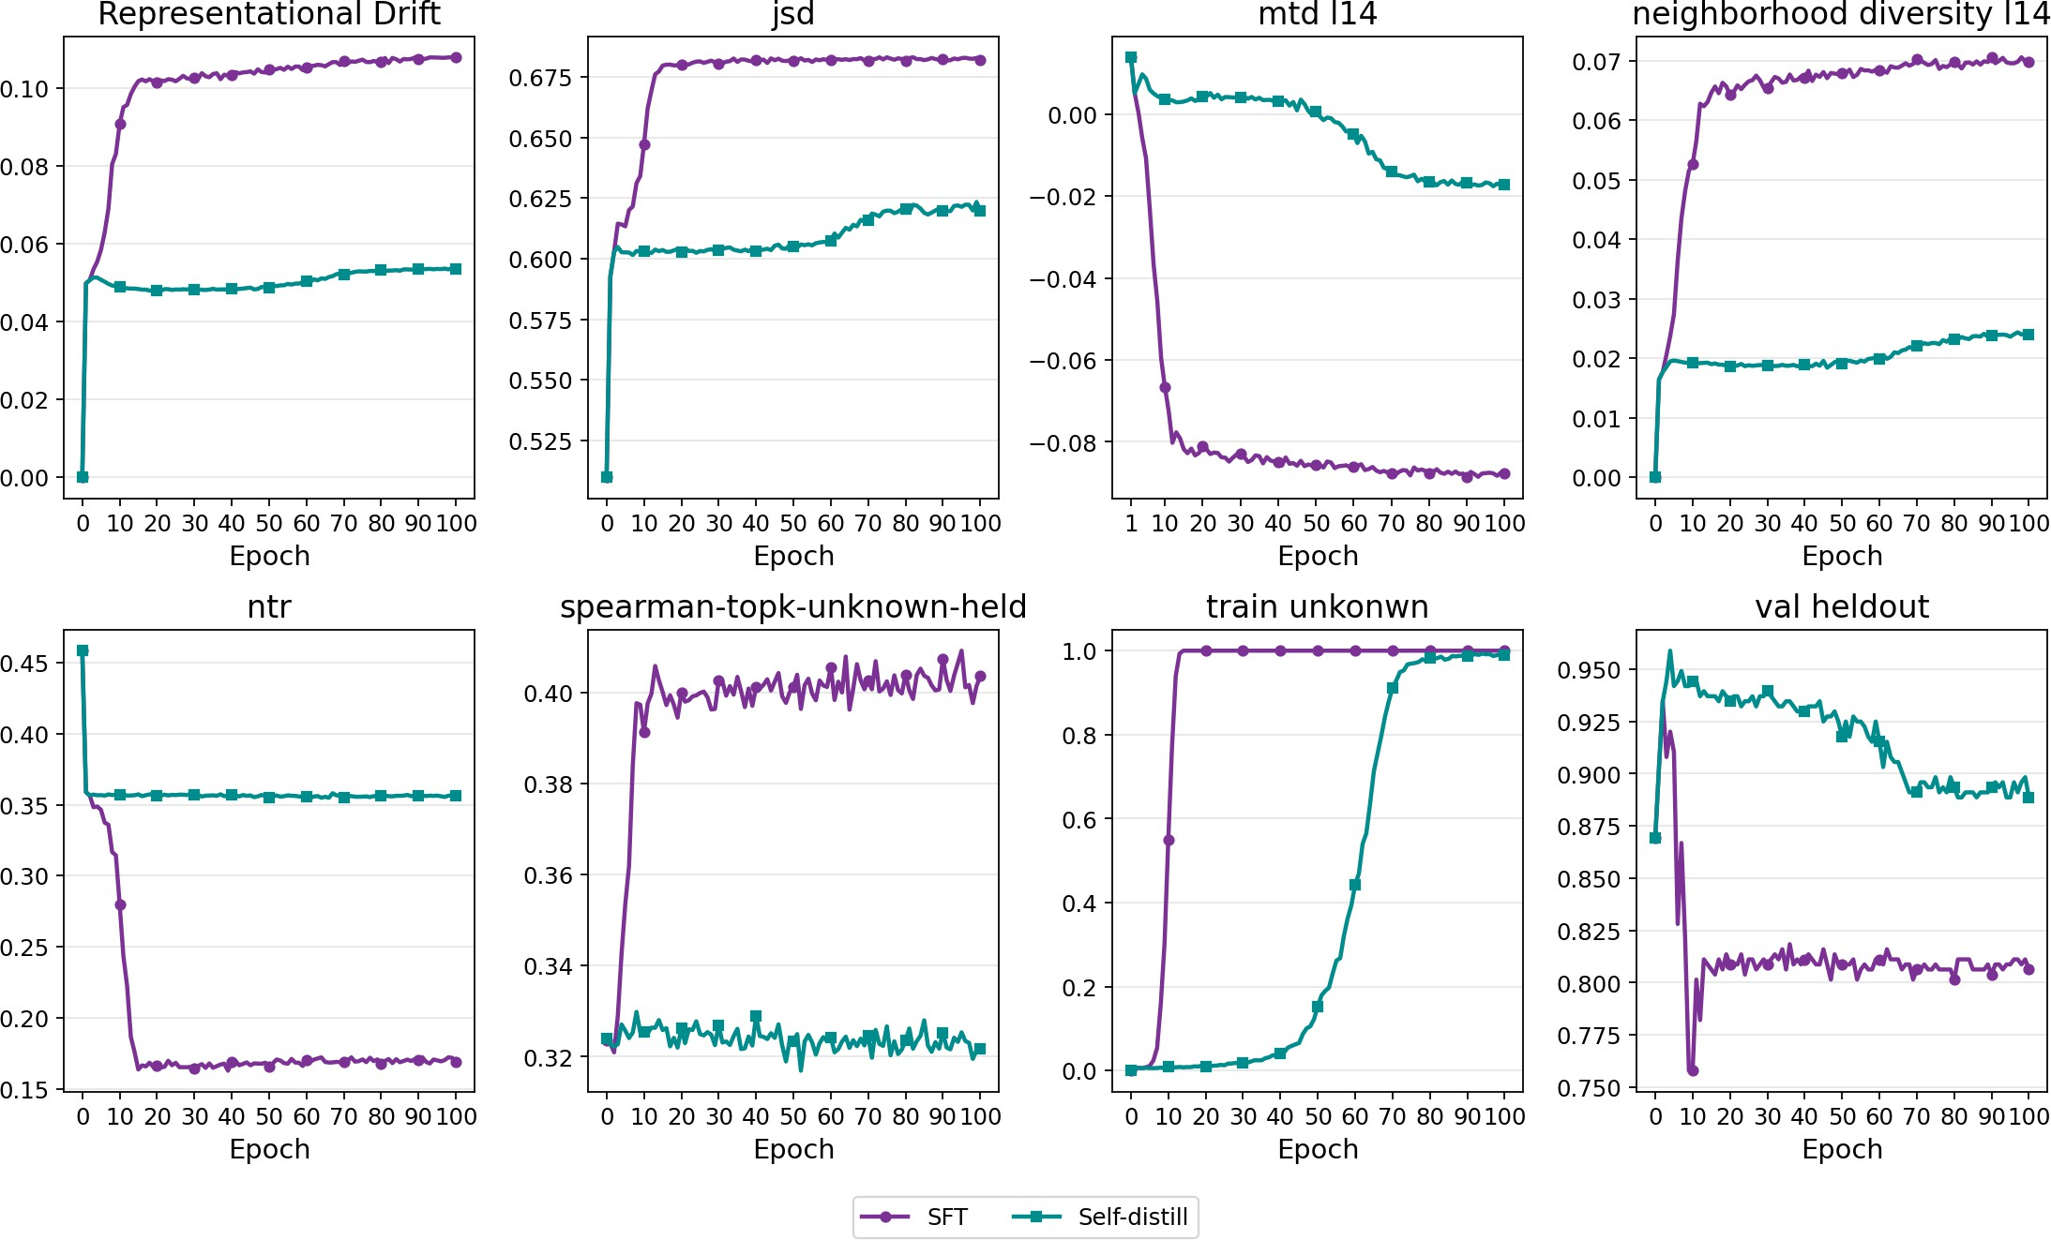
Figure 11: Extended drift metrics under standard SFT and self-distillation over 100 training epochs on the 10K semantic-overlap setting (§5.1). Top row, left to right: Hidden-state drift (RD), Jensen-Shannon divergence (JSD), mean targeted drift (MTD), and neighborhood structure (NS) — all at layer 14. Bottom row, left to right: Neighborhood token ratio (NTR), output-distribution drift (Rank-ρ), training accuracy on D_{Unk}, and validation accuracy on D_{Held}. All metrics consistently show less drift under self-distillation than under standard SFT. Factual acquisition on D_{Unk} proceeds at a comparable pace across conditions.

near 36%. The drop under SFT reflects the model pulling new-entity outputs into a distinct region of output space — consistent with the MTD finding that held-out and synthetic representations diverge.

Jensen-Shannon divergence (JSD).
¨
JSD = E(xu ,xh )∈P JSD p_{θ} (x_{u})_{I} p_{θ}0 (x_{h})_{I} , (10)
where p_{θ} (x)_{I} is the softmax distribution of θ at the answer position renormalized over I. JSD captures differences in the full probability shape rather than just rankings (complementing Rank-ρ). Both conditions show an upward trend, as the model naturally diverges from the fixed pretrained reference as it learns new facts. However, SFT reaches ≈0.68 versus ≈0.63 under self-distillation. The smaller gap here compared to Rank-ρ and NTR reflects the fact that JSD is sensitive to all probability mass, including the task-format learning component shared across conditions; Rank-ρ and NTR, by focusing on the entity-candidate region, isolate the interference-specific signal more cleanly.
Training and evaluation curves. The train unknown and val heldout subplots in Fig. 11 con-firm that both conditions achieve comparable factual acquisition on D_{Unk} — self-distillation converges somewhat later — while held-out accuracy on D_{Held} is substantially better pre-served under self-distillation, consistent with the main results of §4.1. Taken together, all six metrics tell a consistent story: SFT on semantically overlapping entities produces representational and output-space interference that is absent under self-distillation, and this interference is the proximate cause of factual forgetting.

