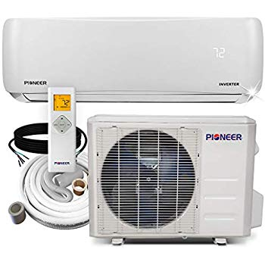Name: **BLACK+DECKER-BPACT08WT**

Price: 748$

Brand: BLACK+DECKER

Origin: America

Power:

Voltage: 115V

Size: 16.5 x 11.5 x 26 Inches

Weight: 53  Pounds

Warranty: 1 Years

Category: Air Conditioner

### Description: Enjoy a comfortable home climate with this versatile BLACK+DECKER unit. It cools, dehumidifies, and circulates air to stand up to summer heat. Offering immediate, uninterrupted comfort, this Portable Air Conditioner features easy-to-use LED electronic controls and is quiet while you sleep (75dB on high setting). This unit comes with rolling castors and side carrying handles for easy-to maneuver mobile comfort and everything needed for an effortless installation. Keeps a room, home, bedroom, apartment, dorm or garage that is approximately 100 - 150 square feet or 10 x 12` foot room pleasant and comfy during the summer months when the heat sets in. Works in double hung or sliding windows only, no crank windows. To minimize noise and vibration, the air conditioner should be placed on a firm floor. For safe and secure positioning, place the unit on a smooth, level floor strong enough to support the unit. For a better Cooling - Make sure all the windows and doors are closed, connect the duct and make sure it can function properly and Clean the air filter. Also note that, micro processor control delays the compressor from operating until 3 mins have passed.