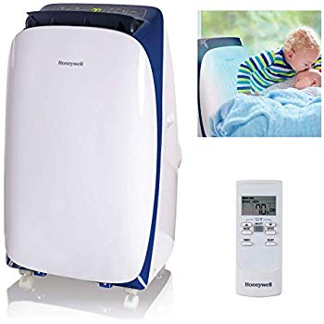Name: **Honeywell-HL14CESWB**

Price: 800$

Brand: Honeywell

Origin: America

Power:

Voltage: 220V

Size: 18.9 x 20.5 x 18.2 Inches

Weight: 64 Pounds

Warranty: 1 Years

Category: Air Conditioner

### Description: "The Honeywell HL series portable air conditioner combines 3-in-1 technology into one sleek body, cooling and dehumidifying areas up to 550-700 square feet. It features an auto-evaporation system, a reliable dehumidifying function as well as a traditional three speed fan only function delivering optimum cooling, dehumidification and fresh ventilation. The full-function remote control allows you to operate each feature from across the room. Unlike a fixed air conditioner unit, the Honeywell Portable Air Conditioner requires no permanent installation and the smooth-gliding caster wheels provide easy mobility from room to room. A special sleep mode setting allows you to control the temperature for comfort during the night. This portable air conditioner comes with everything needed including a flexible exhaust hose and an easy-to-install window venting kit. The window vent can be removed when the unit is not in use.