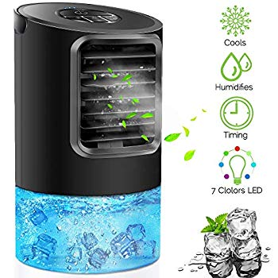Name: **KUUOTE**

Price: 50$

Brand: KUUOTE

Origin: America

Power:

Voltage: 220V

Size: 10.8 x 5.7 x 5.7 Inches

Weight: 2 Pounds

Warranty: 1 Years

Category: Air Conditioner

### Description:

### Features: 3 adjustable speeds A tank of water can continuously spray cooling mist for 3-5 Hours. Humidification function can automatically turn-off when the tank lack of water. Wind outlet blade can be 120° adjusted up and down like air conditioning. Suitable for dressing table, dining table, study desk, office table, computer desk, etc.