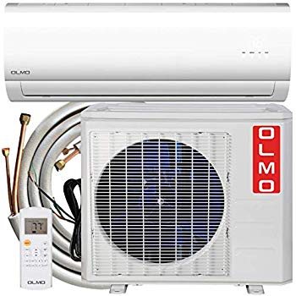Name: **OLMO-OS-12HP115V**

Price: 700$

Brand: OLMO

Origin: America

Power:

Voltage: 220V

Size: 26 x 21 x 10 Inches

Weight: 83 Pounds

Warranty: 1 Years

Category: Air Conditioner

### Description:

PERFECT FOR

BEDROOMS | LIVING ROOMS | DINING ROOMS | HOME OFFICES | SUNROOMS | BASEMENTS | SERVER ROOM