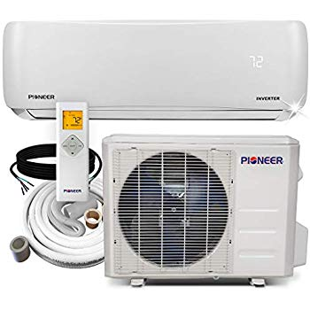Name: **PIONEER-WYS012GMFI17RL**

Price: 748$

Brand: PIONEER

Origin: America

Power:

Voltage: 220V

Size: 31.5 x 7.4 x 11.6Inches

Weight: 19  Pounds

Warranty: 1 Years

Category: Air Conditioner

### Description: For full technical specks and other Information, please refer to the highseer web site. Pioneer newest ways series wall mount mini split ductless Inverter air conditioning and heat pump system. Full system set, containing indoor section, outdoor section, remote controller and standard installation accessories. With a Pioneer ductless mini split type air conditioning system, it is possible to heat or cool any contiguous area, quietly, effectively and efficiently. Pioneer brand ways series ductless split heat pump systems come in a range of capacities; from 9000 BTU/hour to 36000 BTU/hour. Ways is an Inverter system with variable speed compressor, providing very high efficiency levels. Included wireless remote digital controller allows the users easily select among the 4 operating modes; cooling, heating, dehumidification and ventilation. Additionally, an automatic switchover mode is available for totally automatic operation through it's on board computer. A timer function allows the user to set the system to start or stop running at a certain time. Night mode function automatically adopts the temperature settings to the naturally changing body temperature levels during the night. Auto restart function memorizes all settings in case of a temporary power failure and restarts the system to continue running the same way after the power is reconnected. Cloud programmable wireless Internet remote access function is also available. Smart buyers choose Pioneer brand Inverter split systems for their top quality, reliability and performance, available at extremely affordable prices.