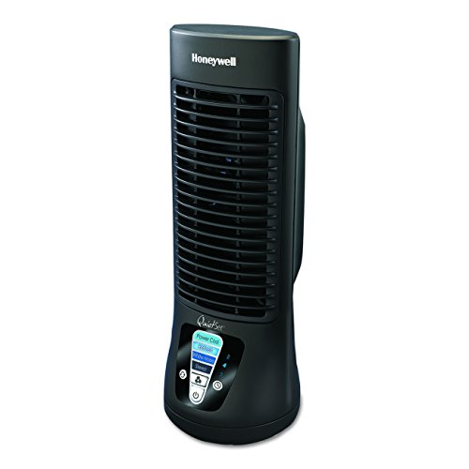Name: Honeywell HTF210B

Price: 20$

Brand: Honeywell

Origin: America

Power:

Voltage: 220V

Size: 5 x 5 x 13 Inches

Weight: 2 Pounds

Warranty: 1 Years

Category: Fan

### Description: The Honeywell QuietSet Mini Tower Table Fan is a slim and compact model that's ideal for cooling small areas of personal space. The aspects of comfort and convenience can be observed with the inclusion of Advanced QuietSet Control that allows owners to personalize sound and cooling power. An easy-touch display and 2-8 hour auto off timer have also been incorporated for increased ease of use. This table fan also carries the additional bonus of saving you up to 50% energy as opposed to AC motors. The slim design of the Honeywell QuietSet Mini Tower Table Fan makes it a natural addition for desktops, nightstands and other areas of personal space.