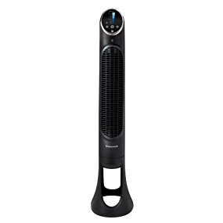Name: Honeywell HYF290B

Price: 50$

Brand: Honeywell

Origin: America

Power:

Voltage: 220V

Size: 10 x 8 x 32 Inches

Weight: 10 Pounds

Warranty: 1 Years

Category: Fan

### Description: Honeywell QuietSet Whole Room Tower Fan!

Quiet Cooling Power!

The slim modern shape of this quiet and powerful whole room fan, paired with the QuietSet technology that allows users to control their sound and cooling options, make it the perfect year-round fan for any home.