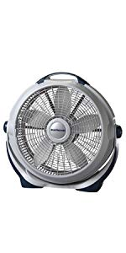Name: Lasko-3300

Price: 30$

Brand: Lasko

Origin: America

Power:

Voltage: 220V

Size: 26 x 24 x 7 Inches

Weight: 10 Pounds

Warranty: 1 Years

Category: Fan

### Description: Lasko’s wind machine features 3 high-performance speeds, providing energy-efficient operation with a pivoting head for directional air power.additional features include: 3 high performance speedspivots to direct air flow & circulationBuilt-in carry handlefully assembledThe slim modern shape of this quiet and powerful whole room fan, paired with the QuietSet technology that allows users to control their sound and cooling options, make it the perfect year-round fan for any home.