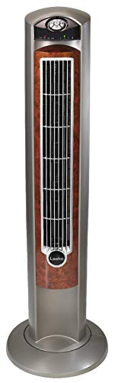Name: Lasko-T42954

Price: 55$

Brand: Lasko

Origin: America

Power:

Voltage: 220V

Size: 13 x 13 x 43 Inches

Weight: 12 Pounds

Warranty: 1 Years

Category: Fan

### Description: The Lasko T42954 Tower Fan is 42. 5” tall with a woodgrain face and grey body. The sturdy plastic base assembles easily with a Philips-head screwdriver, and occupies a 13” x 13” footprint on your floor. This sleek, vertical space saving design allows you to put the fan in small places, where pedestal & box fans won’t fit, without sacrificing air circulation, comfort or style. Powered by 3 quiet speeds, this fan helps you beat the heat. This standing fan delivers excellent air flow but is still quiet enough to hear the TV – even on HIGH. It creates just the right amount of white noise making it ideal for sleeping at night when it’s warm and stuffy. Perfectly sized to aim over a high bed and powerful enough to reach across the room. If you live in the heat with no central air, and window units do a poor job of moving air around your home or apartment, this fan creates excellent air flow and will help make you feel cooler. The fan is portable and easy to operate and comes with remote control, optional oscillation, 7. 5-hr programmable timer and a Nighttime Setting that automatically dims the control display and puts the fan on High for an hour, then Medium for an hour, and then stays on Low until you interact with the fan again. The remote is the best for when you don’t feel like getting up to change the settings.