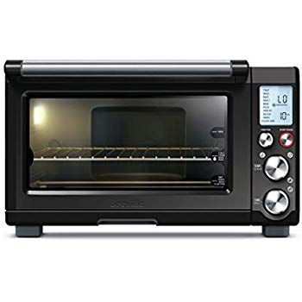Name: **Breville BOV845BKSUSC**

Price: 346$

Brand: Breville

Origin: America

Power:

Voltage: 220V

Size: 18.5 x 14.5 x 11 Inches

Weight: 23 Pounds

Warranty: 1 Years

Category: Oven

Description: The smart oven Pro with element IQ is an essential tool for the cook who desires a countertop oven that bakes the perfect pizza pie, crispy yet chewy cookies, toasts evenly and roasts succulent meat. The convection setting reduces cooking time by up to 30%. Do not place cardboard, plastic, paper, or other flammable materials in the oven