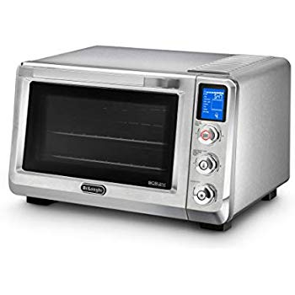Name: **DeLonghi-EO241250M**

Price: 263$

Brand: De'Longhi

Origin: America

Power:

Voltage: 220V

Size: 19 x 17.5 x 12 Inches

Weight: 25 Pounds

Warranty: 1 Years

Category: Oven

### Description: The De'Longhi Livenza Oven, model EO241250M, features a range of cooking and baking settings that focus on performance no matter the culinary task. The Triple Surround Cooking System features three heating areas - upper and lower plus one around the fan - to create a unique "M" shaped design to help distribute heat evenly and efficiently. With 4 different cooking levels and the ability to cook on 2 levels at once using the rack assist guide, the 24L capacity allows you to make multiple recipes without ever having to turn on your traditional, full sized oven. Settings to choose from include bake, convection bake, broil/grill and defrost. You can also choose from unique settings such as fresh or frozen cookie bake and thin, normal or deep dish crust selections for pizza. The Livenza Oven's unique advanced insulation maintains an accurate, consistent cooking temperature on the inside, while staying cooler on the outside. It is the perfect tool to create great tasting recipes like unique appetizers, perfectly broiled steaks, and even apple pie. The double glass door and internal temperature check offer added protection and peace of mind. Additional features include a nonstick interior for a scratch resistant, easy to clean cavity and an auto shut off setting. Comes with two wire racks, bake tray, crumb tray and pizza pan.