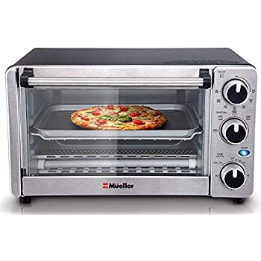Name: **MuellerAustria-MT-175**

Price: 50$

Brand: Mueller Austria

Origin: America

Power:

Voltage: 220V

Size: 17 x 14 x 11 Inches

Weight: 20 Pounds

Warranty: 1 Years

Category: Oven

Description: Making something to eat doesn’t have to be difficult. In fact, with the right appliance it’s quite simple. Enjoy lightly browned and bubbly bruschetta or prepare chicken nuggets for the children in minutes. This compact toaster oven lets you toast golden brown bread slices or cook pizzas with a tender, crispy crust in less time. You can make a variety of foods by easily switching cooking modes with the slide of a lever. No need to heat up the conventional oven, this trusty machine has four functions that will have you cooking in a hurry—bake, broil, toast, and keep warm settings take care of all your cooking tasks. The large window and timer with stay-on functionality allow you to cook exactly to your specifications. The large glass door lets you keep an eye on your food during cooking.