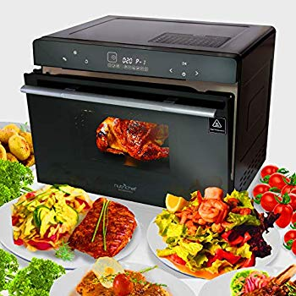Name: **NutriChef PKSTMOVN72**

Price: 280$

Brand: Nutrichef

Origin: America

Power:

Voltage: 220V

Size: 24 x 22 x 20 Inches

Weight: 55 Pounds

Warranty: 1 Years

Category: Oven

Description:

• Multi-Function Kitchen Oven Cooker

• Next Generation Sleek Kitchen Style

• Ability to Air Fry, Steam, Roast & Bake

• Convection Oven Air Circulating Vortex Fan

• Simple Electric Plug-in Operation

• LED Digital Display Screen

• Soft-Touch Digital Button Controls

• Adjustable Time & Temperature Settings

• (8) Preset Cooking Function Modes

• Easy-Refill Water Tray for Steaming

• Pre-Heat ‘Keep Warm’ Ability

• Upper & Lower High-Powered Heating Elements

• Heat-Resistant Glass Door with Flip-Down Access

• Convenient Cooking View Window

• Built-in Oven Lamp

• Smart Automatic Descaling Reminder

• Easy-to-Clean & Stain Resistant Housing