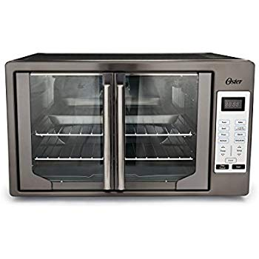Name: **Oster TSSTTVFDDG-DS**

Price: 250$

Brand: Oster

Origin: America

Power:

Voltage: 220V

Size: 20 x 24 x 16 Inches

Weight: 29 Pounds

Warranty: 1 Years

Category: Oven

### Description: With its blend of style and superior performance, the Oster black stainless digital French door oven is the perfect choice for your kitchen's matter your decor. Its innovative finish is warmer and softer than traditional stainless steel, and it requires minimal maintenance to retain a lustrous appearance. Simply wipe with a dry cloth to remove any smudges in seconds. This countertop oven also features two racks for maximum cooking real estate, a durable baking pan and baking rack that can be combined to make a broiler, and a one handed door pulls that open both doors simultaneously. A preheat ready indicator lets you know when your desired cooking temperature has been reached, and the oven's Turbo convection baking results in faster, more evenly cooked food. You can set a cooking duration of up to 90 minutes with the integrated timer, all while getting a clear view of your food thanks to the interior light. When the dish is done and the signal sounds, your oven will automatically turn off, allowing you to grab your meal and remove the crumb tray for easy cleanup.