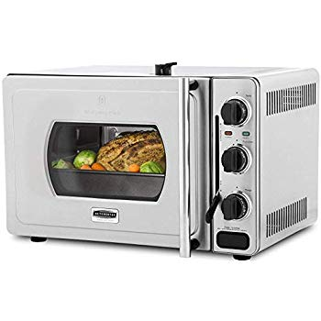Name: **Wolfgang-Puck**

Price: 300$

Brand: Wolfgang Puck

Origin: America

Power:

Voltage: 220V

Size: 20 x 16 x 12 Inches

Weight: 26 Pounds

Warranty: 1 Years

Category: Oven

### Description: Wolfgang Puck WPBROR1002 Pressure Oven