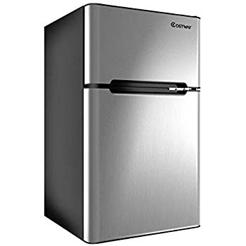Name: **Costway 22672GR-CYEP**

Price: 225$

Brand: COSTWAY

Origin: America

Power:

Voltage: 120V

Size: 22 x 24.5 x 58.5 Inches

Weight: 113 Pounds

Warranty: 2 Years

Category: Refrigerator

### Description:

### 2-Door Design

Our refrigerator includes a freezer and a refrigeration compartment to keep your food and drinks fresh and completely refrigerated.

It is equipped with a cooling compressor for optimum cooling performance.

The compact design is both beautiful and practical. It is perfect for small spaces and small corners, saving you space！

### Large Storage Space

A roomy inside of our fridge features a freezer compartment, two slide-out glass shelves, a storage drawer and can dispensers built into the interior of the door. It offers ample storage space. You can store, refrigerate and freeze food and beverages anytime, anywhere. It's a perfect complement to your home, office and anywhere else.

#### Built in Lamp

The soft lighting makes your vision clear, and you can easily take food or put it in even at night.

#### Adjustable Thermostat

You can use the adjustable thermostat to set the temperature to 32℉to 50℉to keep your food at the desired temperature.

#### Removable Shelves

The two removable shelves are free to adjust the height to meet the storage needs of different foods. And they also offer convenience for cleaning.