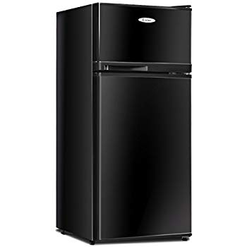Name: **Costway 22756BK-CYPE**

Price: 245$

Brand: COSTWAY

Origin: America

Power:

Voltage: 220V

Size: 17.5 x 17 x 39 Inches

Weight: 42 Pounds

Warranty: 2 Years

Category: Refrigerator

### Description: You can use the adjustable thermostat to set the temperature to -13°F to 50°F to keep your food at the desired temperature. It is easy to operate and can better preserve food.

The small glass shelf is movable and easy to clean. Drinks can be cooled to the coldest touch by the included drip tray. It can bring great convenience to your life.

The crisper drawer is designed for your fruits and vegetables, which always keeps them fresh. And huge capacity is enough to meet your daily needs.