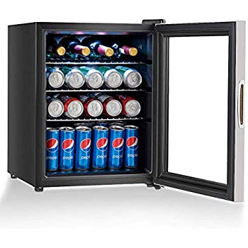

Name: **Costway 23752-CYPE-CS**

Price: 210$

Brand: COSTWAY

Origin: America

Power:

Voltage: 220V

Size: 17 x 17 x 22 Inches

Weight: 40 Pounds

Warranty: 2 Years

Category: Refrigerator

### Description: Keep drinks cool and easily on-hand with the beverage wine center. Our beverage cooler features an attractive double pane glass door with stainless steel frame that allows you to view your wine and beverages at a glance. With 2 adjustable Chrome finished shelves, this 1.73CUFT cooler can make you keep a supply of your favorite soda, beer, water or other beverages chilled. Manual temperature controls let you keep your drinks as cool as you prefer. With its sleek appearance and stainless steel-look frame, this black beverage center is ideal for small space. Don't hesitate to buy it!