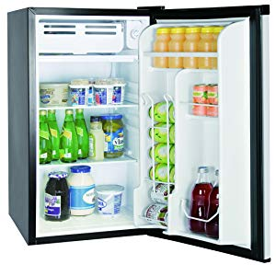Name: **RCA RFR321**

Price: 150$

Brand: Curtis International LTD

Origin: Canada

Power:

Voltage: 120V

Size: 20 x 18 x 32 Inches

Weight: 45 Pounds

Warranty: 2 Years

Category: Refrigerator

### Description: RCA's latest 3.2 Cubic Foot refrigerator is perfect for your college dorm room, bed room, office, and any place you need a compact fridge to keep your food and beverages cold. The fridge is CFC free and has a built in accurate adjustable thermostat so you can keep your food and drinks at the perfect temperature. The sleek tempered glass shelves look great, and are easy to clean. RCA's 3.2 cu. ft. fridge is compressor cooled, meaning it will perform well no matter what the outside and inside temperature is! Within the fridge there is a freezer compartment. The sides of the door sport a very convenient can dispenser and a 2 Liter bottle holder. With a space saving flush back design, the adjustable level feet and a clever reversible door allows you to open the fridge to the right or the left, so you can safely and conveniently place this fridge in any spot! If you are looking for a quality fridge at an affordable price, look no further, this RCA fridge made with decades of experience is one of the most popular on the market and will be perfect for your needs. Do not allow children to hang on the doors; the refrigerator may be tipped over and hurt children.