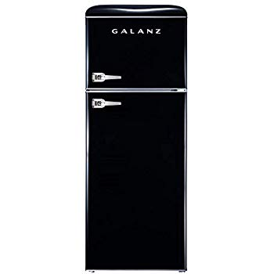Name: Retro-Look

Price: 900$

Brand: Galanz

Origin: China

Power:

Voltage: 120V

Size: 22 x 24.5 x 58.5 Inches

Weight: 113 Pounds

Warranty: 2 Years

Category: Refrigerator

### Description: 7.6 Cu Ft Refrigerator Dual Door True Freezer (RETRO), ESTAR