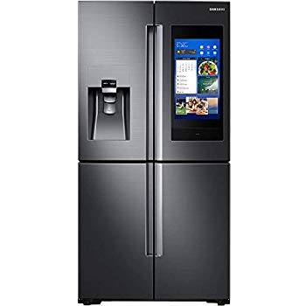Name: **Samsung RF22N9781SG 22 CU**

Price: 3300$

Brand: Samsung

Origin: Korea

Power:

Voltage: 220V

Size: 30 x 45 x 60 Inches

Weight: 150 Pounds

Warranty: 2 Years

Category: Refrigerator

### Description: 22 Cu. Ft. Capacity Family Hub Bixby Voice for Hands-Free Control FlexZone Adjustable Shelves Wine Rack Ice Master Triple Cooling System Wi-Fi Connectivity Filtered Ice and Water Dispenser High Efficiency LED Lighting ENERGY STAR Black Stainless Steel Finish.