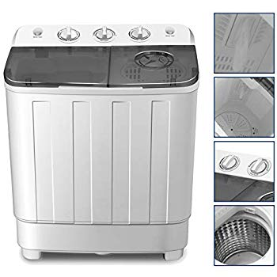Name: **4-Ever-LE**

Price: 127$

Brand: **4-Ever**

Origin: America

Power: 360W

Voltage: 220V

Size: 24 x 14 x 29 Inches

Weight: 29 Pounds

Warranty: 1 Years

Category: Washer

### Description: Our washing machine is a new semi-auto washing machine, half laundry, half dehydrated. Its large capacity design make you surprise, washing clothes is no longer a chore. Compact size-ideal for dorms, apartments, RV’s, camping and more. Eco-friendly design-less water and detergent used which leads you for money saving.