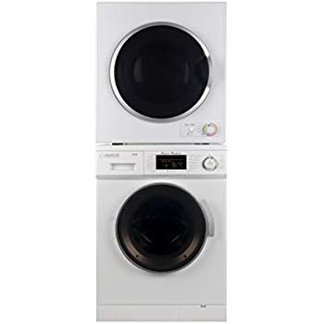Name: **Equator-EW824N-ED850**

Price: 1470$

Brand: Equator

Origin: America

Power:

Voltage: 220V

Size: 33.5 x 23.5 x 22 Inches

Weight: 40 Pounds

Warranty: 1 Years

Category: Washer

### Description: This Set is an upgraded version. The front-loading machine has 12 programmable features that enable it to stand proudly alongside larger counterparts. The 13 lb. load capacity cleans small loads efficiently, with minimal water and electricity usage. At only 33.5 x 23.5 x 22 inches (HxWxD), this washer fits easily into small homes, apartments or anywhere, where space is an issue. The 850 dryer maximizes your laundry efficiency, without compromising drying speed or design. At just 26.5 x 23.5 x 21.5 inches (HxWxD) when stacked, this compact machine is built to fit into the smallest spaces. With a door safety switch, 180-degree opening door and premium steel drum, you can rest assured that your dryer is built with your family’s safety and convenience in mind.