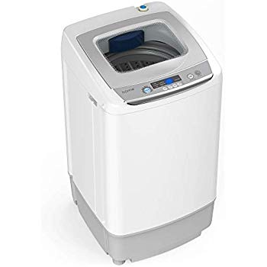Name: **hOmeLabs-HME030238N**

Price: 210$

Brand: **hOmeLabs**

Origin: America

Power: 1400W

Voltage: 120V

Size: 23.3 x 18 x 27.2 Inches

Weight: 48.5 Pounds

Warranty: 1 Years

Category: Washer

### Description: Quick Connection to Most Faucets

You don't need to be a plumber to use this washing machine. For most applications you will just remove the aerator from your faucet and then screw on the quick adapter. With the quick adapter installed you will connect your inlet hose and turn on your faucet, adjusting to the desired temperature. You will keep your faucet on through the entire wash cycle.