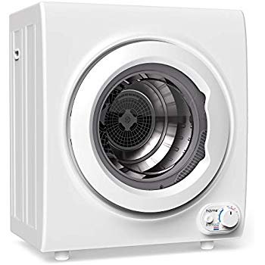Name: **hOmeLabs-HME030239N**

Price: 270$

Brand: **hOmeLabs**

Origin: America

Power: 1400W

Voltage: 120V

Size: 17.9 x 23.3 x 27.2Inches

Weight: 48.5  Pounds

Warranty: 1 Years

Category: Washer

### Description: Compact Size, Full-Featured Laundry Dryer

We've designed our hOmeLabs laundry dryer for those in apartments, dorms or RVs who are tired of air drying their clothes but don't need or want a full-size machine. At just 23.28 x 17.91 x 27.16 inches our electric front-loading dryer fits neatly in any small space while still packing 1400 watts of drying power. This is enough power to handle up to 9 pounds of laundry to perfectly dry your clothes, sheets and dedicates.

### 