Configure IP Address
Command:
ip a
Or
hostname -I
(Write down the IP address)
• Server 1: 10.190.139.4
• Server 2: 10.190.139.5
• Server 3: 10.190.139.6
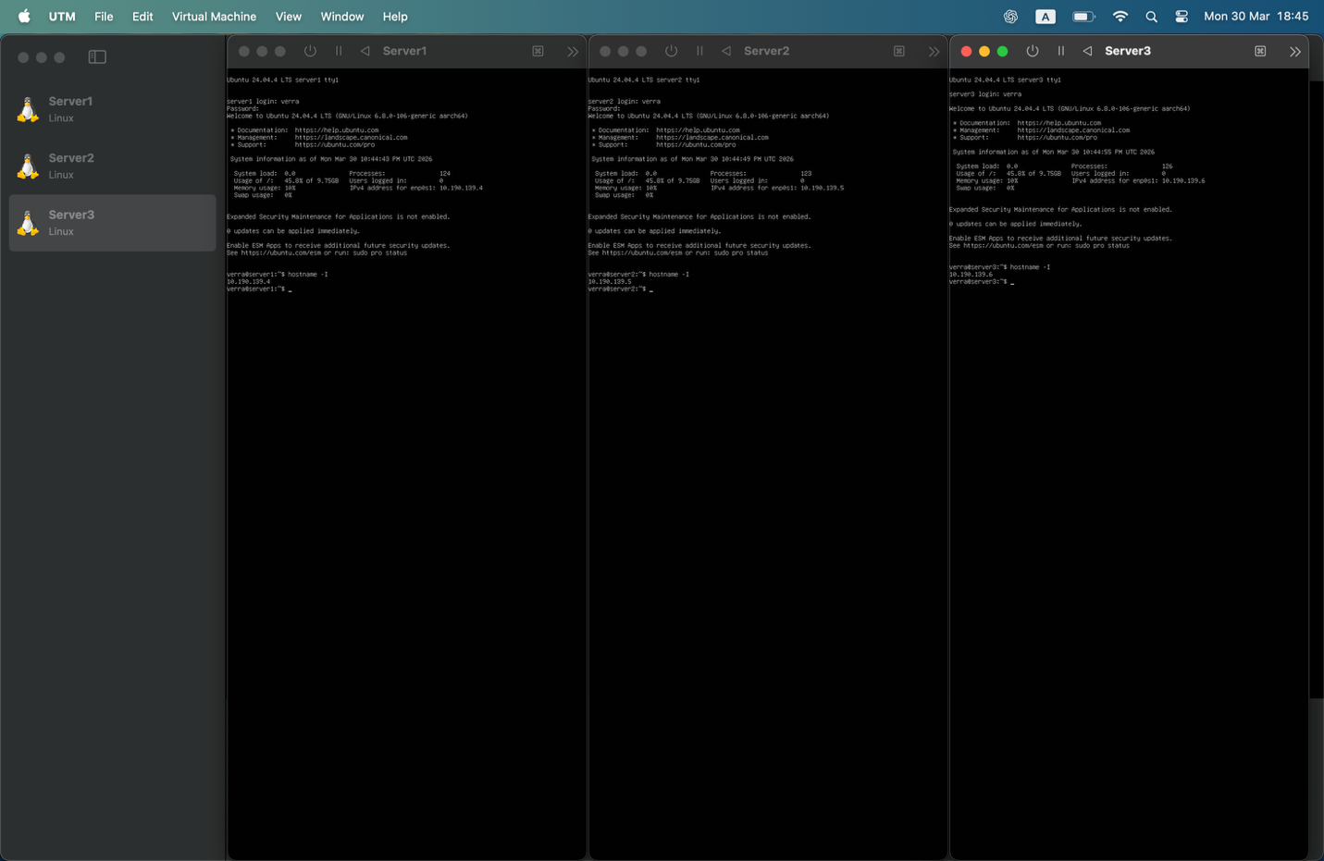

Test Connectivity
From server 1 to server 2
Command:
ping -c 4 10.190.139.5
Reverse:
ping -c 4 10.190.139.4
From server 1 to server 3, and reverse
ping -c 4 10.190.139.6 (on S1)
ping -c 4 10.190.139.4 (on S3)

