Tên: Phạm Thị Minh Phi_1150070033

LẬP TRÌNH DI ĐỘNG

Bài Tập Lap3

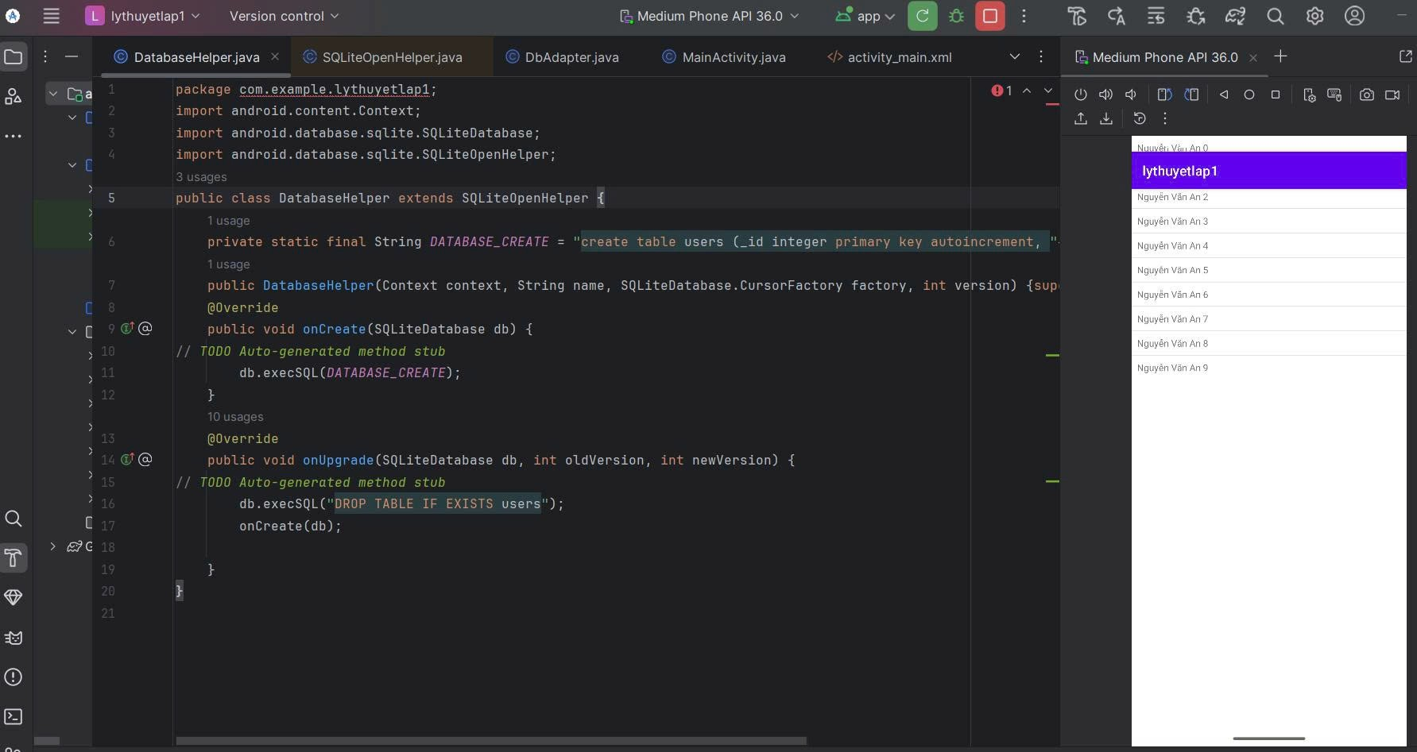

Code:

package com.example.lythuyetlap1;

import android.content.Context;

import android.database.sqlite.SQLiteDatabase;

import android.database.sqlite.SQLiteOpenHelper;

public class DatabaseHelper extends SQLiteOpenHelper {

private static final String DATABASE_CREATE = "create table users (_id integer primary key autoincrement, "+ "name text not null);";

public DatabaseHelper(Context context, String name, SQLiteDatabase.CursorFactory factory, int version) {super(context, name,factory, version);}

@Override

public void onCreate(SQLiteDatabase db) {

// TODO Auto-generated method stub

db.execSQL(DATABASE_CREATE);

}

@Override

public void onUpgrade(SQLiteDatabase db, int oldVersion, int newVersion) {

// TODO Auto-generated method stub

db.execSQL("DROP TABLE IF EXISTS users");

onCreate(db);

}

}

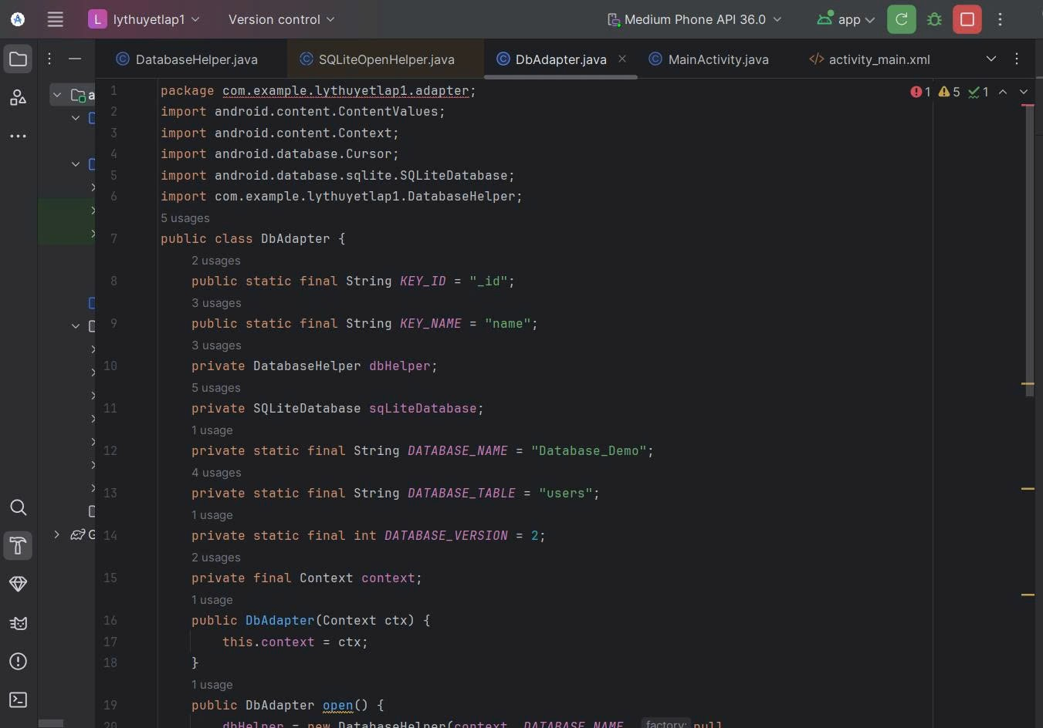

package com.example.lythuyetlap1.adapter; import android.content.ContentValues; import android.content.Context; import android.database.Cursor; import android.database.sqlite.SQLiteDatabase; import com.example.lythuyetlap1.DatabaseHelper; public class DbAdapter { public static final String KEY_ID = "_id"; public static final String KEY_NAME = "name"; private DatabaseHelper dbHelper; private SQLiteDatabase sqLiteDatabase; private static final String DATABASE_NAME = "Database_Demo"; private static final String DATABASE_TABLE = "users"; private static final int DATABASE_VERSION = 2; private final Context context; public DbAdapter(Context ctx) { this.context = ctx; } public DbAdapter open() { dbHelper = new DatabaseHelper(context, DATABASE_NAME, null, DATABASE_VERSION); sqLiteDatabase = dbHelper.getWritableDatabase(); return this; } public void close() { dbHelper.close(); } public long createUser(String name) { ContentValues inititalValues = new ContentValues(); inititalValues.put(KEY_NAME, name); return sqLiteDatabase.insert(DATABASE_TABLE, null, inititalValues); } public boolean deleteUser(long rowId) { return sqLiteDatabase.delete(DATABASE_TABLE, KEY_ID + "=" + rowId, null) > 0; } public boolean deleteAllUsers() { return sqLiteDatabase.delete(DATABASE_TABLE, null, null) > 0; } public Cursor getAllUsers() { return sqLiteDatabase.query(DATABASE_TABLE, new String[]{KEY_ID, KEY_NAME}, null, null, null, null, null); } }

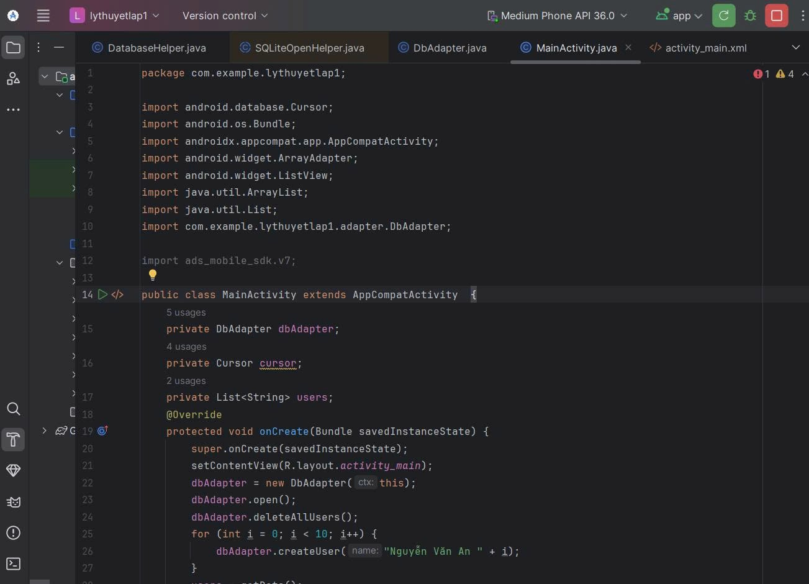

package com.example.lythuyetlap1;

import android.database.Cursor;

import android.os.Bundle;

import androidx.appcompat.app.AppCompatActivity;

import android.widget.ArrayAdapter;

import android.widget.ListView;

import java.util.ArrayList;

import java.util.List;

import com.example.lythuyetlap1.adapter.DbAdapter;

import ads_mobile_sdk.v7;

public class MainActivity extends AppCompatActivity {

private DbAdapter dbAdapter;

private Cursor cursor;

private List<String> users;

@Override

protected void onCreate(Bundle savedInstanceState) {

super.onCreate(savedInstanceState);

setContentView(R.layout.activity_main);

dbAdapter = new DbAdapter(this);

dbAdapter.open();

dbAdapter.deleteAllUsers();

for (int i = 0; i < 10; i++) {

dbAdapter.createUser("Nguyễn Văn An " + i);

}

users = getData();

showData();

}

private List<String> getData() {

List<String> users = new ArrayList<>();

cursor = dbAdapter.getAllUsers();

while (cursor.moveToNext()) {

users.add(cursor.getString(cursor.getColumnIndex(DbAdapter.KEY_NAME)));

}

return users;

}

private void showData() {

ListView lvUser = (ListView) findViewById(R.id.lv_user);

ArrayAdapter<String> userAdapter = new

ArrayAdapter<String>(MainActivity.this, R.layout.item_user, users);

lvUser.setAdapter(userAdapter);

}

}

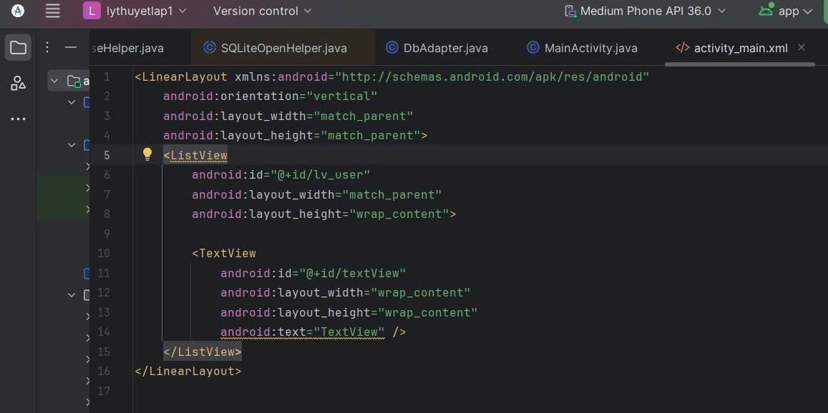

<LinearLayout xmlns:android="http://schemas.android.com/apk/res/android"

android:orientation="vertical"

android:layout_width="match_parent"

android:layout_height="match_parent">

<ListView

android:id="@+id/lv_user"

android:layout_width="match_parent"

android:layout_height="wrap_content">

<TextView

android:id="@+id/textView"

android:layout_width="wrap_content"

android:layout_height="wrap_content"

android:text="TextView" />

</ListView>

</LinearLayout>

KẾT QUẢ:

