Review on Facial Expression Recognition System Using Machine Learning Techniques

Amreen Fathima(&) and K. Vaidehi

Department of Computer Science and Engineering,

Stanley College of Engineering and Technology for Women, Abids,

Abstract. Facial expressions are the most convenient way of expressing ones thoughts. The aim facial expression recognition (FER) algorithm is to extort the discriminative and distinguishable characteristic of a face. Multiple methods have been devised to identify face and facial expression. Facial expressions not only depict the feelings of any individual but it is also used to judge his/her intellectual views. This paper not only includes the introduction of the face detection and facial expression recognition but also provide an exploration on the recent previous researches to extract the useful and capable method for facial expression recognition. The identi *fi*cation of various facial expressions are done through geometric features, appearance features and hybrid features. This paper presents a literature summary of the various strategies used for facial expression reputation. The comparative study is also carried out using various preprocessing, feature extraction and classi *fi*cation techniques used for facial expression recognition.

Keywords: Face detection Facial expression recognition

Feature extraction  Classi *fi*cation

# Introduction

Sirovich and Kirby introduced the foremost facial recognition method in 1988. Initially they apply linear algebra to the crisis of facial identi *fi*cation, which is known as the Eigen face method and started as a research for a lowdimensional representation of facial images. Facial expression is most commanding, likely and extreme means of human beings to communicate their feelings and intentions. The facial expression contains one or more action or position of the muscles beneath the skin of the face [1]. The one set of divisive theory, these actions expresses the emotional state of an human being to observe. Facial expression is one of the most frequent nonverbal ways that humans exploit to convey their internal emotional states and consequentially, plays a major role in interpersonal communications. The Facial Expression is a visible manifestation of the affective state, cognitive activity, intention, individuality and psychopathology of a person.

The nonverbal statement technique by which one can understand the state of a human being is the expression of face like happy, sad, fear, disgust, surprise and anger.

Automatic facial expression recognition (FER) has become an attractive and demanding area of the computer visualization  *fi*eld and its application areas are not limited to intellectual state identi *fi*cation, security, regular therapy system, face expression fusion, lie detection, music for mood, automated training systems, operator fatigue detection etc.

The preliminary form of a computer application is seen in portable platform and in other forms of technology, such as robotics. It is classically used as access control in security systems and can be compare to other biometrics such as  *fi*ngerprint, iris recognition systems, and gait. The truth of the face identi *fi*cation system as a biometric technology is lesser than iris recognition and  *fi*ngerprint recognition, it is widely taken due to its contactless and noninvasive process. The facial expression becomes popular as a commercial detection and a marketing device. The further applications include advanced humancomputer interaction, video surveillance, automatic indexing of images, and video database. The key bene *fi*t of FER is capable to know person mass classi *fi*cation as it does not require the collaboration of the test subject to work. The system installed in the airport, banks and other public places can recognize individuals among the crowd, without passerby even being aware of the system.

Emotions have a great control on every human being in one or additional way. The feelings of humans are represented in many ways, such as facial expression, voice and body gesture. The facial expressions are one of the most signi *fi*cant methods of nonverbal communication especially in human. The movement of one or more than one muscles underneath the skin constitutes facial expression. The facial expressions are the facial change in response to a persons internal emotional state, intention or communications [2]. It is the most observable and powerful sign of emotional state of mind. FER plays a vital role in Human Computer Interaction. Computer visualization system can interrelate with a human by interpreting facial expression in a normal way. Six major facial expressions are accepted universally such as sad, fear, disgust, happy, surprise neutral and anger which is shown in Fig. 1.

In the facial recognition system quality measures are the important factors as large degrees of variations are possible in face images. The factors such as illumination, expression, pose and noise, affects the performance during the capturing of the image in facial recognition systems [3]. The facial recognition is the most accurate system among all the biometric system which used in railway stations and airports. The FER system is a technology which is capable of identi *fi*cation or veri *fi*cation of a person from a digital image. There are multiple methods in which facial recognition systems work, but generally they work by comparing the selected facial features from given image with the faces of the person within the database. It is also called as a biometric arti *fi*cial intelligence based application that can individually identify a person by evaluating patterns based on the persons facial textures and shape.

It is a computer application for recognizing the facial expressions of any person either using an image or a video clip or the person itself. A Facial recognition is generally used for security purposes. Facial expressions recognition is still an activeopen research  *fi*eld of machine learning. It has several existing applications in various areas. The fully automatic and real time facial expression systems helps in understanding nonverbal facial gestures used in different applications like behavioral research, videocalling, computer vision systems health care, games and elearning.

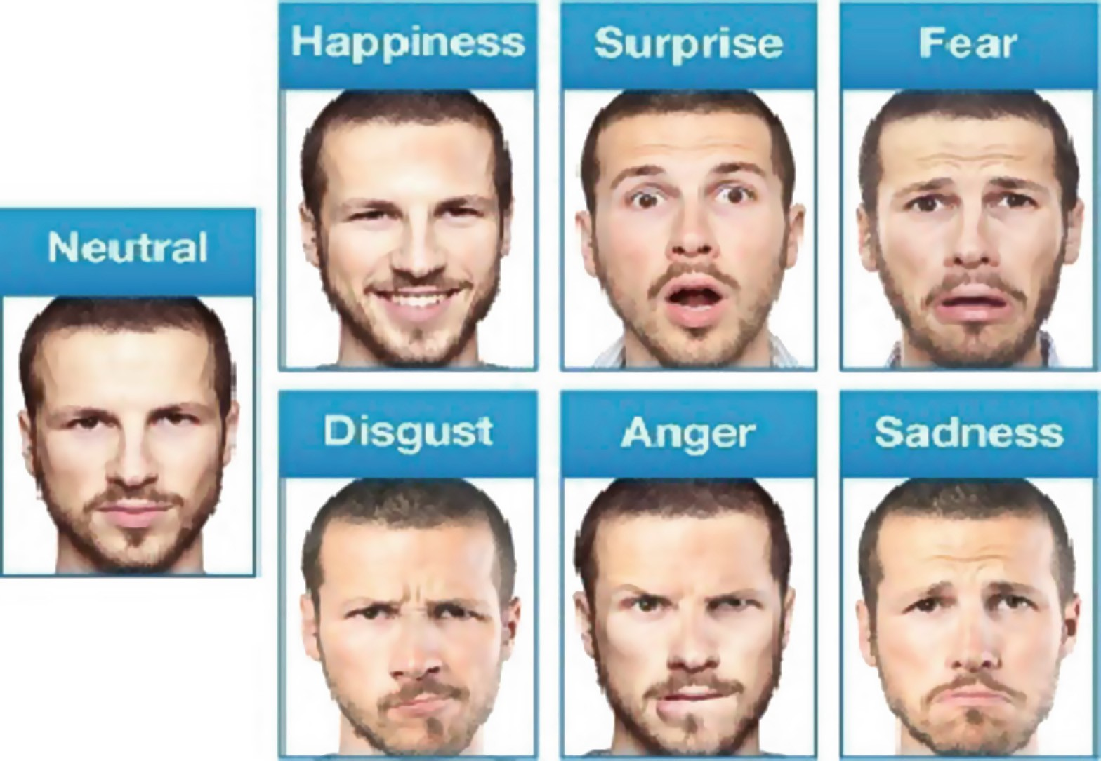

Fig. 1. Different facial expressions

The technique used for recognizing a facial expression are face detection, feature extraction and expression classi *fi*cation [4].

Face Detection: The preprocessing step for identifying facial expression is face detection. The steps implicated in converting an image to a normalize facial image for facial characteristics extraction which is used for detecting characteristic points, locating, rotating to line up and cropping the face region using a rectangle, according to the face model. The face detection involves methods for classifying faces in a single image.

Feature Extraction: Feature extraction change pixel data into a higher level representation of shape, motion, color, texture, and spatial input space. The reduction process should uphold essential information as it is an important task in pattern identi *fi*cation system. Various techniques are used for feature extraction.

Expression Classi fication: Expression classi *fi*cation is performing by a classi *fi*er, which consists of model of pattern sharing which is attached to a decision procedure. To recognize expressions various classi *fi*cation techniques are used.

# Review on Databases Used for Facial Expression Recognition

FER Database

In the  *fi*eld of FER [5], frequent databases have been used for relative and extensive experiments. The 2D static images or 2D video sequence are used to calculate human

facial emotions. A 2Dlarge pose variation and facial behaviors has the complexity in handling 2D based examinations. It briefly introduces some accepted databases related to FER consisting of 2D and 3D video sequence and motionless images.

The Extended Cohnkanade Dataset (CK+): CK+ [6] contains both posed and nonposed emotion, and 593 video sequences along with added types of metadata. The database consist of 123 subjects from 18 30 years, most of them are female. Prototypes and action units are used to measure and analyze the image. It provides results for protocol and baseline emotion recognition, AUs, and facial feature tracking. The image

has a pixel resolution of 640 480 and 640 490.

Japanese Female Facial Expressions (JAFFE): The JAFFE database [7] contains 213 images of seven facial emotions (six basic facial emotion and one neutral) posed by ten different female Japanese models. Each image is based on six emotions using 60 Japanese person images. The original size of each facial image is 256 pixels 256 pixels (Fig. 2).

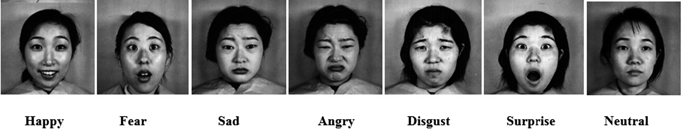

Fig. 2. Sample Images from JAFFE Database

# Literature Review

Banu, Danciu et al. [8], implemented a novel approach for face expression recognition. In this work the face features are extracted by means of Haar classi *fi*ers with openCV library. The faces are rotated so that the lines which are connected to the eyes are kept parallel. The exact eye curve is recognized and approximated this curve by using bezier curve. The pixels are eliminated on behalf of the skin. The three features for each eye and two feature of mouth is extracted. The facial appearance is extracted and classi *fi*ed by means of neural networks. The facial expressions are separated into moduleby using Kmeans categorization.

Zhen, Zilu et al. [9] FER based on adaptive local binary pattern and sparse representation (SRC) approaches are used in this work. SRC algorithm is helpful to both the gray expression images and ALBP features of appearance images. The facial appearance is detected by using GRAY + SRC and ALBP + SRC methods. Initially input the matrix of instruction samples for k classes. Reshape the instructionsample by using GRAY + SRC and test the sample of the vectors by stacking its column, then calculate the categorization by using SRC. When the categorization results of GRAY + SRC and ALBP + SRC algorithms are the same then the  *fi*nal class label remains unaffected. The categorization is done based on the SVM, LDA, KPCA classi *fi*ers.

Deepthi, Archana et al. [10] implemented FER using Arti *fi*cial Neural Networks. Image processing techniques is used to improve, develop or modify an image and to get ready it for image analysis. It is divided into many sub process, including histogram analysis, thresholding, masking, edge detection, segmentation and others. A 2D DCT is used for feature extraction and neural network is used like a classi *fi*er by using JAFFE database.

Liu, Song et al. [11] implemented FER based on discriminative dictionary learning. Preprocessing is done by using gray value feature and local binary patterns. Gray value features are applied in the conventional SRC based face detection. FER experiments are also conducted by means of gray value facial appearance as a baseline. A local binary pattern (LBP) is an ef *fi*cient texture explanation operator and can measure and extort the texture information on the local neighborhood in gray images. The LBP methods calculate each pixel of the image and the binary association of local neighborhood points on the grayscale. Then the binary relationship weighted to form the LBP code. Finally, the LBP histogram series of image subregion can be regard as the image characterization. Gabor has applied widely in image analysis for its outstanding description of texture. Hence, in this work used  *fi*vescale, eightdirection Gabor  *fi*lters. It is also used to extract facial features. Gabor  *fi*lter is used for feature extraction and SRC (DKSVD) is used as a classi *fi*er by using JAFFE database.

Punitha, Geetha et al. [12] implemented HMM based real time facial expression recognition. Face region isidenti *fi*ed by using HMM such as mouth which plays an important role in expressing feeling and its facial appearance which is used for classifying expressions. The mouth concentration code value (MICV) extracted from the mouth region is used. The MICV difference between the  *fi*rst and the greatest facial appearance intensity frame is used as an input to a Hidden Markov Model (HMM) and HMM is used as a classi *fi*er, with the own created dataset and achieved 94% accuracy. Zhang, Liu et al. [13] implemented the FER using LBP and LPQ based on the Gabor wavelet transform. The preprocessing is done by using LBP and LQP. Gabor  *fi*lter is used for feature extraction. PCA and LDA is used to reduce dimensions of features by Gabor LBP feature and Gabor LPQ features Multi class SVM classi *fi*er is

used for classi *fi*cation by using JAFFE database. The accuracy obtained is 98%.

Shah, Khanna et al. [14] implemented FER for Color Images using Gabor, Log Gabor Filters and PCA.. Gabor  *fi*lters are used to extract the features from the images. The features are detected to extract the feature vector by using Gabor and Log Gabor  *fi*lter. Dimensions are reduced to extract features by using Principle Component Analysis (PCA). The Euclidian distance is used to classify the reduced features. The selfdatabase is used for testing with an accuracy of 86.7%.

Lajevardi, Husain et al. [15] implemented Feature extraction for facial expression recognition based on hybrid face regions. A FER system is built based on hybrid face regions (HFR). Using Log Gabor  *fi*lter features are extracted based on whole face image and face region. Principle component analysis PCA, mutual information MI and independent component analysis ICA is used for feature extraction. Naive Bayes is used as a classi *fi*er. JAFFE database and Cohnkanade database are used for testing with an accuracy of 97% and 91% respectively.

Rejila, Menon et al. [16] implemented Automatic Facial Expression Recognition based on the Salient Facial Patches. PCA and LDA are used for feature extraction by

generating a high dimensional feature vector. The database used inthis work is JAFFE database. SVM and ANN are used for classi *fi*cation of the data. The accuracy obtained is 97%. The low resolution images give the best images.

ELLaban, Ewees, Elsaeed et al. [17] implemented A RealTime System for Facial Expression Recognition using Support Vector Machines and *k*Nearest Neighbor Classi *fi*er. The preprocessing is done by using ViolaJones approach. Gabor, PCA are used for feature extraction. SVM and KNN classi *fi*ers are used for classi *fi*cation of the features extracted. The accuracy we achieve by testing the selfdatabase using SVM is 90%. SVM outperformed than KNN.

Hernansez Matamoros et al. [18] implemented facial expression recognition with automatic segmentation of face regions. Appearance based is done for preprocessing and gabor functions are used to extract the features. Classi *fi*cation is done by using SVM classi *fi*er and achieved 99% accuracy.

Sumathi, Santhanam and Mahadevi et al. [19] implemented, Automatic Facial expression analysis using Facial Action Coding System(FACS) action units and the methods which recognize the action units parameter using facial expression data that are extracted, various kinds of human facial expressions are recognized based on their geometric facial appearance, and hybrid features. The two essential concepts of extracting features are based on facial deformation and facial motion by using RUFACS record achieved good accuracy. Siddiqi, Ali et al. [20] implemented Depth CameraBased Facial Expression Recognition System Using Multilayer Scheme, Depth camera, Principal component analysis, Independent component analysis, Linear discriminate analysis, Hidden Markov model are the techniques used. A hierarchical classi *fi*er was used, where the expression group was recognized at the  *fi*rst level, followed by the actual expression recognition at the second level, achieved animportant improvement in accuracy 98.0%.

Lee, Uddin and Kim et al. [21] implemented Spatiotemporal Human Facial Expression Recognition Using Fisher Independent Component Analysis and Hidden Markov Model. Cohnkanade database is used to detect features. The FICA Fisher Linear Discriminant (FLD) is used for feature extraction based on a class speci *fi*c learning algorithm. The idea of this method is to  *fi*nd a best local presentation of face images in a low dimensional space and to acquire the feature space having also temporally evolving shape. The hidden markov model is used for classi *fi*cation by using cohnkanade database and achieved 92% accuracy.

# Proposed System

The methodology requires preprocessing, feature extraction, classi *fi*cation after face detection and using a strong classi *fi*er.

Steps:

1. Image preprocessing: Image preprocessing implies the operation done on any image prior to using it for either training or testing. This process is essential in the view to remove the local variations present in an image and thereby improving feature extraction process.
2. Feature extraction: Every speci *fi*c patterns has some invariable features. It includes color, shape, dimension and many others attributes which can be easily seen. Features of every patterns are different from others because of these features that every patterns.
3. Classi fication: SVM is used as a classi *fi*er.

It is based on simple ideas of hyper plane and leads to high performance in practical application.

# Comparitive Study on Various Methods for FER

Comparision Between Merits and Demerits of the Related Work

# Conclusion

This paper has reviewed on facial expression recognition system. FER used in many applications such as medical, lie detection, cognitive activity, robotics interaction, forensic section, automated training systems, security, intellectual state identi *fi*cation, music for mood, operator fatigue detection, etc. The publically available FER databases are explained in this paper. The technique used for recognizing a facial expression are face detection, feature extraction and expression classi *fi*cation. Hence, various feature extraction and classi *fi*cation techniques used by researchers for FER is compared. According to the comparative analysis Gabor function with SVM classi *fi*cation method provides 99% accuracy and it recognized the several expressions such as happy, smile, sad, anger, fear, neutral. Most of the previous work has done with CK + and JAFFE databases.