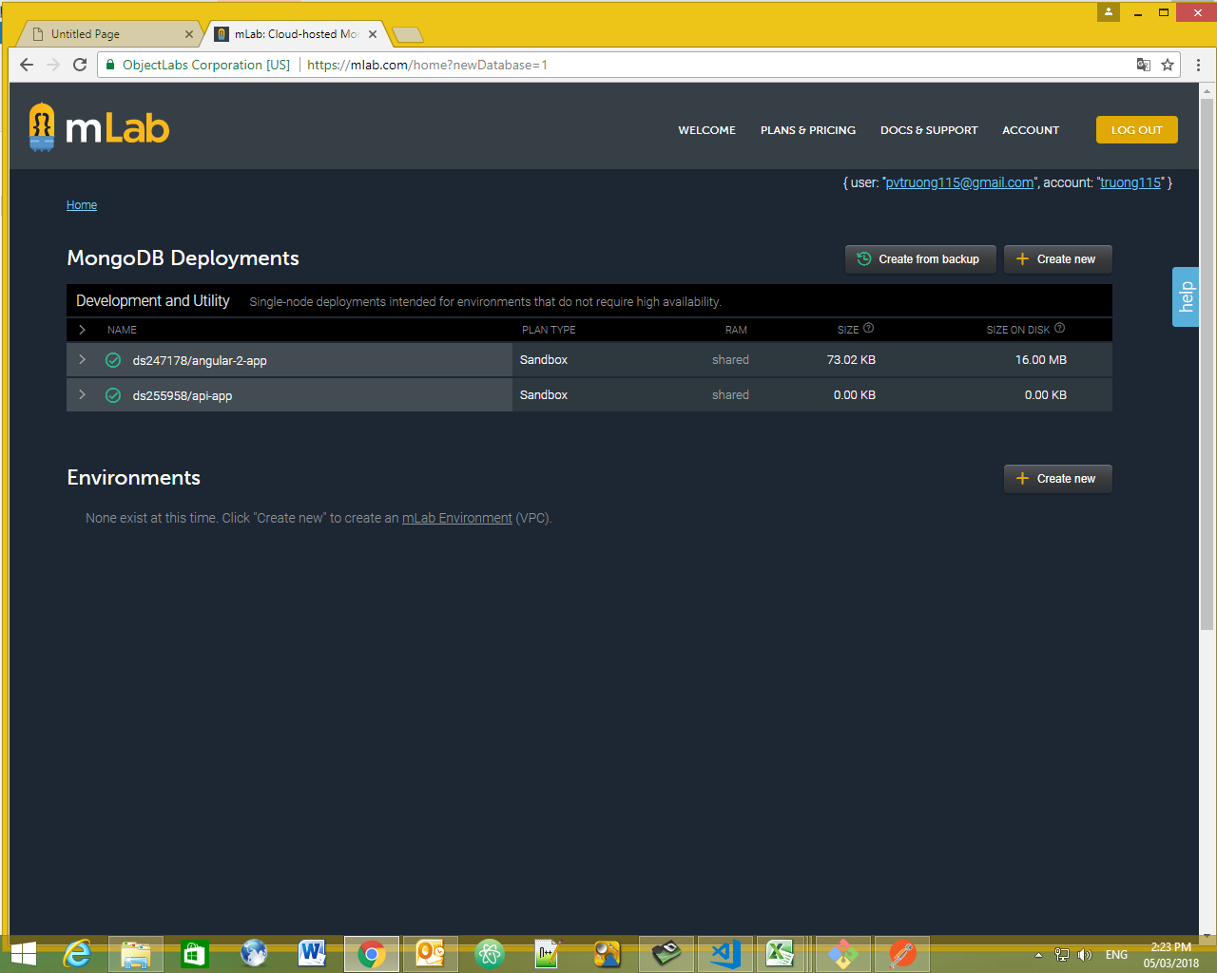

{

"email": "test4@test.com",

"password": "tester"

}