PROJECT ON

Developed by

Name: Ngo Xuan Binh Name: Phi Trung Duc

Reg. No: Reg. No:
GroupFund Bank

Batch Code : B010101
Start Date : May 12, 2011
End Date : May 19, 2011
Name of the Coordinator : Mr. Pham Tuan
Name of Developers : Ngo Xuan Binh
Phi Trung Duc

Date of Submission : May 26, 2011

CERTIFICATE

This is to certify that this report, titled GroupFund Bank, embodies the original work done by Ngo Xuan Binh and Phi Trung Duc in partial fulfillment of their course requirement at NIIT.

Coordinator : Mr. Pham Tuan
ACKNOWLEDGEMENT

We have benefited a lot from the feedback and suggestions given to us by Mr. Pham Tuan and other faculty members.
SYSTEM ANALYSIS

System Summary: GroupFund Bank queue system is an Internet-based application. It will generate a coupon number for each customer visiting the bank. The different customer service desks will cater to the different needs of the customers.
There are three types of users:
- Administrator: Will be responsible for maintaining master data
- Banking Officers: Will be responsible for interacting with the customers, and increse ticket number after a customer is servered.
- Customers: Will be responsible to obtain a new ticket number
All users have themselves username and password. They can retrive lost password by providing certain authenticated information such as their date of birth.
INDIVIDUAL PROJECT SCHDULE
S. No. | Activity Description | Planned Date of Completion | Actual Date | Responsibility | Remarks
1
TECHNOLOGY DIAGRAM

This top-level diagram represents the technologies used to develop a J2EE Web applications.

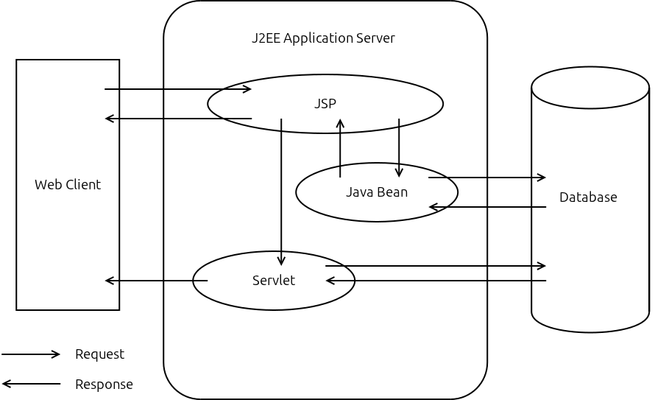

USE CASE DIAGRAM

This use case diagram represents the functional relationship among the various entities in the system.
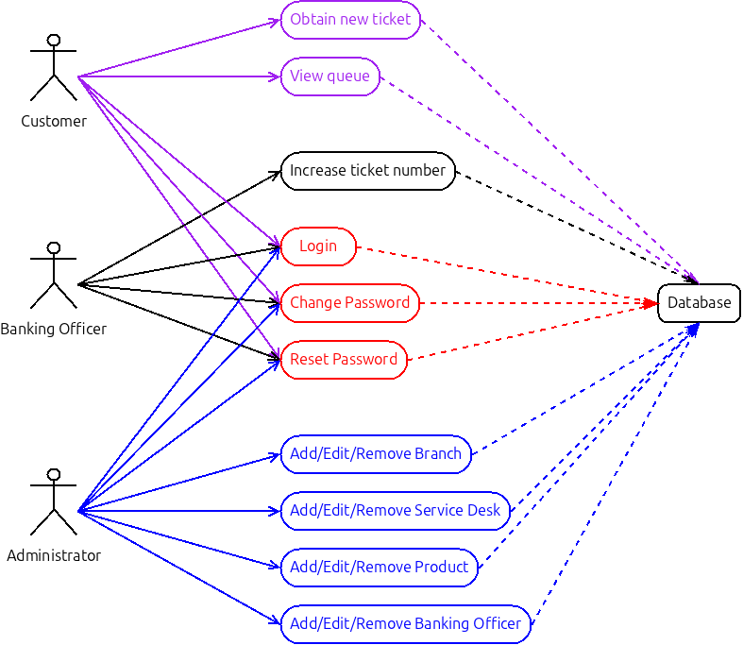
E-R DIAGRAM

Database Name : GroupFund
This E-R diagram represents the relationship among the various entities of the database.
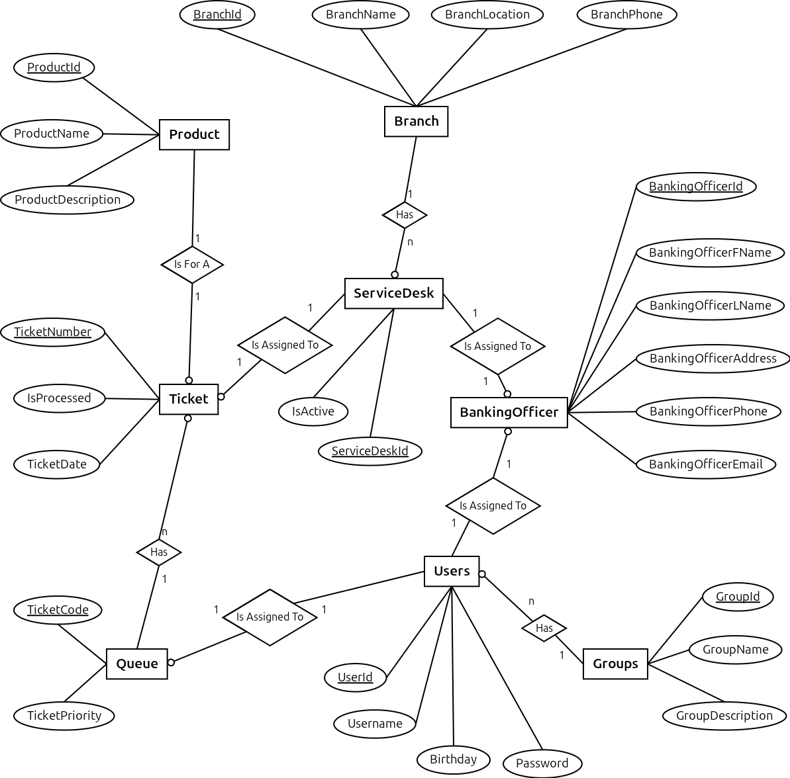
SCHEMATIC DIAGRAM
OF THE DATABASE

Database Name : GroupFund

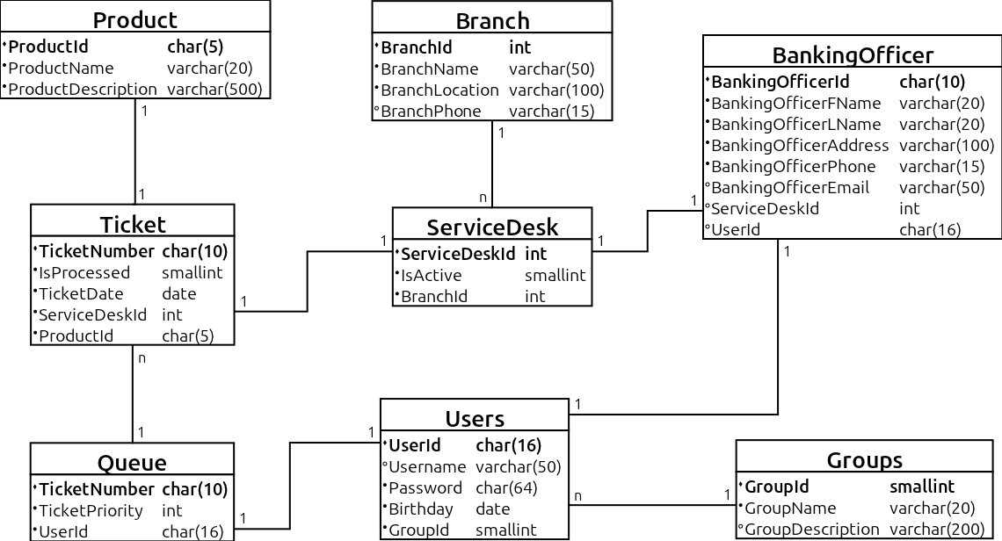

LOGICAL FLOW DIAGRAM

The logical flow diagram represents the control flow of the GroupFund- Bank application.

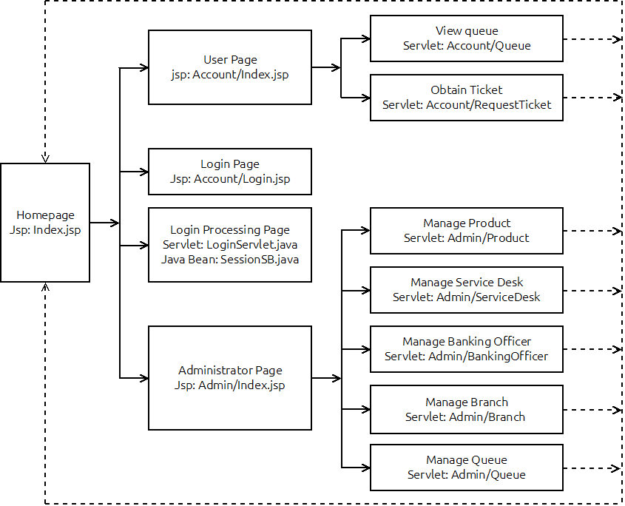
CONFIGURATION

Hardware : PC compatible with a Intel Core i3 processor, 2 GB RAM, and 320GB of Hard- disk
Operating System : Ubuntu 11.04 Natty Narwhal
Software : Netbeans IDE 7.0 bundled, JDK1.6.21
PROJECT FILE DETAILS
S. No. | File Name | Remarks
1 | Index.jsp | Home page
2 | Account/Index.jsp | User home page
3 | Account/Login.jsp | Display login form
4 | LoginServlet.java | Process login request
5 | SessionSB.java | Process session
6 | Account/Logout.java | Process logout request
7 | Queue/Queue.java | Display queue
8 | Queue/RequestTicket.java | Given a tiket to a customer
9 | Ultilities/Encryption.java | Encrypt/ Decrypt string data
10 | Ultilities/Hash.java | Hash password
11 | Admin/Index.jsp | Admin home page
12 | Admin/Branch.java | Manage branch, such as add, update or delete
13 | Admin/Product.java | Manage product, such as add, update or delete
14 | Admin/ServiceDesk.java | Manage service desk, such as add, update or delete
15 | Admin/BankingOfficer.java | Manage banking officer, such as add, update or delete
16 | Admin/Queue.java | Delete ticket from queue when customer is served
17 | Error.java | Display error

