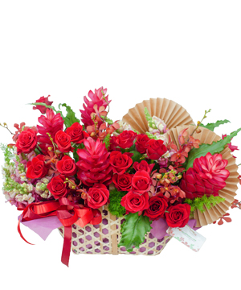

## Thanks Flowers – Charming Basket - 19

**$48.89**

*Price include VAT - This product does not support free shipping*

#### Product includes:

* Cẩm chướng chùm đỏ : 3
* Cẩm chướng đơn đỏ : 3
* Hồng đỏ sa : 2
* Hướng dương : 2
* Lan Moka đỏ: 3
* Red Elegance : 3

*The actual product received may differ from the image shown on the website (due to handmade characteristics and the natural properties of agricultural products)*

#### SPECIAL OFFER

* Free Cards
* Discount 1$ - 5$ For Online Purchases
* Discount 3% For The 2nd Online Order, 5% For The 6th Online Order And 10% For The 12th Online Order (Applied In Ho Chi Minh City And Hanoi)
* Free Delivery In Canter Areas
* Fast Delievery In 2 Hours
* Guarantee 100% Customer Satisfaction Or We Will Refund
* Guarantee Flowers Stay Fresh In 3 Days