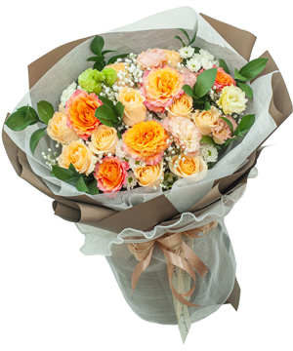

## Birthday flowers - Story of the sun - 4

**$33.33**

*Price include VAT - This product does not support free shipping*

#### Product includes:

* Cát tường nhật hồng: 1
* Cúc rossi trắng: 4
* Free Spirit Rose (10): 6
* Hoa baby : 1
* Hồng trứng gà : 10

*The actual product received may differ from the image shown on the website (due to handmade characteristics and the natural properties of agricultural products)*

#### SPECIAL OFFER

* Free Cards
* Discount 1$ - 5$ For Online Purchases
* Discount 3% For The 2nd Online Order, 5% For The 6th Online Order And 10% For The 12th Online Order (Applied In Ho Chi Minh City And Hanoi)
* Free Delivery In Canter Areas
* Fast Delievery In 2 Hours
* Guarantee 100% Customer Satisfaction Or We Will Refund
* Guarantee Flowers Stay Fresh In 3 Days