Bookstore Management Website

Software Development Plan

Version 1.0

Revision History

|  |  |  |  |  |
| --- | --- | --- | --- | --- |
| **Date** | **Version** | **Description** | **Author** | **Student Id** |
| 24/03/25 | 1.0 | General Software planning | Thai Bao | 22120027 |
| 24/03/25 | 1.0 | General Software planning | Pham Tai Phuc | 22120279 |
| 24/03/25 | 1.0 | General Software planning | Pham Nguyen Quang Thoai | 22120352 |
| 24/03/25 | 1.0 | General Software planning | Pham Ngoc Bao Uyen | 22120424 |
| 24/03/25 | 1.0 | General Software planning | Le Nguyen Huyen Vy | 22120449 |

Contents

**1. Introduction 4**

**2. Project Overview 4**

*2.1 Project Purpose, Scope, and Objectives 4*

*2.2 Assumptions and Constraints 4*

*2.3 Project Deliverables 5*

**3. Project Organization 5**

*3.1 Organizational Structure 5*

*3.2 Roles and Responsibilities 6*

**4. Management Process 6**

*4.1 Project Estimates 6*

*4.2 Project Plan 6*

4.2.1 Phase and Iteration Plan 6

4.2.2 Releases 8

*4.3 Project Monitoring and Control 9*

4.3.1 Reporting 9

4.3.2 Risk Management 9

4.3.3 Configuration Management 9

Software Development Plan

# Introduction

This Software Development Plan outlines the Bookstore Management Application's vision, scope, objectives, and the project team's organizational structure. It describes the details of the project plan, the tasks that need completed, and the detailed schedule for every task. Finally, this document shows our meeting reports and the tool we use to store and share our source code and files.

# Project Overview

## Project Purpose, Scope, and Objectives

Purpose: The purpose of the Bookstore Management Application is to develop an effective tool that serves to operate the bookstore, manage inventory and import books, sales tracking, and offer discounts for customers.

Objectives:

* Building an application that is easy to use.
* Efficient and has no faults.
* Improving the productivity of the bookstore owners and other staff.
* Minimizing mistakes that may occur while working.

Deliverables:

* A fully functional bookstore management software that meets all the user's demands.
* A friendly user interface for managers and staff.
* Maintaining and updating frequently.
* Documentation and guide materials for users.

## Assumptions and Constraints

* Assumptions:

All the users had a basic computer literacy.

Users need to have an Internet connection to use this application.

* Constraints:

Project duration: The project has a fixed schedule of 12 weeks.

Budget: This is a zero-budget project.

Team size: The project has a maximum of 5 people.

Scopes: Developers must concentrate only on the features initially defined.

Resources:

* Employees will commit to spending 48 hours per week on this project.
* Software Requirement Specification is available.
* All the tools and technology are up to date.

Risk:

* The absence of developers due to either objective or subjective causes.
* Failure to meet the expected completion time of the tasks in the project.

Quality:

* Code clarity and maintainability.
* It must be effective in improving work productivity and the economy as well.

## Project Deliverables

|  |  |
| --- | --- |
| **Deliverable** | **Description** |
| **Group Registration & Tools Setup** | Register team, propose project ideas and set up necessary tools. |
| **Vision Document** | Outlines project objectives, scope and expected impact |
| **Project Plan** | Detailed project schedule, milestones, and resource allocation. |
| **Software Requirement Specification (SRS)** | Detailed document of functional and non-functional requirements. |
| **Design Document** | Database models, diagrams, user interface prototypes…. |
| **Test Plan** | Strategy for testing, test cases, and success criteria. |
| **Source Code** | Complete implementation of the system (backend, frontend, database). |
| **Deployment Guide** | Step-by-step instructions for installing and launching the system. |
| **Final Report & Presentation** | Summary of the project, lessons learned, and final demo. |

# Project Organization

## Organizational Structure

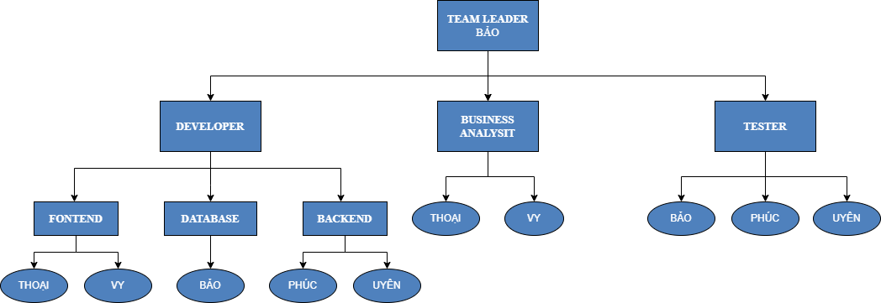

Figure : Organizational Structure

## Roles and Responsibilities

|  |  |  |  |
| --- | --- | --- | --- |
| Person | Role | Responsibility | Note |
| Thai Bao | Team leader | * Setting goals, planning, assigning tasks, and ensuring work progress is on schedule. * Monitoring and evaluating the members' performance. * Uniting team members into a unified entity. |  |
| Thai Bao | Developer | * Developing the features of the bookstore management application with clean and efficient code. * Fixing bugs and optimizing the system. * Collaborating with other team members to reach the expected outcome. | Database Engineer |
| Pham Tai Phuc | Backend Developer |
| Pham Nguyen Quang Thoai | Frontend Developer |
| Pham Ngoc Bao Uyen | Backend Developer |
| Le Nguyen Huyen Vy | Frontend Developer |
| Thai Bao | Tester | * Developing and executing test cases. * Identifying and reporting any bug in software in time. * Ensuring product quality meets customer requirements. |  |
| Pham Tai Phuc |
| Pham Ngoc Bao Uyen |
| Le Nguyen Huyen Vy | Business Analyst | * Gathering and analyzing business requirements through customer interviews and questionnaire responses. * Defining and documenting functional and non-functional requirements. |  |
| Pham Nguyen Quang Thoai |

# Management Process

## Project Estimates

## Project Plan

### Phase and Iteration Plan

1. *Requirements analysis:*

* Time: 24/03/2025 - 30/03/2025 (1 weeks)
* Members: all members in team
* Tasks:
* Read the general problem
* Break down the problem into smaller requirements
* Develop specifications and business analysis for each requirement of the problem
* Build the overview interface and prototype of the application
* Product: Project Proposal

1. *Software design:*

* Time: 31/03/2025 - 13/04/2025 (2 weeks)
* Members: all members in team
* Tasks:
* Structure design: analysis, break down system into smaller and create diagrams.
* Database design: collect specifications, constraints and business rules, and then use ERD models to show those specifications and constraints.
* Product: Software design document

1. *Software implements:*

* Time: 14/04/2025 - 11/05/2025 (4 weeks)
* Members: all members in team
* Tasks:
* According to requirements, choose suitable technologies for the project.
* Break down these requirements into smaller parts and single tasks.
* Create a detailed plan and set up timelines for each part and task.
* Implement features based on parts and tasks with regular testing.
* Finnish all features of the software.
* Product: Software (website for bookstore management)

1. *Software testing:*

* Time: 12/05/2025 - 18/05/2025 (1 week)
* Members: all members in team
* Tasks:
* Build testing plan
* Create test cases for each feature (test cases automatically generated by AI and test cases created by tester)
* Release beta version for user testing.
* Record all testing results.
* If there are any mistakes, ask developers to edit the software.
* Product: standard software, testing document.

1. *Deployment and maintenance:*

* Time: 19/05/2025 - 25/05/2025 (1 week)
* Members: all members in team
* Tasks:
* Software deploys
* Receive feedback from actual users.
* Maintenance, update software
* Product: high-quality software which satisfies all requirements of customers.

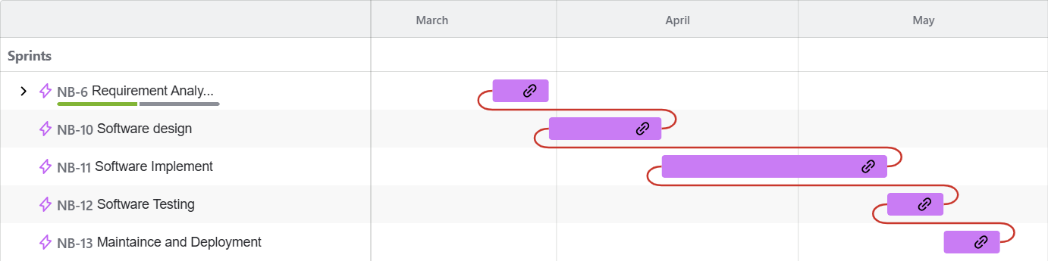

Figure : Gantt chart for project timeline

### Releases

The development of NASA BookStore Management Application will follow a structured release plan with multiple phases:

* Alpha Release (Internal testing):
* This version will include features such as book management, invoice processing and customer management.
* The development team will check the errors and ensure the main functions as expected.
* Sprint Demo Release:
* At the end of each sprint, the development team will showcase this version to evaluate progress, verify completed features, and gather feedback for improvements in the next sprint.
* Beta Release (User Testing):
* The near-final version will be provided to employees for real-world testing.
* The purpose this time is to gather requirements and identify issues with the application. Based on these requirements, necessary improvements will be made to release the official version.
* Final Release:
* This is the official version with full functionality, ready for deployment.
* The system will support book inventory management, invoice tracking, customer promotions,...
* Future Updates & Maintenance
* New versions will be provided regularly to improve functionality, enhance security, and introduce additional features based on the store's business needs.
* These updates will ensure that the system remains efficient, user-friendly, and compatible with evolving industry standards.
  + 1. *Project Schedule*

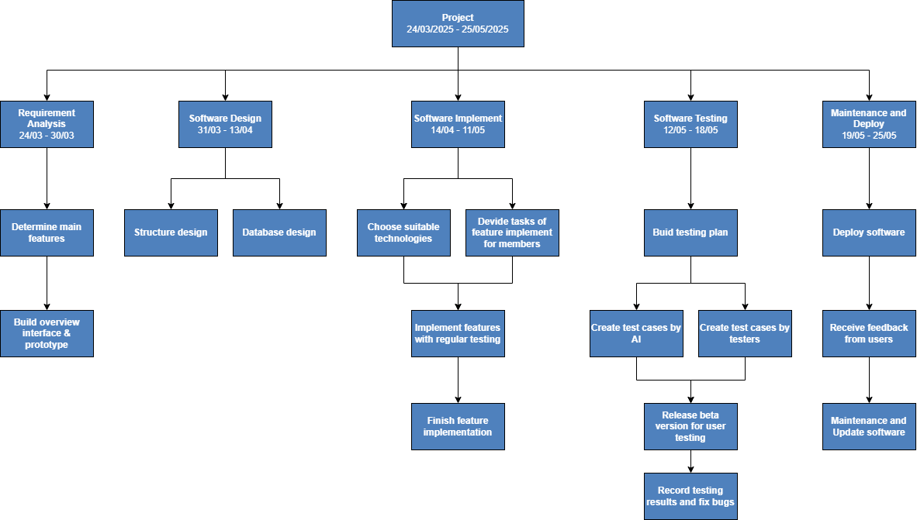

Figure : Project diagram

## Project Monitoring and Control

### Reporting

* Weekly Meetings: My team will conduct scheduled meetings each week to review progress, address obstacles, and plan for upcoming tasks. Each member will provide updates on their assigned work.
* Weekly Progress Reports: A structured report will be compiled every week to outline completed tasks, encountered issues, and upcoming work.
* Code Reviews: The development process will include regular code reviews and testing sessions to ensure the system’s quality and functionality.
* Ongoing Team Communication: Team members will engage in informal discussions via messaging platforms to facilitate quick problem-solving and collaboration. (Facebook)

### Risk Management

*[Identify risks in your project. The risks should be prioritized, and shorted according to their priority.]*

|  |  |  |  |  |  |  |
| --- | --- | --- | --- | --- | --- | --- |
| *Risk ID* | *Risk Description* | *Probability* | *Impact* | *Risk Exposure* | *Priority* | *Mitigation Strategy or Contingency Plan* |
|  |  |  |  | *=Probability * Impact* |  |  |
|  |  |  |  |  |  |  |
|  |  |  |  |  |  |  |

### Configuration Management

* Tools to be used for storage and sharing source code and files.
* Using [Google Drive](https://drive.google.com/drive/folders/1txifIxwC_MPbQQ0MCb44pGQOTdKpisgU?fbclid=IwY2xjawJURaZleHRuA2FlbQIxMAABHT9J18Bbj89jbHAhPcQJX6oRLj558SdOGrzBGCDI1octmDlMkNnQVyt4WQ_aem_0vy7x68Vim8EIfOcGHdK3A) to save documents, files and periodic reports.
* Use [Git](https://github.com/phamuyen171/NMCNPM_Nasa-BookStore) to store source code, synchronize team members' work, a tool to help work more productively and efficiently.

**References**

[1]<https://www.mobindustry.net/blog/what-are-constraints-in-a-software-development-project/#:~:text=Time%2C%20scope%20and%20cost%20are,software%20engineering%20and%20project%20management>.

[2]<https://www.pace.edu.vn/tin-kho-tri-thuc/leader-la-gi#:~:text=Team%20leader%20l%C3%A0%20ng%C6%B0%E1%BB%9Di%20ch%E1%BB%89,h%C6%B0%E1%BB%9Bng%20%C4%91%E1%BA%BFn%20m%E1%BB%A5c%20ti%C3%AAu%20chung>.

[3]<https://codestar.vn/vai-tro-cua-kiem-thu-phan-mem/>