Bookstore Management Software

Vision Document

Version 1.0

Revision History

|  |  |  |  |  |
| --- | --- | --- | --- | --- |
| **Date** | **Version** | **Description** | **Author** | **Student ID** |
| 24/03/25 | 1.0 | Overview about users of website | Pham Ngoc Bao Uyen | 22120424 |
| 24/03/25 | 1.0 | Overview about features of website | Le Nguyen Huyen Vy | 22120449 |

Table of Contents

1. Introduction 4

2. Positioning 4

2.1 Problem Statement 4

2.2 Product Position Statement 4

3. User Descriptions 4

3.1 User Profiles 4

3.2 User Task and Environment 5

4. Product Features - functional user requirements 10

5. Non-Functional Requirements - non-functional user requirements 12

5.1. Performance Requirements 12

5.2. Security Requirements 12

5.3 Maintenance 13

5.4 Requirements for accuracy and availability 13

5.5 Compliance requirements 13

5.6 Usability requirements 13

Vision (Small Project)

# Introduction

The purpose of this document is to collect, analyze, and define high-level needs and features of the bookstore management website. It focuses on the capabilities needed by the stakeholders and the target users, and **why** these needs exist.

# Positioning

## Problem Statement

|  |  |
| --- | --- |
| The problem of | manage books, orders and human resources of a bookstore complicatedly in traditional ways |
| affects | wasting time of staff and money for them: manager, sales agent and accountant |
| the impact of which is | The bookstore wants to have a website in order to manage some basic activities related to books (selling, restoring, arranging, discount,…), book orders (statistics, delivery...), and human (employers, customers for discount programs,...) |
| a successful solution would be | a system which can make the operation of bookstore happen smoothly |

## Product Position Statement

|  |  |
| --- | --- |
| For | staff of the bookstore |
| Who | manage some basic activities related to books, orders and employers |
| The (product name) | Nasa |
| That | allow staffs to manage books smoothly with the ability to filter, arrange, restore,... book, create many discount programs, manage book delivery, make statistics to calculate the profit and also manage the employers’ & customer information |
| Unlike | Fahasa, Phuong Nam Bookstore |
| Our product | can guarantee the orders are available and delivered on time so that the bookstore can increase the customers’ services. |

# User Descriptions

## User Profiles

1. Store Manager:

* Roles and Responsibilities:
* System Management : ensure the website runs smoothly by monitoring performance and handling technical issues promptly.
* User Management: books, orders, profit, employers, and customers management
* Discount Management: plan discount programs,...
* Regulation Management: set rules,...
* Skills and requirements:
* Technical skills: Proficient in website management, basic knowledge of server administration and database management
* Management skills: ability to lead, coordinate, and communicate effectively with various departments,...
* Experience: experience in website management and all steps of operating the bookstore
* System Usage frequency: daily monitoring
* Limitation: No

1. Accountant:

* Roles and Responsibilities: Oversee the financial and accounting operations of the bookstore.
* Record, categorize, and track daily financial transactions.
* Prepare periodic financial reports, verify and reconcile data to ensure accuracy.
* Manage receivables/payables, control costs, and assist in budget planning for the bookstore.
* Collaborate with other departments to ensure smooth execution of accounting procedures.
* Ensure compliance with current tax laws and accounting standards.
* Skills and requirements:
* Technical Accounting Skills: mastery of accounting processes, bookkeeping, and financial reporting, in-depth knowledge of tax regulations and accounting standards.
* Software Proficiency: skilled in using accounting software: excel,..
* Experience with sales management, inventory and financial management tools.
* Solid foundation in computer usage.
* System Usage frequency: daily monitoring for recording transactions, monthly and yearly for generating financial reports.
* Limitation: Cannot control the process of managing books (create, edit, restore, arrange,...) or human (employers, customers,...)

1. Sales agent:

* Roles and Responsibilities:
* Check and update order information and sales transactions through the system.
* Monitor inventory, assist in stock entry, and verify products as directed by management.
* Report issues to management promptly while executing tasks according to established procedures.
* Skills and requirements:
* Computer Skills: Proficient in basic computer operations and smartphone usage; familiar with web applications.
* Job-Specific Skills: Understands basic sales processes, inventory control, and order processing.
* Learning Skills: Understands basic sales processes, inventory control, and order processing.
* System Usage frequency: daily usage for updating orders, inventory, and assist customers.
* Limitation: Cannot control the responsibilities of accountants and limit in some tasks of managers: set rules, manage employers’ information,...

## User Task and Environment

3.2.1 Book Management:

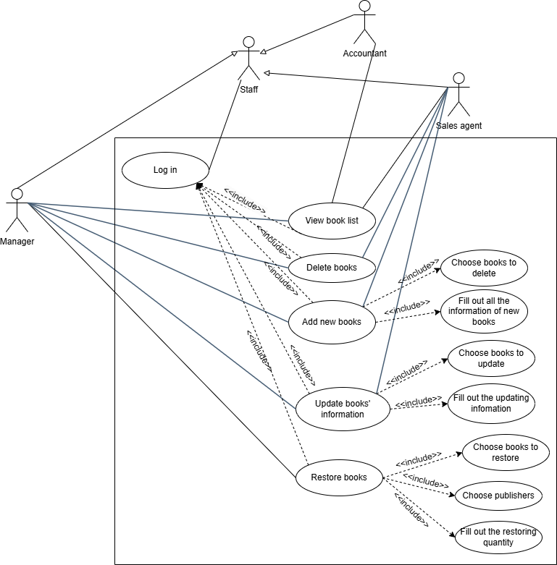

Figure : Book Management Use case

3.3.2 Order Management:

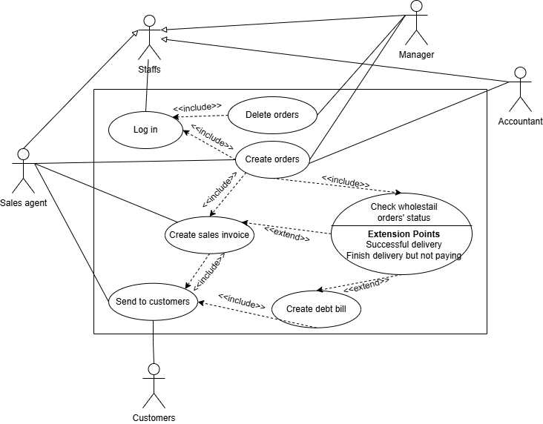

Figure : Order Management Use case

3.2.3 Human Resource Management:

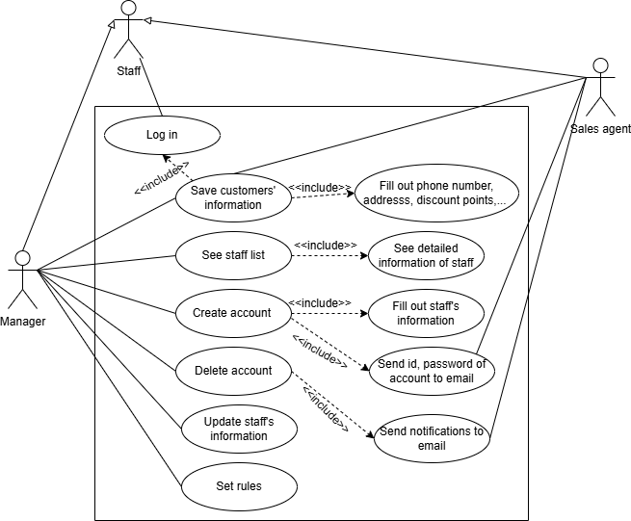

Figure : Human Resource Management Use case

3.2.4 Discount Management:

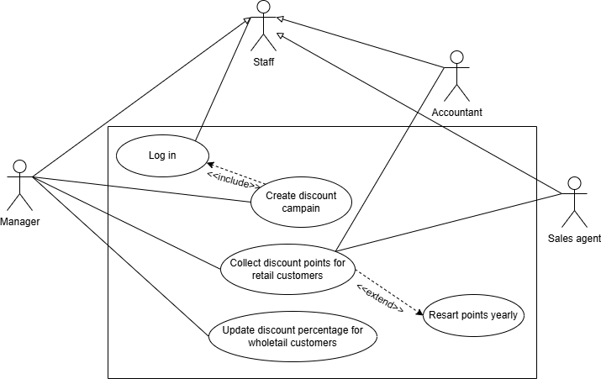

Figure : Discount Management Use case

3.2.5 Profit Statistics:

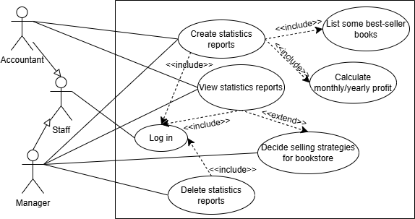

Figure : Profit Statistics Use case

# Product Features - functional user requirements

|  |  |  |
| --- | --- | --- |
| **Features** | **User** | **Description** |
| Updating new books information | Sale agent, store manager | Each book product will have a page that stores detailed information (publisher, author, price, quantity in stock, etc.). Users can update this information for new books, edit current product information, etc. |
| Adding, deleting products | Sale agent, store manager | When a new book appears that the store needs to import or a book is no longer available, the sales agent will update the information and send it to the store manager. When the store manager approves, the product will be updated in the book list. |
| Viewing books list | Store manager, sale agent, accountant | All users with a staff account will be able to see the product list. The list will display all products available in the store, along with filters and search tools to filter the list to what users want to see (e.g. search for books by author, publisher, out of stock books, etc.) |
| Creating sales invoice | Store manager, sale agent, accountant | - Any employee can create a sales invoice.  - The search engine will be integrated into this function for easier operation by employees.  - Products that are out of stock and no longer for sale will not appear in the list when the staff makes the invoice, avoiding confusion.  - Promo codes, discounts, use of points for discounts can be used. |
| Books restored | Store manager | - The book list will automatically display the quantity of each title, and indicate which books are almost out of stock.  - This additional book import must be based on the initial rules set by the user, which are the rules on maximum restore quantity or book inventory quantity.  - Not all out of stock books will be restored, the store manager will choose which books to restore after reviewing the list of out of stock books. |
| Creating "loyalty" accounts for customers | Store manager, sale agent, accountant | - Each customer will have an account, identified by the customer's phone number (customer name can also be saved)  - When paying, the customer will read the phone number, if the phone number already exists in the system, the staff will update the points. If not, the staff will create a new account and start accumulating points. |
| Collecting and using points for customers | Store manager, sale agent, accountant | - Points will be calculated according to the formula: 1 point = 10,000 VND.  - If the customer has accumulated enough X points, one of the next bills will be deducted Y (VND) (Customers can choose the bill they want to get the discount on, the values ​​of X and Y are determined by the store.). |
| Points recreation |  | After one year, the points accumulated by the customer will be returned to 0. This means that the accumulated points cannot be accumulated from year to year. |
| Debt management | Accountant | - Credit is only applicable to customers who are units (schools, companies) or agents who buy in large quantities.  - The repayment period will be agreed between the customer and the store, then the accountant will update.  - When the debt is about to be due, the system will notify the accountant so that the accountant can promptly resolve the debt with the customer.  - The accountant can write off the debt, convert the debt to bad debt, or refuse to let the customer owe. |
| Manage units and agents purchasing in bulk | Store manager | - Purchasing units and agents will always receive a discount. The discount level will be agreed upon and then updated into the system by the staff.  - The store manager is the person who has the right to update the list of agents and units. That means, customers/partners who reach a certain level of purchase and frequency of purchase will be upgraded to agents/units. |
| Human resource management | Store manager | - A detailed list of personnel will be provided to the store manager.  - The store manager has the right to add, delete, and edit this list. When adding an employee, this employee will be given an account to log in to the website.  - When deleting an employee, the employee has the right to respond within 24 hours, after which the account will be revoked and the employee will be removed from the list.  - Managers also have the right to set rules for other staff. |
| Log in account | Store manager, sale agent, accountant | Staff have to log in to the website before doing any actions on the website. |
| Change password | Store manager, sale agent, accountant | Staff who have accounts can change their password many times with the OTP code provided to their phone numbers. |
| Profit Statistics | Accountant, Store manager | * Accountants create profit reports monthly/yearly. * Managers view these reports and decide strategies for upcoming months/years. |

# Non-Functional Requirements - non-functional user requirements

## 5.1. Performance Requirements

* For search tasks, the system must have a response time of less than 2 seconds.

## 5.2. Security Requirements

* For important tasks (tasks related to debt management, human resource management, etc. of store managers) an additional authentication step may be required.
* Assign permissions to system user types:
  + Sales agents can only view product lists, perform search tasks, update new book information, send requests to the store manager for confirmation, and create sales invoices.
  + Store managers will have the right to manage personnel (recruitment, dismissal, ...), manage debts, manage agents, units, and manage book imports. Store managers have almost all the rights that lower-level employees have.
  + Accountants have the right to manage and update debts, evaluate and review the purchase and sale status of agents and units. Accountants have the right to extract all invoices upon request, and make monthly revenue and expenditure statistics.
  + Admins have the right to manage the entire system.
* The password to log into the system will be encrypted and securely protected during storage.
* Only the highest-ranking employee can have detailed information about the employee (because they have the right to manage human resources)
* Employees have the right to set privacy for information on their personal page if they want.

## 5.3 Maintenance

* Modular design for easy modification or addition of new functions without affecting the entire system.
* Fault detection and handling procedures must be rapid, ensuring continuous operation without service interruption.

## 5.4 Requirements for accuracy and availability

* All operations related to data (add, delete, edit) must be checked and processed accurately.
* If there is a data error, the system must notify the user clearly and promptly.
* The system must have a quick recovery mechanism when an incident occurs
* Minimize downtime as much as possible.

## 5.5 Compliance requirements

* The system must comply with regulations related to the security of users' personal information or local data protection regulations.
* The system must comply with legal regulations on trade, economics, labor law,...

## 5.6 Usability requirements

* Functions such as login, search, list viewing, etc. must be designed as simply and easily understandable as possible so that users do not need to read the user manual to operate.
* Functions related to business (debt management, debt settlement, human resource management, etc.) must be accompanied by clear user instructions.