Fostering Software Architect and Programmer Collaboration

ABSTRACT
Model-Driven Engineering (MDE) is a development paradigm that brings the benefits of increased automation to the software development cycle. The MDE community tries to promote MDE adoption by pushing models written in graphical (i.e., diagram-based) languages, supported by extensive tooling. While there is increasing evidence that MDE facilitates the design of complex software, its level of acceptance by software developers is still low. On one hand, rather than use graphical languages, most programmers still prefer to work with their favorite textual programming language (e.g. Java and C++) and integrated development environment. On the other hand, software architects are among the early adopters and promoters of graphical languages. They consider such languages to be much more suitable for describing architectures compared to textual languages. Synchronizing manually written artifacts in either type of language is not simple and is often very time-consuming and error prone unless it is supported by automated methods and tools.
To solve this issue, we propose a model-code synchronization pattern supported by corresponding tooling. The solution tackles the fundamental problem of round-trip engineering: synchronization of concurrently evolving artifacts. On one side, we have the architecture model maintained by the software architects, while on the other, we have code written by programmers. Applying our approach to the development of an actual runtime system, we show that both parties involved, software architects and programmers, can collaborate efficiently while continuing to work in their favoured development environment.

CCS Concepts
•Software and its engineering → Software development methods; Collaboration in software development;

Keywords
Round-trip engineering, Model-driven engineering, Model code co-evolution, UML, C++, Eclipse, Papyrus

INTRODUCTION
Model-Driven Engineering (MDE) [60] is a development paradigm that seeks to increase productivity, by, among other things, increasing the level of automation. Traditionally, the MDE community draws a sharp distinction between development using a graphical or, diagram-based, language (commonly called a modeling language in the MODELS [48] community) and development using a textual language. (i.e., a programming language or code). Proponents of MDE have argued that adopting model-centric approaches would benefit software developers due to its many advantages [61], especially for development of complex systems. They encourage the greater use of model-driven development, by, among other initiatives, providing graphical languages supported by appropriate tools [24] such as automated code generation.
In industrial practice, there is still significant reticence to adopt a fully model-centric approach in the industry [32, 70]. This is due in part to the perceived gap [8] between graphical languages and textual languages. On one hand, programmers often shy away from graphical languages, preferring to use the more familiar combination of a programming language and integrated development environment (IDE). On the other hand, software architects, working at higher levels of abstraction, tend to favor the use of models, and, therefore, prefer graphical languages for describing the architectures of systems.
Even within teams that use a model-driven approach, the gap between model and code is not bridged seamlessly. The survey described in [33] polled stakeholders in companies that use MDE approaches. It notes that 70% of the respondents primarily work with models, but still require manually-written code to be integrated. Furthermore, 35% of the respondents noted that they spend a lot of time and effort synchronizing models and code.
This back-and-forth switching between graphical languages and textual languages, as well as between models and code, has hindered the adoption of MDE in industrial practice. To resolve this issue, we believe the sharp distinction between model and code must be blurred. We feel that a collaborative solution [44] must be offered to different categories of developers (e.g., architects, programmers) who use different development practices, one that does not impose a choice between a diagram-based language and a textual language.
Collaboration between developers producing different types of artifacts in different languages using different tools, raises the issue of artifact synchronization. This is a well-known concern with round-trip engineering. Namely, round-trip engineering requires the ability to maintain consistency between multiple concurrently evolving software artifacts [4, 30, 62]. It is related to traditional software engineering disciplines such as forward engineering [13] and reverse engineering [13]. Round-trip engineering achieves synchronization between related artifacts that may evolve concurrently by incrementally updating an artifact in response to changes made in other related artifacts.
In this paper, we propose to use automated model-code synchronization as a means of bridging the gap between models edited by software architects, and code written by programmers. Our approach is based on the following contributions, described in detail later in this paper:
- A generic model-code synchronization methodological pattern to solve the problem of collaboration between different types of developers, when models and code co-evolve. This contribution is based on several assumptions:
- The availability of a generic IDE with functionalities necessary for model-code synchronization. The functionalities required are not dependent on a particular approach or technology.
- Processes that use an IDE to synchronize models and code based on several defined scenarios, which correspond to common development practices found in many development processes.
- An Eclipse-based implementation of the approach for synchronization between UML models and corresponding C++ code.
- Experience on applying the proposed solution to the development of a real-world example.
Contrary to traditional solutions, we generalize our work by considering the case where the model is not only used for architectural design, but also for full implementation [12]. The tooling of our solution focuses on the Unified Modeling Language (UML) [58], because it is a very widely used software architecture description language [46]. We want to synchronize models specified in a graphical language like UML with code in a popular textual programming language like C++ (used by 4.4 million [38] developers worldwide).
The work presented in this paper is motivated by the Papyrus-RT [11] runtime system, which was developed in collaboration by CEA, Ericsson, and Zeligsoft. These companies are contributors to the MDE eco-system. The architecture of this system follows an object-oriented paradigm, and it was initially implemented as a C++ project with about 15,000 lines of code. This project encountered the problem of collaboration between MDE developers and programmers working in the traditional manner.
The rest of the paper is organized as follows: Section 2 defines the actors (roles) we considered in our work and the use cases of the generic IDE for our model-code synchronization approach. In Section 3, we propose processes for synchronizing model and code, in several scenarios. A possible implementation of our solution, based on Eclipse technologies, is proposed in Section 4. The approach is evaluated in Section 5 through simulations and the case-study of the Papyrus-RT runtime. Section 6 relates our work to existing research and industrial approaches. Finally, in Section 7 we conclude with some perspectives.

ACTORS AND USE CASES
In this section we define the actors who will use our model-code synchronization approach to collaborate during development and the main capabilities expected from a generic IDE used by these actors. Some basic concepts related to the actors and use cases are also defined in this section.

Actors and artifacts
In this paper we propose a methodological model-code synchronization pattern for collaboration between software architects and programmers. For the sake of generality, we postulate that the architect and programmer are actors with starkly opposite development practices. This allows the approach to be used even in cases where model and code can both be used for the full implementation of a system, rather than just architectural design for the former, and code implementation for the latter. First, we introduce the concepts of development artifact and baseline artifact.
DEFINITION 1 (DEVELOPMENT ARTIFACT). A development artifact is an artifact, as defined in [52] that can be used for the full implementation of the system.
For example, a system can be entirely implemented as code. The code is then a development artifact. A model may also be a development artifact. In that case, it is then not only documentation of specification but part of the implementation. For example a model can be used for implementation either by compiling it directly [12], or by generating code from the model, and compiling the code without the need to edit or complete the code.
A development artifact may be the baseline artifact, defined as follows:
DEFINITION 2 (BASELINE ARTIFACT). A baseline artifact is one that is edited manually. All other artifacts are produced from the baseline artifact through some process, and only through a process. Manual modification of artifacts other than the baseline artifact is forbidden.
Two primary actors, called model-driven developer and code-driven developer, are introduced. The main difference between them is what they consider as a baseline artifact.
DEFINITION 3 (MODEL-DRIVEN DEVELOPER). A model-driven developer is an actor in a software development process for whom the baseline artifact is a model.
In other words, for a model-driven developer, only the model should be edited manually. The code must always be produced from the model automatically by some process that guarantees that the code is consistent with the model. A software architect is a kind of model-driven developer who edits the model to specify the architecture of the system. An architect presumes that the reference for the architecture of the system should be specified as a model.
DEFINITION 4 (CODE-DRIVEN DEVELOPER). A code-driven developer is an actor of the software development process for whom the code is the baseline artifact.
A programmer is a specialization of the code-driven developer. Indeed, programmers may modify the code, such as editing method bodies. The code is then the main reference for the implementation of methods.

Use cases
In this section we propose a generic IDE with use cases that represent functionalities required by our model-code synchronization approach. Figure 1 shows a UML use case diagram of the IDE and associations to the actors.
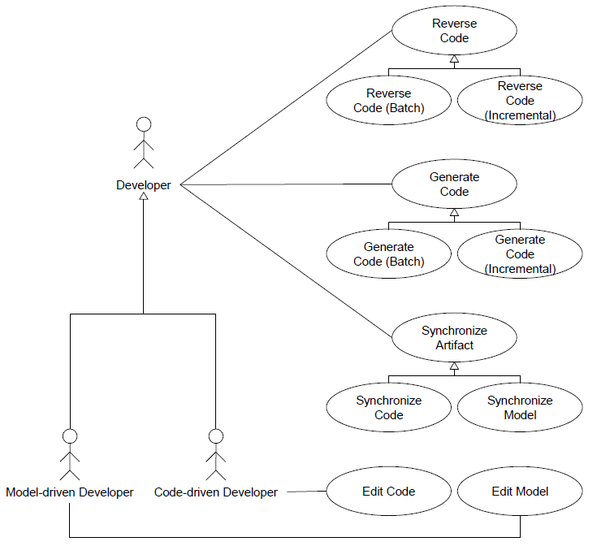
Figure 1: Use case diagram (UML)
There are some use cases for manual edition of artifacts. The Edit Artifact use case implies that the IDE must have some tool to let the developer manually edit an artifact. The Edit Model and Edit Code use cases are specializations of the Edit Artifact use case where the artifact is the model or code.
There are also some use cases related to the synchronization of artifacts. The Synchronize Artifact use case is the synchronization of two artifacts by: (1) comparing them, (2) updating each artifact with changes made in the related artifact, and (3) reconciling conflicts, when appropriate. The Synchronize Model and Synchronize Code use cases are specializations where, respectively, the model or the code are the artifacts being synchronized.
The Generate Code use case is related to forward engineering [13]. It is the production of code in a programming language from a model. The developer can either use Generate Code (Batch) or Generate Code (Incremental).
DEFINITION 5 (BATCH CODE GENERATION [25]). Batch code generation is a process of generating code from a model, from scratch. Any existing code is overwritten by the newly generated code.
Incremental code generation is a specialization of incremental model transformation, which is defined in [25] as model transformation that does not generate the whole target models from scratch but only updates the target models by propagating changes made in the source models.
Derived from the definition of incremental model transformation, incremental code generation is defined in this paper as follows:
DEFINITION 6 (INCREMENTAL CODE GENERATION). Incremental code generation is the process of taking as input an edited model, and existing code, and then updating the code by propagating changes in the model to the code.
Finally, the Reverse Code use case is related to reverse engineering [13]. Reverse Code is the generation of a model specified in a modeling language, from code, written in a programming language. The developer can either use Reverse Code (Batch) or Reverse Code (Incremental), which are defined as follows:
DEFINITION 7 (BATCH REVERSE ENGINEERING). Batch reverse engineering is the process of producing a model from code, from scratch. The existing model is overwritten by the newly generated model.
DEFINITION 8 (INCREMENTAL REVERSE ENGINEERING). Incremental reverse engineering is the process of taking as input modified code, and an existing model, and then to updating the model by propagating changes in the code to the model.
For readability, in this paper we will sometimes designate batch and incremental as modes of code generation/reverse engineering; e.g., we say that we generate code in batch mode from a model.
The use cases are generic. They do not depend on any particular approach or tool. Therefore, software developers can choose the approach or tool that suits their development preferences best.
In the next section, the use cases of the IDE are integrated into some processes that cover model-code synchronization in several different scenarios. The scenarios correspond to behaviors performed by both kinds of actors, i.e., model-driven developers and code-driven developers.

PROCESSES FOR SYNCHRONIZING MODEL AND CODE
This section describes some processes for synchronizing model and code in different scenarios. The scenarios are differentiated according to the type of developers, i.e., the type of actors, working on the system to be developed.
For each of the scenarios, we assume that the common starting point of each process is a complete model. Therefore, if there is some legacy code sitting outside of the model, it must first be inserted back into a new model before the processes described below can be applied. This can be done with the Reverse Code (Batch) use case of the IDE proposed in Section 2.
Each of the following subsections describes a scenario and the process associated with it for model-code synchronization.

Scenario 1: code-only changes
The assumption in scenario 1 is that the code is the only baseline artifact. (In other words, only the code may be edited manually.) We assume that, during development, the model needs to be synchronized sporadically with the code. This scenario is usually more appropriate for the code-driven developer. Figure 2 shows a sequence diagram that illustrates the process for synchronizing code and model in scenario 1. The general approach is to always overwrite the model with a new model produced from the edited code.
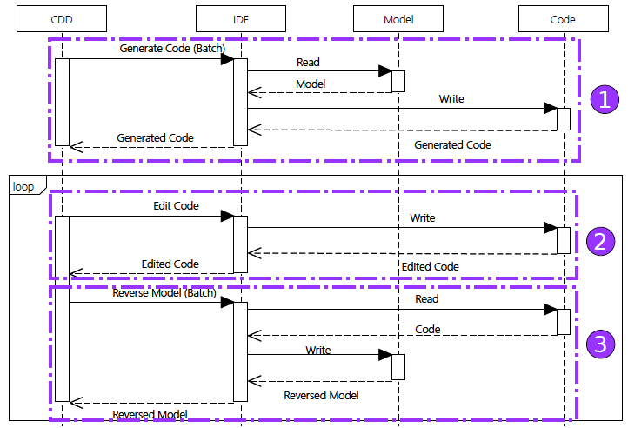
Figure 2: The synchronization process for scenario 1, in which only code is edited (CDD = Code-Driven Developer). The API calls for Model and Code are represented generically as “Read” and “Write”.
In Figure 2, the code-driven developer interacts with the IDE, which then writes and reads from the code and the model. Note that messages between the code-driven developer and the IDE are the use cases of the IDE proposed in Section 2. In Figure 2, there are some markups to highlight the general steps of the process. Keep in mind the general assumption that the starting point of the process is a model.
The general steps of the process are described as follows:

- Scenario 1 synchronization process general steps -
Step 1 To begin implementation, the code is generated in batch mode from the model. The developers then work with this generated code.
Step 2 The code is edited.
Step 3 After the code has been edited, it is reverse engineered in batch mode, i.e., the existing model is overwritten by a new model reverse engineered from the code.
Obviously, code may be modified multiple times through successive editions. After each change cycle, the model can be reverse engineered in batch mode. Therefore steps (2) and (3) may be repeated multiple times in this process.
Since code is the baseline artifact here, we only need to overwrite the model by batch reverse engineering for the artifacts to be synchronized. Using incremental code reverse has the same effect as batch code reverse.

Scenario 2: model-only changes
Scenario 2 is the opposite of scenario 1: the assumption here is that the model is the only baseline artifact. That is, only the model may be edited manually. This scenario is appropriate for the model-driven developer.
Figure 3 shows a sequence diagram that illustrates the process to synchronize code and model in scenario 2. The general approach is to always overwrite the code with new code produced from the modified model. Recall that we assume here that the model is a development artifact, which means that it contains enough information for the full implementation of the system.
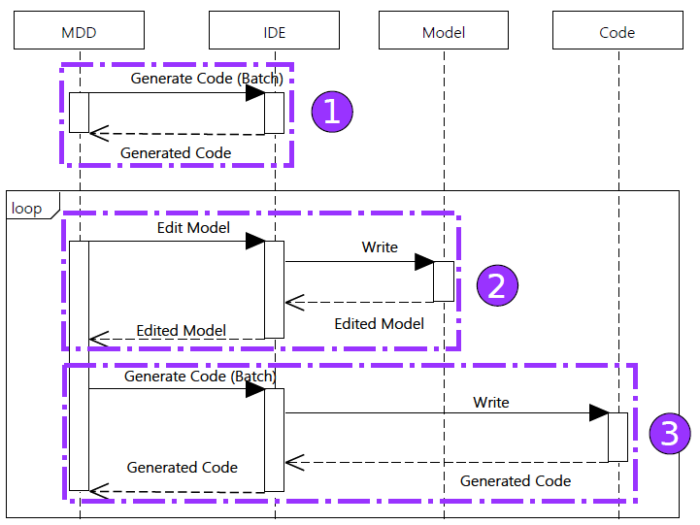
Figure 3: The synchronization process for scenario 2, in which only the model is edited (MDD = Model-Driven Developer). The API calls for Model and Code are represented generically as “Read” and “Write”.
Highlighted steps of the process shown in Figure 3 are described as follows:

- Scenario 2 synchronization process general steps -
Step 1 To begin the implementation, the code is generated in batch mode from the model. (To simplify Figure 3, we do not show the Read and Write interactions for this step, as was the case in Figure 2.)
Step 2 The model is edited.
Step 3 After the model has been edited, code is generated in batch mode; i.e., the existing code is overwritten by new code generated from the model.
Each time we edit the model, code is generated from it in batch mode. Therefore steps (2) and (3) are repeating steps in the process.
Since the model is the baseline artifact, we only need to overwrite the code with the model, by batch generation, for both artifacts to be synchronized. Using incremental code generation has the same effect as batch code generation.

Scenario 3: concurrent changes
Note that the process proposed for scenario 1 and scenario 2 are classic cases of forward and reverse engineering, rather than fully-fledged round-trip engineering with a need for synchronization. Consequently, code is produced from model in batch mode. When it is reverse engineered, it is revered to the model in batch mode. There is no need for additional synchronization strategies, since only either the code or the model is the baseline artifact, i.e., only one of them is edited manually and there are no concurrent changes being made to the two artifacts. Therefore, batch mode operation is sufficient for synchronization.
However, in scenario 3, there is no unique baseline artifact; both the model and the code may be edited manually. Therefore, they may evolve concurrently during development activities and synchronization issues will occur. This scenario tackles the problem where model-driven and code-driven developers are working together on the same system.
We propose two synchronization strategies for this scenario. The general approach behind our synchronization strategies is to represent one artifact using the language of its corresponding other artifact. These two can then be compared. For this, we define the concept of a synchronization artifact:
DEFINITION 9 (SYNCHRONIZATION ARTIFACT). A synchronization artifact is an artifact used to synchronize a model and its corresponding code. It is an image of one of the artifacts, either the model or the code. In this context, an image I of an artifact A is a copy of A obtained by transforming A to I. A and I are semantically equivalent but are specified in different languages.
For example, a synchronization artifact can be code that was generated from the edited model in batch mode. In that case, it is code that represents an image of the edited model.
Using the concept of synchronization artifact, two strategies are proposed in this paper: one in which the synchronization artifact is code, and the other in which the synchronization artifact is a model. The developer can choose to use either the Synchronize Code or Synchronize Model use cases of the IDE. The choice may be determined by preferred development practices or the availability of suitable tools.
Figure 4 shows the first synchronization strategy based on using code as the synchronization artifact.
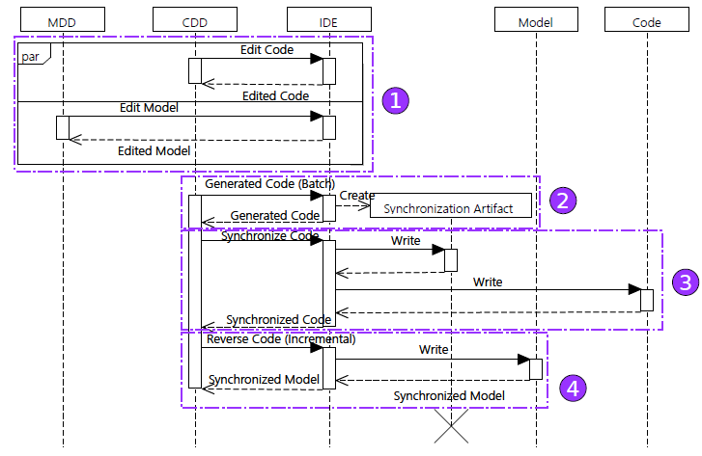
Figure 4: The synchronization process for scenario 3, in which the model and the code are concurrently edited with code as the synchronization artifact (CDD = Code- Driven Developer, MDD = Model-Driven Developer). The API calls for Model and Code are represented generically as “Read” and “Write”.
The highlighted general steps of the process shown in Figure 4 are as follows:

- Scenario 3 synchronization process steps –
Step 1 Both the model and code may be edited concurrently. (To simplify Figure 4, we don’t show the Read and Write interactions for this step.) After both artifacts have been edited concurrently, we need to synchronize them.
Step 2 First, we create a synchronization artifact from the edited model by generating code in batch mode. This synchronization artifact is code and is an image of the edited model.
Step 3 The synchronization artifact is synchronized with the edited code. Since the synchronization artifact is code itself, this step is done with the Synchronize Code use case of the IDE.
Step 4 Once synchronization artifact and edited code are synchronized, the former is reverse engineered incrementally to update the edited model.
The second strategy, based on using model as the synchronization artifact, is the opposite of the first strategy. In the second strategy, the synchronization artifact is obtained by reversing the edited code in batch mode. Afterwards, the synchronization artifact is synchronized with the edited model. Finally, we generate code incrementally from the synchronization artifact to update the edited code.
We propose two strategies to accommodate the preferences of developers. They may even use both strategies, successively, as a kind of hybrid strategy. This may be useful when developers want to synchronize parts of the system using one strategy, and other parts using the other strategy. For example, they may choose to synchronize method bodies using strategy 1, where the synchronization artifact is code. Then strategy 2, in which the synchronization artifact is a model, can be used to to synchronize the architectural elements of the system.
In the next section we propose an implementation of an IDE and the proposed synchronization processes.

AN IMPLEMENTATION: SYNCHRONIZING UML MODELS AND C++ CODE
The proposed model-code synchronization approach can be automated. We examine an Eclipse-based implementation of the IDE proposed in Section 2. The implementation is used in the synchronization processes proposed in Section 3. Our implementation targets synchronization of Object Management Group (OMG) standard UML 2 [53] and C++11 code.
The use cases of the IDE are implemented with some Eclipse technologies. Eclipse CDT is an IDE for C++ development. It is used in the Edit Code use case.
Eclipse Papyrus [24] is used for the Edit Model use case. Papyrus is a UML modeler that uses the Eclipse Modeling Framework (EMF) [65] implementation of the OMG-standard UML 2. Papyrus supports UML profiles for domain-specific modeling, and we use the UML profile feature of Papyrus dedicated to C++ to facilitate and accelerate modeling of some C++ features.
We developed plugins for Papyrus to implement Generate Code from UML to C++ and also for the Reverse Code use case. The batch modes of these use cases do not need additional technologies to implement. For use cases Generate Code (Incremental) and Reverse Code (Incremental), we chose to listen for modification events in the model and code respectively. Listening for modification events is one possible approach in incremental model transformation [43]. The Viatra [5] API is used to listen for such events in the model. The Eclipse CDT API is used to listen for modification events in the code. These events are used to either generate code or reverse code incrementally.
EMF Compare [9] is used for the Synchronize Model use case when implemented with EMF. We adapted EMF Compare for Papyrus in order to synchronize UML models for our specific work. Eclipse CDT is used for the Synchronize Code use code with its built-in C++ features.
The next section describes some experiments performed using the above implementation of our synchronization solution.

EXPERIMENTS
Two experiments were conducted in order to assess the proposed methodology and its applicability to the development of a realistic system. In the following subsections, we first describe the results of some simulations designed to test the proposed approach. Next, we report on a realistic case-study intended to help us assess certain scalability and usability aspects.

Simulations
Simulations were conducted to test that our proposition respects the round-trip engineering laws [20], namely right-invertibility and left-invertibility. These laws are defined as follows:
Law 1: Right-invertibility means that not changing the code (or model, respectively) shall be reflected as not changing the model (code). If no changes are made to the code, then the model used for generating the code and the model received by immediately reverse engineering the generated code must be the same.
Law 2: Left-invertibility means that all changes made to the code are captured and correctly propagated to the model, so that the edited code can be fully recreated by applying code generation to the updated model.
In the following, the model generator used for the simulations is presented first. Then, the simulations performed for both above laws are described. Finally, we discuss the simulation of the process defined for scenario 3 (Section 3.3), in which both the model and the code are edited concurrently

Randomly generated UML models
In the simulations, random UML models are generated with a configurable model generator. The generated models contain C++ features represented via UML. The generator can be configured to generate a desired average number of each type of C++ feature to be represented as a UML element.
Three packages are generated for each model. Each package contains 60 classes, and, on the average 10 enumerations, 10 structures, and 10 function pointers. Class members include methods with parameters, and attributes.
The types of parameters and attributes are chosen randomly. Methods have randomly generated bodies that use other classes. Attributes have randomly generated default values of the appropriate types.
Relationships between classes are also generated: associations, sub class relationships, and dependencies. When a dependency is generated, the generator enforces that the source class of the dependency has a method that uses the target class of the dependency.

Simulation for Law 1 (right-invertibility)
In the first simulation, Law 1 was evaluated. The procedure for the simulation is shown in Figure 5.
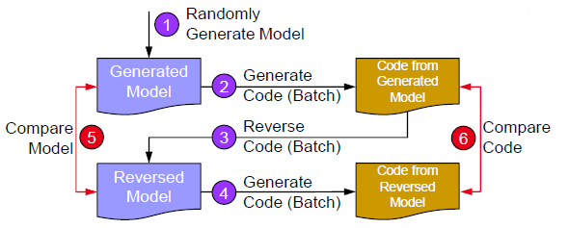
Figure 5: Simulation 1 for Law 1 (right-invertibility)
The general idea behind the simulation procedure is to do a full round-trip of the UML model randomly generated in step (1). The round-trip of the model is done according to steps (2) to (3). The randomly generated model is compared with the reverse engineered model after the round-trip. This is done in step (5).
A full round-trip is also done for the C++ code that is generated from the original randomly generated model in step (2). The round-trip is done through steps (3) to (4). The code generated from the original randomly generated model is compared with code generated from the reversed model in step (6).
Code generation and reverse generation are done in batch mode since no editions are made to the models or code in this simulation. Comparison of models is done by first comparing the number of elements of each type. If these numbers match, EMF Compare is used. Comparison of code is done by using the built-in code comparison tool in the Eclipse CDT.
Table 1 shows the number of each type of elements in the randomly generated model, including the comparison results, for 3 of the 200 models created by the generator. We limited ourselves to 200 models for practical reasons. These same models were later used for a simulation that involved some manual editions.
Table 1: Three of 200 generated models for simulation 1: Abbreviations are classes (C), methods (M), method parameters (P), attributes (A), associations (AS), inheritances (G), method body (B), dependencies (D), enumerations (E), structures (S), default values (DV), function pointers (F)
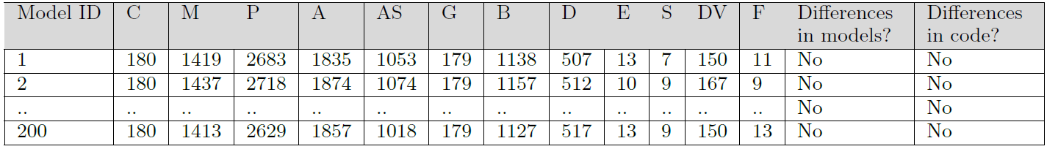
After launching the simulation for the 200 models, no differences were found during model comparison and code comparison. This result indicates that our model-code synchronization approach satisfies Law 1 of round-trip engineering.

Simulation for Law 2 left-invertibility
In the second simulation, Law 2 was evaluated. The procedure for the simulation is shown in Figure 6.
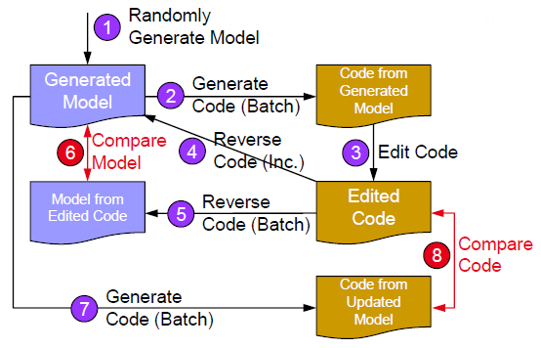
Figure 6: Simulation 2 for Law 2 (left-invertibility)
The general idea behind the simulation procedure is to do a full round-trip of a randomly generated UML model, but with changes introduced to the generated C++ code. As shown in Figure 6, the procedure to test the framework consisted of the following steps:
Step 1 A UML model is randomly generated and becomes the generated model.
Step 2 Through batch code generation, we obtain code from the generated model.
Step 3 The code produced from generated model is then edited. We thus obtain edited code. The different kinds of editions are discussed with the results of the simulation.
Step 4 The edited code is reversed incrementally to the generated model. The generated model then be- comes an updated model.
Step 5 The edited code is also reversed in batch mode to a model from edited code. This model is an image of the edited code.
Step 6 The updated model (the previously generated model) is compared to the model from edited code (image of the edited code).
Step 7 The code from the updated model is generated.
Step 8 The code from the updated model is compared to the edited code.
The simulation is run for 200 randomly generated models. We limited ourselves to 200 models because in step (3), some of the editions had to be done manually to emulate real development conditions. Therefore the limit of 200 models is purely based on practical concerns.
During the simulations, the code generated from each model underwent seven different kinds of modifications independently (the kinds of changes performed are listed in Table 2). As its name suggests, only “Manual editions”, were done manually, to emulate actual development conditions.
The changes triggered three kinds of Eclipse CDT modification events: ADDED, REMOVED, and CHANGED. Events ADDED and REMOVED mean addition and deletion of classes, attributes or methods to the code, respectively. Event CHANGED is the update of elements in code including: (1) renaming of attributes, classes, or methods, (2) changing the type of attributes and parameters, or (3) changing the behavior code of methods.
Table 2 shows the average number of ADDED, REMOVED, and CHANGED events that were triggered by each of the six kinds of changes. The last two columns show the results of model comparison and code comparison for all 200 simulations following each kind of change (the changes are made independently).

Table 2: Changes descriptions: (A = ADDED, C = CHANGED, R = REMOVED)
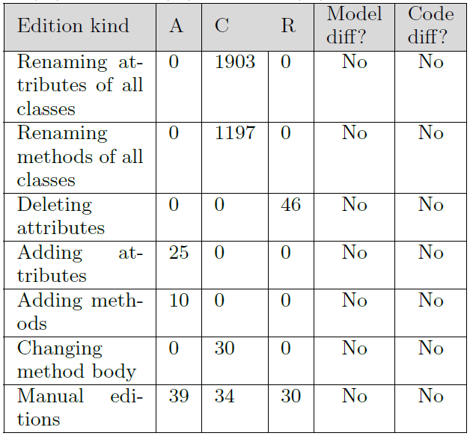

Simulation of concurrent changes to model and code
A third simulation aims at emulating the process described in Figure 6 of Section 3.3, in which the model and the code are concurrently edited. The process is simulated for 200 randomly generated UML models and their generated C++ code.
To simplify the simulation, the simulator only introduces attribute renaming editions on the model side. On the code side, the simulator only made changes to method bodies. To synchronize edited model and edited code, the strategy using code as the synchronization artifact was chosen (see Figure 4).
The simulator propagates all method body changes from the changed code to the synchronization artifact. The simulator then propagates all attribute renaming changes from the synchronization artifact to the changed code. Next, the synchronization artifact is reverse engineered incrementally to produce the changed model. At this point the model and the code are considered synchronized.
To assess that both synchronized model and code are images of one another, the synchronized code was reversed in batch mode to a new model. The new model was then compared with the synchronized model. No differences were found during these simulations. We also generated new code in batch mode from the synchronized model. The new code was compared to the synchronized code. No differences were found in the comparison.
The same simulation is repeated for the case where the model is used as the synchronization artifact. Again the synchronized code and model were images of one another.
Once the proposed model-code synchronization approach was verified through the three simulations, we decided to apply it to the development of a practical real-world system. The results of this experiment are discussed in the next section.

Realistic Case-study
In Section 5.1 the approach was tested for UML and C++ synchronization, using simulations. In this section, we describe the application of the full synchronization approach to a case- study. The intent here was to evaluate:
- The usability of the proposed synchronization approach
- The scalability of the tooling for realistic situations
The case-study is related to the development of the runtime underlying Papyrus-RT [11]. This is a custom modeling tool based on Papyrus that supports UML extensions for the design of a category of event-driven real-time systems (UML-RT). Papyrus-RT features full automated code generation for UML models. The generated code executes within a corresponding runtime environment, which provides C++ realizations of the high-level concepts defined in UML-RT.
At the start of the project, the resource available to develop the UML-RT runtime was an experienced C++ programmer. For the obvious pragmatic reasons, it was decided to implement the runtime in C++ without the benefits of models. However, later it was concluded that even if the result was satisfactory, it would be beneficial to take exploit the advantages that MDE provides. Thus, an MDE approach would improve both the maintainability and the evolvability of the runtime. Moreover, as development progressed, the project team was expanded to include new developers, all of whom were proponents of MDE and are eager to work with models.
As a result, this project represented an ideal case study to assess the practicality of the proposed approach. In particular, we were interested in determining its usability and scalability.
The runtime was originally implemented as an open-source plain C++11 project. Most of its architecture was object- oriented. The runtime had 65 classes and 14,945 lines of code. Other than including typical patterns found in object-oriented architectures, the runtime used C/C++ features, such as type definitions, templates, pointers, references, function pointers, and variadic functions to name a few. These features were supported by the reverse engineering and code generation tools in Papyrus, coupled with a C++ UML profile.
In order to use our model-code synchronization approach, the original Papyrus-RT runtime had first to be reverse engineered to a UML model. This step was crucial because the original runtime contained some elements that were not object-oriented. Consequently, some modifications and refactorings were made to the original runtime to make it fully object-oriented. This enabled it to be modeled entirely in a language like UML. Table 3 shows the two main differences between the original runtime, and the revised object-oriented runtime.
Table 3: Differences in papyrus-RT runtime versions
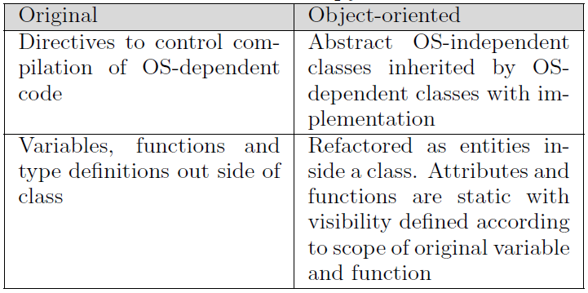
To reverse engineer the object-oriented runtime in batch mode takes about 12 seconds. All 65 classes were reversed, with all of their attributes and methods. Code generation in batch mode of the entire reversed UML model takes about 5 seconds and produces 22,053 lines of code. The difference in the number of lines of code is due to automatically generated documentation comments. The generated runtime compiles and the updated existing unit tests all pass when applied to the runtime compiled from the generated code.
Once the runtime was reverse engineered, our model-code synchronization processes could be used. We noticed that using the proposed approach introduced MDE style development for the Papyrus-RT runtime. This brought about several advantages as several manual tasks were automated:
- Automatic handling of relationships between model elements (associations, dependencies, subclassing)
- Automatic generation of includes and forward declarations in code that avoids cyclic dependencies
- Graphical representation of the architecture in automatically updated UML diagrams (a feature of Papyrus)
In applying the proposed synchronization approach to achieve a collaborative development of the runtime system, we found that the only real difficulty faced was initializing the synchronization processes. This required the reverse engineering of the original runtime, with some non-object-oriented code, into an object-oriented UML model. The reverse engineering was successful following some modifications and refactorings. Once the full model-code synchronization process was in place, we were able to use it and develop concurrently both the UML model and its generated C++ code.

RELATED WORK
Our work is motivated by the desire to reduce the gap between models and code, between graphical languages and textual languages. We used automation-supported model-code synchronization as a means to achieve this goal. In the following we compare our work to related works recorded in the literature.

Comparisons of graphical and textual languages
Graphical languages are a subset of visual languages. A number of efforts were undertaken that compared textual languages and visual languages. Many sources [7, 49, 50, 57, 59, 69] discuss the pros and cons of visual languages, compared to textual languages, in various contexts. Others [8, 10] also discuss what limits the adoption of visual languages.
In contrast to these efforts, we avoid a strict separation between textual languages and visual languages. Instead, we prefer to blur the boundaries between them. The idea that visual languages can co-exist with textual languages has already been noted by other authors.
In [14] the author argues that the gap between textual and visual languages is narrow. He proposes a framework to represent code in a visual language to improve comprehension of the code.
In [17] the authors propose a generic framework to use both visual and textual languages at the same time. The visual artifacts are translated to textual code. Much importance is given to the human factor; i.e., the framework can be customized based on developer preferences.
In [42] the authors propose a visual and textual language for the 3D animation domain. It is up to the system to inform the user, in textual form, how his or her visual operation is interpreted.
In domains such as requirements engineering, tools, such as IBM Rational Doors [34] or Visure Requirements [67], it is recognized that requirements are written traditionally in plain text by developers. However, some of these tools allow automation-assisted transformation of requirements written in a textual natural language to use cases and other structured requirements formats.
However, none of these systems are intended to support full implementation of a system. Generally, one one of the artifacts is used for assist in comprehension. There is no need for synchronization between artifacts because the transformation only proceed in one direction.
Our argument that, in order to be more efficient, developers should not be forced to choose between a graphical or textual language, is directly related to software comprehension. Sources that emphasize the role of software comprehension, for efficient software maintenance and evolution, date back to as far as the late eighties/early nineties [45, 68]. In our work we considered both software architects and programmers. The former generally prefer graphical languages for architecture description and comprehension, whereas the latter prefer textual languages since they are deemed much more expressive for specifying fine-grained algorithms, for example.

Artifact synchronization
Our work is also closely related to synchronization of different artifacts used in development. In the following sections, we compare our proposed model-code synchronization approach to other efforts in round-trip engineering, viewpoint synchronization, and model synchronization.

Round-trip engineering of model and code.
Several commercial and open-source tools [1–3, 23, 35, 51, 56, 63, 64] support round-trip engineering between UML models and code. Systematic reviews of some of these tools are available in [15, 28]. Support for Java round-tripping is prominent in most tools. Other languages such as C++ are only available in a few tools [2, 23, 63]. Our methodological pattern does not focus on a particular programming language or a particular modeling language. Furthermore, the current implementation of our approach is dedicated to UML and C++, which are less supported by these tools than Java. Usually, these tools only support architectural elements on the model side. The model cannot be used for full implementation and dependencies derived from method bodies are not considered during the round-tripping. In our work, we assume that the model can be used for a full implementation. Furthermore, our implementation analyzes C++ method bodies not only to reverse engineer them into UML, but also to derive dependencies in the UML model. Some tools [2, 63, 64] only allow one of the artifacts, either model or code, to be edited at a certain time. This avoids the problem of synchronizing model and code since there are no concurrent changes, which limits their applicability. Finally, some tools [23] do not support true incremental reverse engineering or code generation; instead, they treat change as (batch) deletion followed by (batch) addition.
Some round-trip engineering techniques restrict the development artifact to avoid synchronization problems. Partial round-trip engineering and protected regions are introduced in [22, 39]. Such techniques aim to preserve code changes that cannot be propagated to models. This approach separates the code regions that are generated from models from regions that are allowed to be modified by developers. This form of round-trip engineering is unidirectional and does not support iterative development [36]. Fujava [41] offers a round-trip engineering environment for UML and Java. Round-trip engineering is limited to elements that strictly conform to a naming convention. In our work there are no restrictions to modifications on model and code, and we do not impose naming conventions.

Viewpoint synchronization.
Both models and code can be considered simply as different viewpoints [18] of the same system. Viewpoints enable the partitioning of the model of a system into several representations, typically for different sets of concerns. Synchronization between viewpoints is crucial to maintain their consistency.
In [16] the authors improve the modeling of relationships and constraints between elements in different viewpoints in order to better guarantee the consistency of viewpoints. In [27] the authors argue that inconsistencies will exist in systems developed with different actors, using different viewpoints. They suggest that tools must be able to tolerate inconsistencies. A distributed graph transformation is proposed to deal with the problem of formalizing the integration of multiple viewpoints in software development. Their work focuses on requirements engineering. In contrast, our approach targets specifically both model and code. The latter is not usually considered in viewpoint synchronization because code is deemed to be too fine-grained. Furthermore, our approach does not require explicit modeling of the relationships between model elements and corresponding code elements.

Model synchronization.
Viewpoints synchronization is generalized by model synchronization for which there is an abundance of techniques presented in the literature. Model synchronization aims to maintain consistency between a source model and a target model. Model synchronization works are usually categorized by their model transformation which can be total, injective, bi-directional, or partial non-injective [31].
Many model synchronization techniques require the explicit mapping between the source model and target models. In [55], the authors propose an injective mapping of elements in the source model to the target model. The mapping can be used for synchronization. Techniques and technologies, such as Triple Graph Grammar (TGG) [26, 40] and QVT-Relation [54], allow synchronization between source and target elements that have non-injective mappings. The authors in [29] formalize TGG for synchronization of models that are concurrently edited. All of these techniques require a mapping model to connect the source and target models with typed traceability links, which need to be persisted in a model store [6]. This means that editing one model requires the presence of the other. Our model-code synchronization approach does not require a mapping model and artifacts may be edited whether or not the corresponding other artifact is available.
Other techniques [21, 66, 71] are based on bi-directional transformations, which comprise a forward transformation of source to target model, and a reverse transformation of target model to source. Bi-directional transformations provide a novel mechanism for synchronization [19]. Indeed, some works [19, 47] derive a backward transformation based on forward transformation. However, they do not offer any means of synchronizing models that are edited concurrently.
A few approaches derive model synchronization from model transformation while allowing concurrent editions of both source and target models. In [72] the authors propose to automatically derive model synchronization of a source model and a target model related by an ATL [37] model transformation. The synchronization is based on differentiating source and target model states. But, reflectable addition of an element in the target model is not well handled according to [72]. Our approach is generic and does not depend on a specific technology. Furthermore, in our implementation we propose to use modification events rather than state differences for incremental transformations.
As a final note, we argue that our methodological pattern is generic. Therefore, many synchronization techniques found in the literature can be integrated into our approach, such as, for example, the Synchronize Model or Reverse Code use cases of the proposed generic IDE. Finally, our solution targets collaboration between software architects and programmers who wish to use graphical languages or textual languages. Therefore, we propose to use a synchronization artifact in the preferred language of the developer, rather than directly synchronizing artifacts in different languages.

SUMMARY
This paper presents a generic model-code synchronization methodological pattern. The proposed approach is designed to support a continuous collaboration between software architects and programmers allowing each to use the language and tools of choice. An Eclipse-based implementation of the approach was developed for synchronizing models based on the OMG-standard UML modeling language and the C++11 programming language.
Several simulations were used to validate our synchronization approach with respect to both laws of round-trip engineering. In addition, a simulation of scenarios in which both the model and the code were modified concurrently was performed, further demonstrating the viability of the approach, even in such a highly dynamic scenario.
The approach was then applied to a real-world application: the Papyrus-RT runtime system. This was a system that was originally developed in C++ with some non-object-oriented code. This experiment showed that the main difficulty of using the approach to such a system was the need to modify and refactor the program code in such way that it can be reverse engineered into a corresponding UML model without loss of information. Once the processes of our synchronization solution was bootstrapped in this way, dynamic collaboration between software architects and programmers was possible. We were then able to reap the important benefits of MDE; development was facilitated through increased automation and system maintainability and evolvability were improved.
In the future, we would like to make our implementation even more generic. Indeed, we had to modify tools like EMF Compare to suit the implementation of our solution with other Eclipse technologies. Currently, we are also implementing our generic synchronization pattern for the case of UML and Java.
Our work was in part motivated by the perceived gap between graphical languages and textual languages, which impeded greater adoption of MDE among practitioners. Therefore, as a future work item, we would like to assess to what extent our solution helps in eliminating the unnecessary and dogmatic separation of models from code. We feel that this would be useful to both the MDE community and the more traditionally-oriented software communities.

References
[1] O. Acceleo. ”Acceleo Homepage”. https://www.eclipse. org/umlgen/, 2015.
[2] Altova. ”UModel”. http://www.altova.com/umodel. html, 2015.
[3] AndroMDA. AndroMDA Model Driven Architecture Framework. http://andromda.sourceforge.net/, 2016. [4]U. Assmann., Automatic roundtrip engineering. Electronic Notes in Theoretical Computer Science, 82(5):33–41, 2003.
[5] G. Bergmann, I. D´avid, A. Heged A˜ ijs, A. Horva´th, I. R´ath, Z. Ujhelyi, and D. Varr´o. VIATRA 3: a reactive model transformation platform. In Theory and Prac- tice of Model Transformations, pages 101–110. Springer, 2015.
[6] G. Bergmann, I. R´ath, G. Varr´o, and D. Varr´o. Change- driven model transformations, volume 11. mar 2011.
[7] T. Booth and S. Stumpf. End-User Experiences of Vi- sual and Textual Programming Environments for Arduino. In End-User Development, volume 7897, pages 25–39. Springer Berlin Heidelberg, Berlin, Heidelberg, 2013.
[8] N. C. C. Brown, M. Kolling, and A. Altadmri. Position paper: Lack of keyboard support cripples block-based programming. In Proceedings of the 2015 Blocks and Beyond Workshop, Atlanta, GA, USA, 2015.
[9] C. Brun and A. Pierantonio. Model differences in the eclipse modeling framework. UPGRADE, The European Journal for the Informatics Professional, 9(2):29– 34, 2008.
[10] I. Burnett, M. Baker, C. Bohus, P. Carlson, S. Yang, and P. Van Zee. Scaling up visual programming languages. Computer, 28(3):45–54, Mar, 1995.
[11] CEA. Papyrus-RT Website. https://www.eclipse.org/ papyrus-rt/, 2016.
[12] A. Charfi, C. Mraidha, and P. Boulet. An Optimized Compilation of UML State Machines. In Proceedings of 15th International Symposium on Object/Component/Service-Oriented Real-Time Distributed Computing, Guangdong, China, 2012.
[13] E. J. Chikofsky, J. H. Cross, and others. Reverse engineering and design recovery: A taxonomy. Software, IEEE, 7(1):13–17, 1990.
[14] S. Conversy. Unifying Textual and Visual: A Theoretical Account of the Visual Perception of Programming Languages. In Proceedings of the 2014 ACM Internation Symposium on New Ideas, New Paradigs, and Reflections on Programming & Software, Portland, OR, USA, 2014.
[15] D. Cutting and J. Noppen. An Extensible Benchmark and Tooling for Comparing Reverse Engineering Approaches. International Journal on Advances in Software, 8(1):115–124, 2015.
[16] R. Eramo, A. Pierantonio, J. Romero, and A. Vallecillo. Change Management in Multi-Viewpoint System Using ASP. In Proceedings of the 12th Entreprise Distributed object Computing Conference Workshops, Munich, Germany, Sep, 2008.
[17] M. Erwig and B. Meyer. Heterogeneous visual languages-integrating visual and textual programming. In Proceedings of the 11th IEEE International Symposium on Visual Languages, 1995.
[18] A. Finkelstein, J. Kramer, and M. Goedicke. ViewPoint Oriented Software Development. In Proceedings of the 3rd International Workshop on Software Engineering and its Applications, Toulouse, France, 1990.
[19] S. Fischer, Z. Hu, and H. Pacheco. GRACE TECHNICAL REPORTS aˆA˘ IJ Putback aˆA˘ I˙ is the Essence of Bidirectional Programming. (December), 2012.
[20] J. N. Foster, M. B. Greenwald, J. T. Moore, B. C. Pierce, and A. Schmitt. Combinators for bidirectional tree transformations: A linguistic approach to the viewupdate problem. ACM Trans. Program. Lang. Syst., 29(3), May 2007.
[21] J. N. Foster, M. B. Greenwald, J. T. Moore, B. C. Pierce, and A. Schmitt. Combinators for Bidirectional Tree Transformations: A Linguistic Approach to the View-update Problem. ACM Trans. Program. Lang. Syst., 29(3), May 2007.
[22] D. Frankel. Model Driven Architecture: Applying MDA to Enterprise Computing. John Wiley & Sons, Inc., New York, NY, USA, 2002.
[23] E. U. Generators. ”Eclipse UML Generators Homepage”. https://eclipse.org/acceleo/, 2015.
[24] S. G´erard. Once upon a Time, There Was PapyrusaˆA˘ e‹ . In Proceedings of 3rd International Conference on Model-Driven Engineering and Software Development, Montreal, Canada, 2015.
[25] H. Giese and R. Wagner. Incremental Model Synchronization with Triple Graph Grammars. In Proceedings of the 9th international conference on Model Driven Engineering Languages and Systems, Genova, Italy, 2006.
[26] H. Giese and R. Wagner. Incremental model synchronization with triple graph grammars. In Model Driven Engineering Languages and Systems, pages 543–557. Springer, 2006.
[27] M. Goedicke, B. Enders, T. Meyer, and G. Taentzer. ViewPoint-Oriented Software Development: Tool Support for Integrating Multiple Perspectives by Distributed Graph Transformation. In Tools and Algorithms for the Construction and Analysis of Systems, volume 1785, pages 43–47. Springer Berlin Heidelberg, Berlin, Heidelberg, Germany, Jun, 2000.
[28] M. R. C. Hafeez Osman. Correctness and Completeness of CASE Tools in Reverse Engineering Source Code into UML Model. GSTF Journal on Computing, 2(1):193– 201, 2012.
[29] F. Hermann, H. Ehrig, C. Ermel, and F. Orejas. Concurrent model synchronization with conflict resolution based on triple graph grammars. In Lecture Notes in Computer Science (including subseries Lecture Notes in Artificial Intelligence and Lecture Notes in Bioinformatics), volume 7212 LNCS, pages 178–193, 2012.
[30] T. Hettel, M. Lawley, and K. Raymond. Model Synchronisation: Definitions for Round-Trip Engineering. In Theory and Practice of Model Transformations, volume 5063, pages 31–45. Springer Berlin Heidelberg, Berlin, Heidelberg, 2008.
[31] T. Hettel, M. Lawley, and K. Raymond. Model synchronisation: Definitions for round-trip engineering. In Lecture Notes in Computer Science (including subseries Lecture Notes in Artificial Intelligence and Lecture Notes in Bioinformatics), volume 5063 LNCS, pages 31–45, 2008.
[32] J. Hutchinson, M. Rouncefield, and J. Whittle. Modeldriven engineering practices in industry. In Proceedings of the 33rd International Conference on Software Engineering, Honolulu, HI, USA, 2011.
[33] J. Hutchinson, J. Whittle, and M. Rouncefield. Modeldriven engineering practices in industry: Social, organizational and managerial factors that lead to success or failure. Science of Computer Programming, 89:144–161, Sept. 2014.
[34] IBM. Rational DOORS. http://www- 03.ibm.com/software/products/en/ratidoor, 2016.
[35] IBM. Rational Rhapsody Website. http://www-03.ibm.com/software/products/en/ratirhapfami, 2016.
[36] S. J ¨orges. Construction and evolution of code generators: A model-driven and service-oriented approach. Lecture Notes in Computer Science (including subseries Lecture Notes in Artificial Intelligence and Lecture Notes in Bioinformatics), 7747:1–265, 2013.
[37] F. Jouault, F. Allilaire, J. B A˜ l’zivin, and I. Kurtev. ATL: A model transformation tool. Science of computer programming, 72(1):31–39, 2008.
[38] A. Kazakova. Infographic: C/C++ facts we learned before going ahead with CLion. http://blog.jetbrains.com/clion/2015/07/infographics-cpp-facts-before-clion/, 2016.
[39] S. Kelly and J. P. Tolvanen. Domain-Specific Modeling: Enabling Full Code Generation. 2007.
[40] E. Kindler and R. Wagner. Triple graph grammars: Concepts, extensions, implementations, and application scenarios. University of Paderborn, 2007.
[41] T. Klein, U. A. Nickel, J. Niere, and A. Z u¨ndorf. From uml to java and back again. Technical report, University of Paderborn, Paderborn, Germany, 1999.
[42] K. Kojima, Y. Matsuda, and S. Futatsugi. LIVE-Integrating visual and textual programming paradigms. In Proceedings of the 1989 IEEE Workshop on Visual Languages, Rome, Italy, 1989.
[43] A. Kusel, J. Etzlstorfer, E. Kapsammer, P. Langer, W. Retschitzegger, J. Schoenboeck, W. Schwinger, and M. Wimmer. A Survey on Incremental Model Transformation Approaches. In Proceedings of the 7th Models and Evolution Workshop, Miami, FL, USA, 2013.
[44] F. Lanubile, C. Ebert, R. Prikladnicki, and A. Vizcaino. Collaboration Tools for Global Software Engineering. IEEE Software, 27(2):52–55, Mar. Mar, 2010.
[45] D. C. Littman, J. Pinto, S. Letovsky, and E. Soloway. Mental models and software maintenance. Journal of Systems and Software, 7(4):341–355, Dec, 1987.
[46] I. Malavolta, P. Lago, H. Muccini, P. Pelliccione, and A. Tang. What Industry Needs from Architectural Languages: A Survey. IEEE Transactions on Software Engineering, 39(6):869–891, Jun, 2013.
[47] K. Matsuda and M. Wang. Applicative bidirectional programming with lenses. Proceedings of the 20th ACM SIGPLAN . . . , pages 38–41, 2015.
[48] MODELS. Models conference. http://www. modelsconference.org, 2016.
[49] T. G. Moher, D. Mak, B. Blumenthal, and L. Levanthal. Comparing the comprehensibility of textual and graphical programs. In Proceedings of the 5th workshop on Empirical Studies of Programmers, Palo Alto, CA, USA, 1993.
[50] R. Navarro-Prieto and J. J. Canas. Are visual programming languages better? The role of imagery in program comprehension. International Journal of HumanComputer Studies, 54(6):799–829, Jun, 2001.
[51] I. No Magic. ”magic draw”. https://www.nomagic.com/ products/magicdraw.html, 2016.
[52] OMG. Software & Systems Process Engineering Metamodel specification (SPEM) Version 2.0. http://www.omg.org/spec/SPEM/2.0/PDF, 2008.
[53] OMG. UML Specification. Specification 2.4.1, OMG, Aug. 2011.
[54] Q. Omg. Meta Object Facility ( MOF ) 2 . 0 Query / View / Transformation Specification. Transformation, (January):1–230, 2008.
[55] E. Paesschen, W. Meuter, and M. D’Hondt. Model Driven Engineering Languages and Systems: 8th International Conference, MoDELS 2005, Montego Bay, Jamaica, October 2-7, 2005. Proceedings, chapter SelfSync: A Dynamic Round-Trip Engineering Environment, pages 633–647. Springer Berlin Heidelberg, Berlin, Heidelberg, 2005.
[56] V. Paradigm. ”visual paradigm”. http://www. visual-paradigm.com/, 2015.
[57] M. Petre. Why looking isn’t always seeing: readership skills and graphical programming. Communications of the ACM, 38(6):33–44, Jun, 1995.
[58] J. Rumbaugh, I. Jacobson, and G. Booch. Unified Modeling Language Reference Manual. Pearson Higher Education, 2004.
[59] E. Schanzer, K. Shriram, and F. Kathi. Blocks Versus Text: Ongoing Lessons from Bootstrap. In Proceedings of the 2015 Blocks and Beyond Workshop, Atlanta, GA, USA, 2015.
[60] D. C. Schmidt. Model-driven engineering. Computer, 39(2):25, 2006.
[61] B. Selic. What will it take? A view on adoption of model-based methods in practice. Software & Systems Modeling, 11(4):513–526, Oct. 2012.
[62] S. Sendall and J. K A˜ ijster. Taming model round-trip engineering. In Proceedings of Workshop on Best Practices for Model-Driven Software Development, Vancouver, Canada, 2004.
[63] Y. Solutions. Uml lab. http://www.uml-lab.com, 2012.
[64] SparxSysemx. ”enterprise architect”. http://www.sparxsystems.com/products/ea/, 2016.
[65] D. Steinberg, F. Budinsky, E. Merks, and M. Paternostro. EMF: eclipse modeling framework. Pearson Education, 2008.
[66] P. Stevens. A landscape of bidirectional model transformations. In Lecture Notes in Computer Science (including subseries Lecture Notes in Artificial Intelligence and Lecture Notes in Bioinformatics), volume 5235 LNCS, pages 408–424, 2008.
[67] Visure. Visure Requirements. http://www.visuresolutions.com/, 2016.
[68] A. Von Mayrhauser and A. Vans. Program comprehension during software maintenance and evolution. Computer, 28(8):44–55, Aug. 1995.
[69] K. Whitley. Visual Programming Languages and the Empirical Evidence For and Against. Journal of Visual Languages and Computing, 8(1):109–142, Feb, 1997.
[70] J. Whittle, J. Hutchinson, M. Rouncefield, H. Burden, and R. Heldal. Industrial Adoption of ModelDriven Engineering: Are the Tools Really the Problem? In Model-Driven Engineering Languages and Systems, volume 8107, pages 1–17. Springer Berlin Heidelberg, Berlin, Heidelberg, Germany, 2013.
[71] A. Wider. Towards combinators for bidirectional model transformations in scala. Software Language Engineering, 2012.
[72] Y. Xiong, D. Liu, Z. Hu, H. Zhao, M. Takeichi, and H. Mei. Towards automatic model synchronization from model transformations. In Proceedings of the 22nd IEEE/ACM Internation Conference on Automated Software Engineering, 2007.

