LIST OF SHORTEN WORDS

|  |  |  |
| --- | --- | --- |
| **STT** | **Shorten word** | **Fully word** |
| 1 | ALPR | Automatic License Plate Recognition |
|  |  |  |

TABLE OF FIGURES

Figure 1. ALPR system 1

TABLE OF TABLES

Table 1. Table 1 2

Table 2. Nothing 2

CONTENTS

LIST OF SHORTEN WORDS 1

TABLE OF FIGURES 1

TABLE OF TABLES 1

CONTENTS 1

CHAPTER 1. PREFACE 1

1. Reasons for choosing the topic. 1

1.1 Sub section 2

2. Purpose of the topic 3

3. 3

**REFERENCES** 3

CHAPTER 1. PREFACE

1. Reasons for choosing the topic.

Nowadays, with the rapid increase of means of transport, the management and control of traffic vehicles in a smart way is attracting more and more attention. Automated vehicle monitoring and tracking systems have been installed in many countries for traffic monitoring tasks.

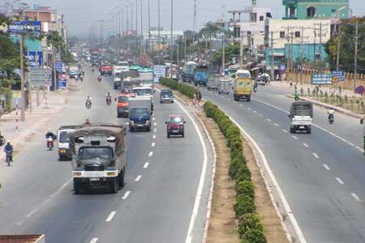

Figure 1. Vietnamese vehicles on a highway street.

An automatic vehicle tracking and monitoring system is a system that takes images or videos as input. If the input contains a vehicle, the system will output the content of the number plate in the form of text and proceed to store and trace the vehicle's route on the map at points with traffic cameras. Techniques to solve the given number plate recognition problem such as object detection [1], image processing [2], pattern recognition [3]. Automated vehicle tracking and monitoring systems are designed for outdoor deployment and therefore are vulnerable to environmental and weather influences, such as in rainy or foggy conditions. Including changing the light between day and night. In fact, it is also difficult to process when the input image has many license plates, and the image quality is poor. In addition, the camera's viewing angle for different vehicles, lighting conditions and color nature of the variable, so the vehicle variable will have different sizes, colors, fonts and offsets, making it difficult to interpret. solve the problem of recognizing license plates for all scenarios. Moreover, there will be separate standards for the license plates of that country between countries, so it is really difficult to apply a system anywhere in the world. Therefore, the techniques to solve this problem are very complex [4], [5].

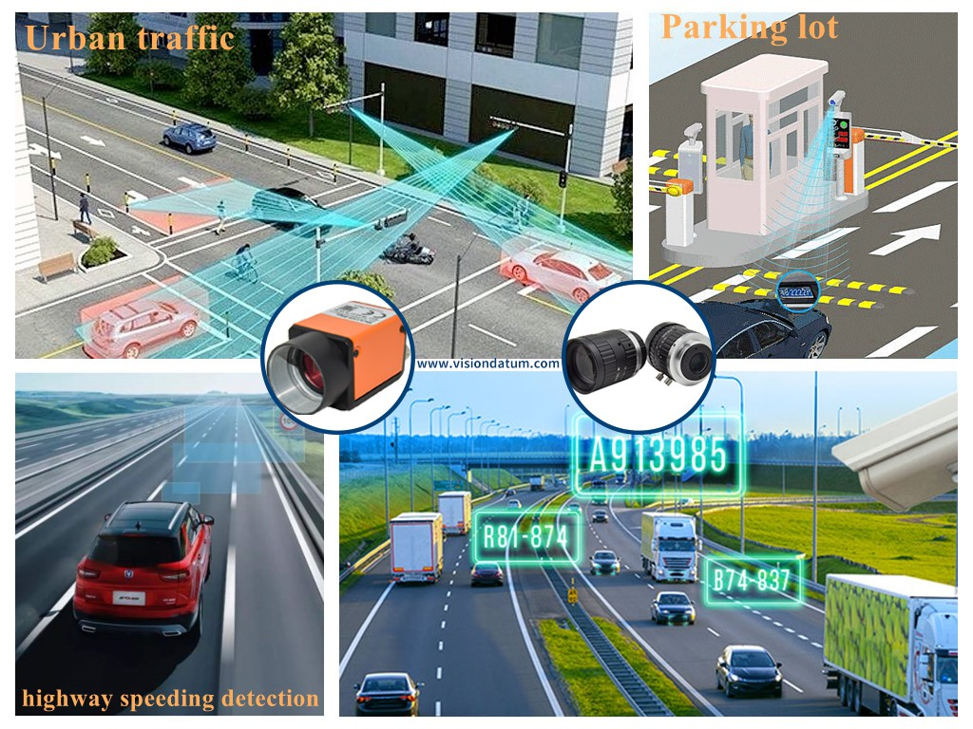

Figure 2. ALPR system

* 1. Sub section

|  |  |  |
| --- | --- | --- |
|  |  |  |
|  |  |  |
|  |  |  |
|  |  |  |

Table 1. Table 1

|  |  |  |
| --- | --- | --- |
|  |  |  |
|  |  |  |
|  |  |  |
|  |  |  |

Table 2. Nothing

Y + x = 9 (1)

A + n = 5 (2)

1. Purpose of the topic

**CHAPTER 2. OVERVIEW OF CAR LICENSE PLATE RECOGNITION PROBLEM**

**CHAPTER 3. OVERVIEW OF CAR TRACKING AND MONITORING SYSTEM ON WIDESPREAD**

# REFERENCES

|  |  |
| --- | --- |
| [1] | R. L. e. al., "A Robust Real-Time Automatic License Plate Recognition Based on the YOLO Detector," 2018. |
| [2] | A. M. A.-G. e. al, "A new vertical edge detection algorithm and its application," 2008. |
| [3] | M. J. A. a. S. A. G. M. Sarfraz, "Saudi Arabian license plate recognition system," 2003. |
| [4] | Y. W. e. al., "An Algorithm for License Plate Recognition Applied to Intelligent Transportation System," 2011. |
| [5] | A. R.-A. e. al., "Effects of Challenging Weather and Illumination on Learning-Based License Plate Detection in Noncontrolled Environments," 2019. |