|  |  |
| --- | --- |
|  | **MINISTRY OF EDUCATION AND TRAINING** |

|  |  |  |
| --- | --- | --- |
| **FPT UNIVERSITY** | | |
| CAPSTONE PROJECT DOCUMENT | | |
| **SITE BUILDER FOR PRODUCT CATALOGUE** | | |
| **SE07.B – GROUP 7** | |
| **Group Members** | |  |  |  | | --- | --- | --- | | Phạm Văn Thắng | Team Leader | SE61092 | | Lê Trần Thịnh | Team Member | SE61152 | | Phạm Khương Duy | Team Member | 60195 | | Lê Thanh Tuấn | Team Member | SE60636 | |
| **Supervisor** | Nguyễn Huy Hùng |
| **Capstone Project code** |  |

- Ho Chi Minh City, January/2014 -

Table of Contents

A. Report No.1 Introduction 7

1. Project Information 7

2. Introduction 7

3. Current Situation 7

4. Problem Definition 8

5. Proposed Solution 8

5.1 Feature functions 8

5.2 Advantages and disadvantages 8

6. Functional Requirements 8

7. Role and Responsibility 9

B. Report No.2 Software Project Management Plan 10

1. Problem Definition 10

1.1 Name of this Capstone Project 10

1.2 Problem abstract 10

1.3 Project Overview 10

2. Project Organization 12

2.1 Software Process Model 12

2.2 Roles and responsibilities 12

2.3 Tools and Techniques 13

3. Project Management Plan 14

3.1 Software development life cycle 14

4. Coding Convention 14

**List of Tables**

Table 1: Roles and Responsibilities 9

Table 2: Current sites builder services’ advantages and disadvantages. 11

Table 3: Hardware Requirement for Server 11

Table 4: Project Role and Responsiility 13

**List of figures**

**Definition, Acronyms, and Abbreviations**

|  |  |
| --- | --- |
| **Name** | **Definition** |
| SBPC | Site Builder for Product Catalogue |
|  |  |

# Report No.1 Introduction

## Project Information

* Project Name: Site Builder for Product Catalogue
* Project Code: SBPC
* Product Type: Web application
* Start Date: January 6, 2015
* End Date: April 25, 2015

## Introduction

Nowadays, the development of internet and information technology led to the dramatic increase in online users. Among of them, a lot of users search for necessary products, suitable prices, brands and price comparison as well. Hence, more and more companies want to create a website for showing their product catalogue as an online marketing method.

Besides, we all recognized that creating a website for non IT Commercial Corporation is time consuming and expensive.

Currently, in Vietnam, there are some websites that provide site builder services for creating a commercial website. However, they are not easy to use and do not concentrate on any fields. Therefore, it is hard for corporations to use their services especially for creating products catalogue website.

From above mentioned reasons, this project is going to build a site builder for products catalogue.

## Current Situation

There are many websites services support for building site in Viet Nam, some of popular sites are websieutoc.vn, wevina.vn, and bizweb.vn. Those sites help user build various types of sites such as online ecommerce, medical, fashion, services and many other fields.

To begin using those sites services, user must register to system, then, user can move to site builder page. The system suggests user for default site templates or blank templates. At site builder page, a tool box helps user drag and drop content into their site. User can also customize site layout, background, header and footer.

Some of features require paying or upgrading account example mapping site domain. After completing building site, user can save their site and publish it if they want. The system supports for publishing with default domain, if choose another, user must pay.

## Problem Definition

Although many function of above mentioned websites, they still have weaknesses. They do not concentrate on any fields especially products catalogue sites. It is not easy to use their service for new user because of confuse interface and difficult manipulation on builder page. Moreover, the system does not support products detail management and website statistics.

## Proposed Solution

### 5.1 Feature functions

This site builder mainly concentrates on creating products catalogue sites. It is not only offers to create site base on available templates but also offers to customize site base on default site template/theme. In addition, the site builder also supports for mapping user’s site domain. If user does not have any domains, the site builder will support for a default domain. User can view statistics about number of visitors to their website, which products visitors mostly view.

### 5.2 Advantages and disadvantages

- Advantages:

* Focus on building products catalogue site
* Enhance visibility and effectiveness by drag and drop function
* Support website statistics
* Support products detail management

- Disadvantages:

* E-Commerce websites are not support
* Websites with volatile and complex data are not suitable.

## Functional Requirements

Function requirements of the system are listed as below:

* Account management
* Advantage template searching
* Default website template/theme creation
* Website template/theme customization
* Website’s statistics handler
* Product items management
* Payment method for premium features
* Website’s domain mapping

## Role and Responsibility

|  |  |  |  |  |
| --- | --- | --- | --- | --- |
| **No** | **Full Name** | **Role** | **Position** | **Contact** |
| **1** | Nguyễn Huy Hùng | Supervisor | Instructor | hungnh@fpt.edu.vn |
| **2** | Phạm Văn Thắng | Developer | Leader | thangpvse61092@fpt.edu.vn |
| **3** | Lê Trần Thịnh | Developer | Member | thinhltse61152@fpt.edu.vn |
| **4** | Phạm Khương Duy | Developer | Member | duypk60195@fpt.edu.vn |
| **5** | Lê Thanh Tuấn | Developer | Member | tuanltse60636@fpt.edu.vn |

Table 1: Roles and Responsibilities

# Report No.2 Software Project Management Plan

## Problem Definition

### Name of this Capstone Project

Site Builder for Product Catalogue (SBPC).

### Problem abstract

In Vietnam, many websites support for building products catalogue site, but they have complex interface and manipulation. User cannot manage products detail information or view site statistics. In addition, they just support for adding products and categories simply or not support.

### Project Overview

#### Current Situation and Disadvantages

Some of the most popular site builder service websites in Viet Name are researched and listed below: (Câu này đã sửa lại theo yêu cầu thầy)

|  |  |  |
| --- | --- | --- |
| **Website name** | **Advantages** | **Disadvantages** |
| websieutoc.vn | * Support building variety sites such as products catalogue, services, fashion, beauty and medical. | * Confuse interface and system flow. * Some function are not perform correctly. |
| wevina.vn | * Can change site type between private and business. * Be able to disable site status from active to inactive and reverse. * Tool box for building site is accessible to user. | * Not support products and categories management. * Not support mapping domain. |
| bizweb.vn | * Tool box for building site is easy to use and also supports for adding products quickly. * Allow adding new module (photo gallery or map). * User can modify module position * Support for customizing CSS and HTML * Support order management. * Integrate store to facebook.com, hangtot.com | * User must remember their created website name to login. * Menu arrangement and interface are confused. * It is difficult to format layout and background. |

Table 2: Current sites builder services’ advantages and disadvantages.

#### The Proposed System

From above disadvantages, this project is going to build up a site builder for products catalogue. User can choose a default template and customize it. For site building manipulation, user can drag and drop elements from a tool box at builder page. User can also upgrade their account type to have more support features. When completing building site, user can preview site and mapping domain. For report, site statistics will show information about number of visitors and which products mostly viewed.

#### Boundaries of System

* The system is a web application, which concentrates on helping user build products catalogue sites only.
* For different account type (Gold, Silver, Free), users may have different features.
* Site statistics will show summary information about number of visitors and viewed products.

#### Development Environment

##### Hardware requirement

**For Server**

|  |  |  |
| --- | --- | --- |
| **Windows** | **Minimum Requirements** | **Recommended** |
| Internet Connection | Cable, Wi-Fi (4 Mbps) | Cable, Wi-Fi (8 Mbps) |
| Operating System | Window 7 | Window 7 |
| Computer Processor | Intel® Xeon® Quad Core 2.50 GHz | Intel® Core™ i3 (2.50GHz) |
| Computer Memory | 1GB RAM | 2GB or more |

Table 3: Hardware Requirement for Server

##### Software requirement (nêu ra các ứng dụng phần mềm để phát triển dự án như .net framework 4.0, MVC 4…)

## Project Organization

### Software Process Model

In this project, we decided to use the Scrum model for developing.

OVERVIEW DIAGRAM

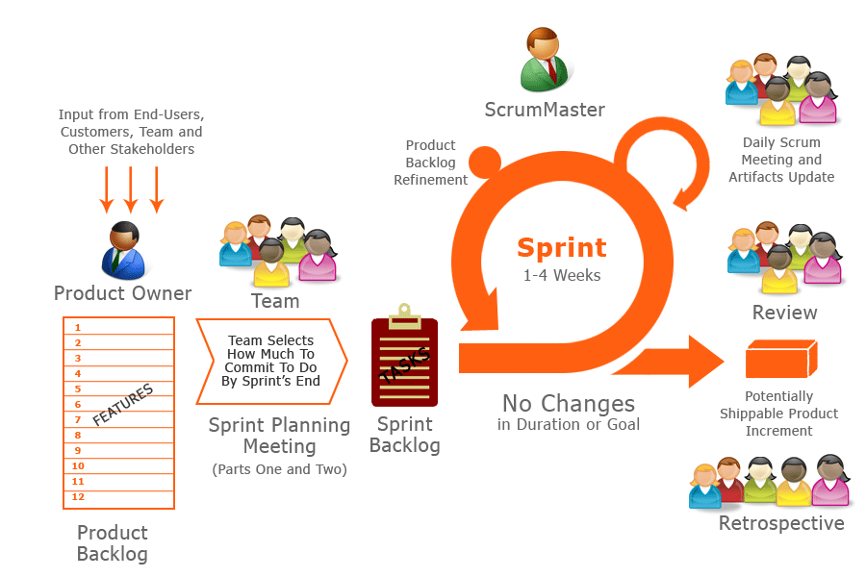

(Đánh số figure và ghi reference nếu có)

Because of the project characteristics, we decide to make progress in series of sprints which are time boxed iterations in one week. At the beginning of one sprint, through sprint planning meeting, all team members will discuss together to define sprint backlog which is suitable to be completed within a week. Daily meeting and online conference are used to manage all activities and issues troubleshoot. At the end of sprint, product owner and developer team will review completed product to figuring out the necessary changes for products.

### Roles and responsibilities

|  |  |  |  |  |
| --- | --- | --- | --- | --- |
| **No.** | **Full name** | **Team Role** | **Scrum Team Role** | **Responsibilities** |
| 1 | Nguyễn Huy Hùng | Supervisor | Product Owner | * Outline work in scrum backlog * Answer question and deliver direction |
| 2. | Phạm Văn Thắng | Team Leader | Scrum Master | * Facilitate productivity – maximize team performance * Complete all individual work |
| 3. | Lê Trần Thịnh | Team Member | Scrum Team Member | * Commit individual product on time * Support each other to complete team work |
| 4 | Phạm Khương Duy | Team Member | Scrum Team Member | * Commit individual product on time * Support each other to complete team work |
| 5 | Lê Thanh Tuấn | Team Member | Scrum Team Member | * Commit individual product on time * Support each other to complete team work |

Table 4: Project Role and Responsiility

**Product Owner** in this project is also Project Manager who supports the whole team by outlining works in the [scrum backlog](http://scrummethodology.com/the-scrum-backlog/), prioritizing it and being available to answer questions and deliver direction.

**Scrum Master** has responsibility to do everything he can do to facilitate productivity – address needs of the team and contribute to Product Owner to maximize team performance. As a real team player, he is required to complete all individual work.

**Scrum Team Member** is expected to be self-organized, cross-functional with high adaptability. All members have the right to do anything within the boundaries of project to meet the sprint goals and have responsibility not only to commit their individual product on time but also to support another members to ensure team can complete its work.

### Tools and Techniques (Ghi ra tất cả tool hỗ trợ làm project)

* MS Excel 2013: Handle Products, Sprints Backlog. (câu này nên ghi lại là : “Handle Products and sprints backlog: MS Excel 2013”)

## Project Management Plan

### Software development life cycle

Every sprint begins with sprint planning meeting, in which the Product Owner and team discuss the prioritized tasks in product backlog then add that tasks to sprint backlog. Once the time team commit sprint backlog, Product Owner can’t add more task.

During daily meeting, team have online meeting to update task status, discuss solution to challenges. It happens each day of the sprint.

At the ending of the sprint, that have a sprint review meeting, in which team present it works to the Product Owner. Project Owner decides each task is met acceptance criteria or not. If a task isn’t accepted, it’s rejected as incomplete.

All team also gather after end of each sprint to share what worked, what didn’t, and how processes could be improved. This meeting is called the sprint retrospective meeting.

### Phase Detail

#### Phase 1: Sprint 1

|  |  |  |  |
| --- | --- | --- | --- |
| **Task** | **Description** | **Person in charge** | **Estimate** |
| Design homepage theme | Using bootstrap, Jquery to create a responsive page, flat design | DuyPK | 20 |
| Design register/login/logout page | Login/register are show as a pop-up, support identity identifier (facebook, google) | DuyPK | 2 |
| Design dashboard page |  | TuanLD | 10 |
| Design site buider page |  | TuanLD | 10 |
| Design ERD | Using Microsoft Visio/StarUML (UML 2.0) | ThinhLT | 10 |
| Design Usecase | ThangPV | 20 |
| Design Systems Architect |  | TuanLD | 2 |
| Design Physical Database |  | ThinhLT | 2 |
| Report 2: |  |  |  |
| 1- Project definition |  | TuanLD | 4 |
| 2- Project oganization |  | DuyPK | 4 |
| 3- Project management plan |  | ThinhLT | 4 |
| 4- Coding convention |  | ThinhLT | 1 |
| Report review |  | ThangPV | 2 |

## Coding Convention

This project is applied some coding convention rules as listed below:

|  |  |  |  |
| --- | --- | --- | --- |
| NO. | Type | Name | Description |
| 2.1 | Naming Convention | Capitalization Styles | Some capitalization rules for differences type of identifiers. |
| 2.2 | Abbreviations |  |
| 2.3 | Namespace Naming Guidelines |  |
| 2.4 | Class Naming Guideline |  |
| 2.5 | ADO.NET Naming class variable |  |
| 2.6 | Interface Naming Guideline |  |
| 2.8 | Enumeration Type Naming Guideline |  |
| 2.9 | Static Field Naming Guideline |  |
| 2.10 | Parameter Naming Guideline |  |
| 2.11 | Method Naming Guideline |  |
| 2.12 | Property Naming Guideline |  |
| 2.15 | Control Naming Standard |  |
| 2.16 | Constant Naming Guideline |  |
| 3.1 | Code Formats | Code Comments | Some rules to comment in code |
| 3.2 | Declarations | Guidelines to declare variables, class and interface, properties |
|  |  |  |  |

Table 5: Coding Convention

Reference Coding Convention document can be found at:

<http://caps-team7-fu.googlecode.com/svn/trunk/Document/C%20Sharp%20Coding%20Convention.doc>